
University of Wisconsin Garden Facts

Provided to you by:
XHT1048

Ash Flower Gall
Phil Pellitteri, UW Insect Diagnostic Lab

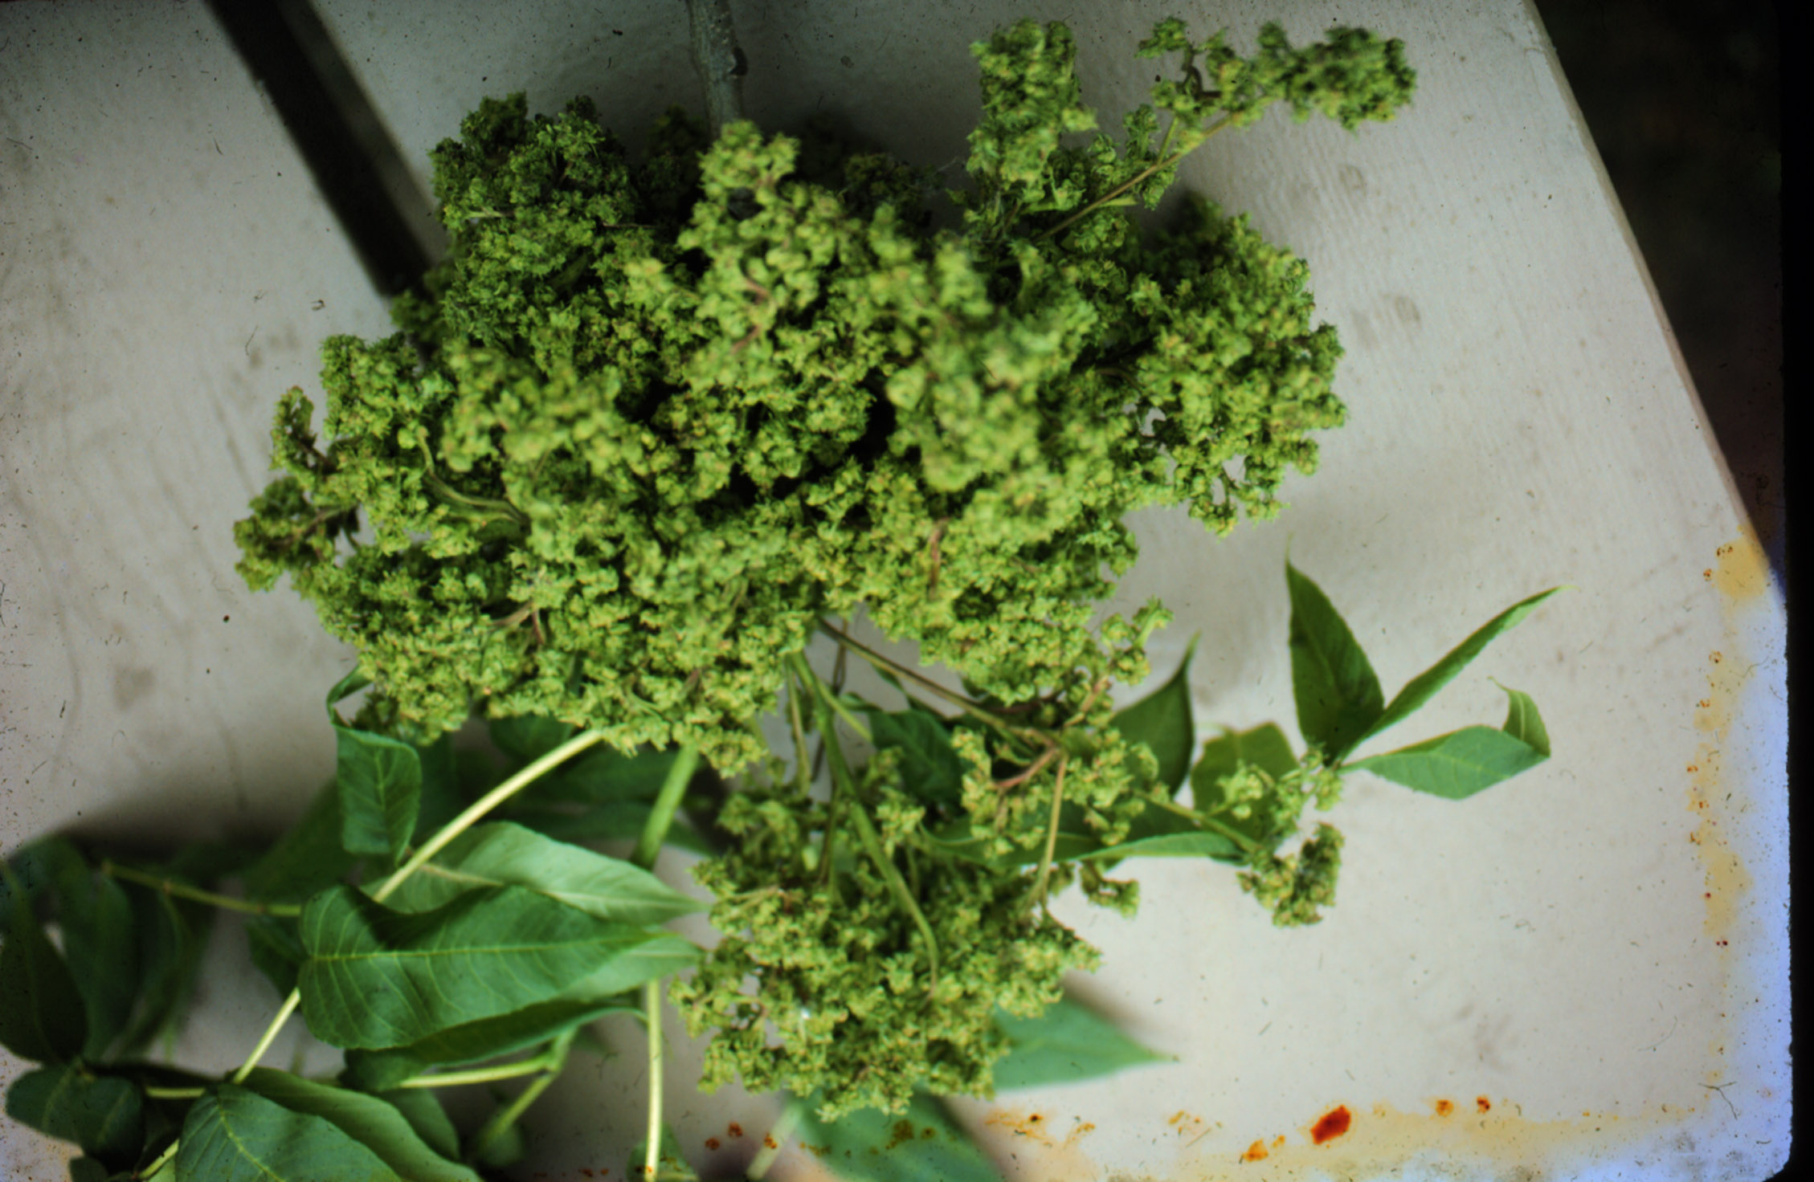
What is wrong with my ash tree? Galls are abnormal plant growth that can be caused by insects, mites or plant diseases. On ash trees, a tiny eriophyid mite causes male flowers to grow into round greenish, ¹∕2 to 1 inch diameter tumor-like structure. Sometimes the lumpy growths also cause leaf distortions. During the late summer the galls turn dark brown and woody, and can remain on the tree for more than one season. Ash flower gall mites are too small to be seen with the unaided eye. These worm-shaped mites spend the winter under the buds and begin feeding, and initiate gall growth early in spring. Once the gall starts growing, it is too late to treat the plant.
Ash flower galls.

Will ash flower gall harm my tree? Ash flower gall does not harm the health of a tree, but in some years will make a tree look unsightly. In rare situations the weight of the gall tissue can cause branches to be strained. Some trees seem to be more prone to this problem than others.

How do I control ash flower gall? Timing is everything. The mites must be killed before galls begin to grow in the spring. Look for the first signs of green in the opening flower buds. An application of carbaryl (Sevin) in the spring when the first blossoms begin to form will reduce the number of galls. However, larger trees are difficult to treat, and because ash flower gall is considered a cosmetic problem, treatment is rarely suggested. Young trees do differ in their susceptibility. Therefore, consider replacing highly susceptible trees.

For more information on ash flower gall: Contact your county Extension agent.

© 1999 by the Board of Regents of the University of Wisconsin System doing business as the division of Cooperative Extension of the University of Wisconsin Extension.

Revised

Apr. 27, 2004
An EEO/Affirmative Action employer, University of Wisconsin Extension provides equal opportunities in employment and programming, including Title IX and ADA requirements. This document can be provided in an alternative format by calling Brian Hudelson at (608) 262-2863 (711 for Wisconsin Relay).

References to pesticide products in this publication are for your convenience and are not an endorsement or criticism of one product over similar products. You are responsible for using pesticides according to the manufacturer’s current label directions. Follow directions exactly to protect the environment and people from pesticide exposure. Failure to do so violates the law.

Thanks to Karen Delahaut and Chris Williamson for reviewing this document.

A complete inventory of University of Wisconsin Garden Facts is available at the University of Wisconsin-Extension Horticulture website: wihort.uwex.edu.

