
University of Wisconsin Garden Facts

Provided to you by:
XHT1093

Bacterial Blight

Gina Foreman* and Brian Hudelson, UW-Madison Plant Pathology

What is bacterial blight? Bacterial blight, also known as blossom blight or shoot blight, is a common and often serious disease of Chinese, Japanese, Persian and common lilac, as well as walnut, apple, pear, plum and cherry. White flowering varieties of common lilac are most susceptible to the disease.

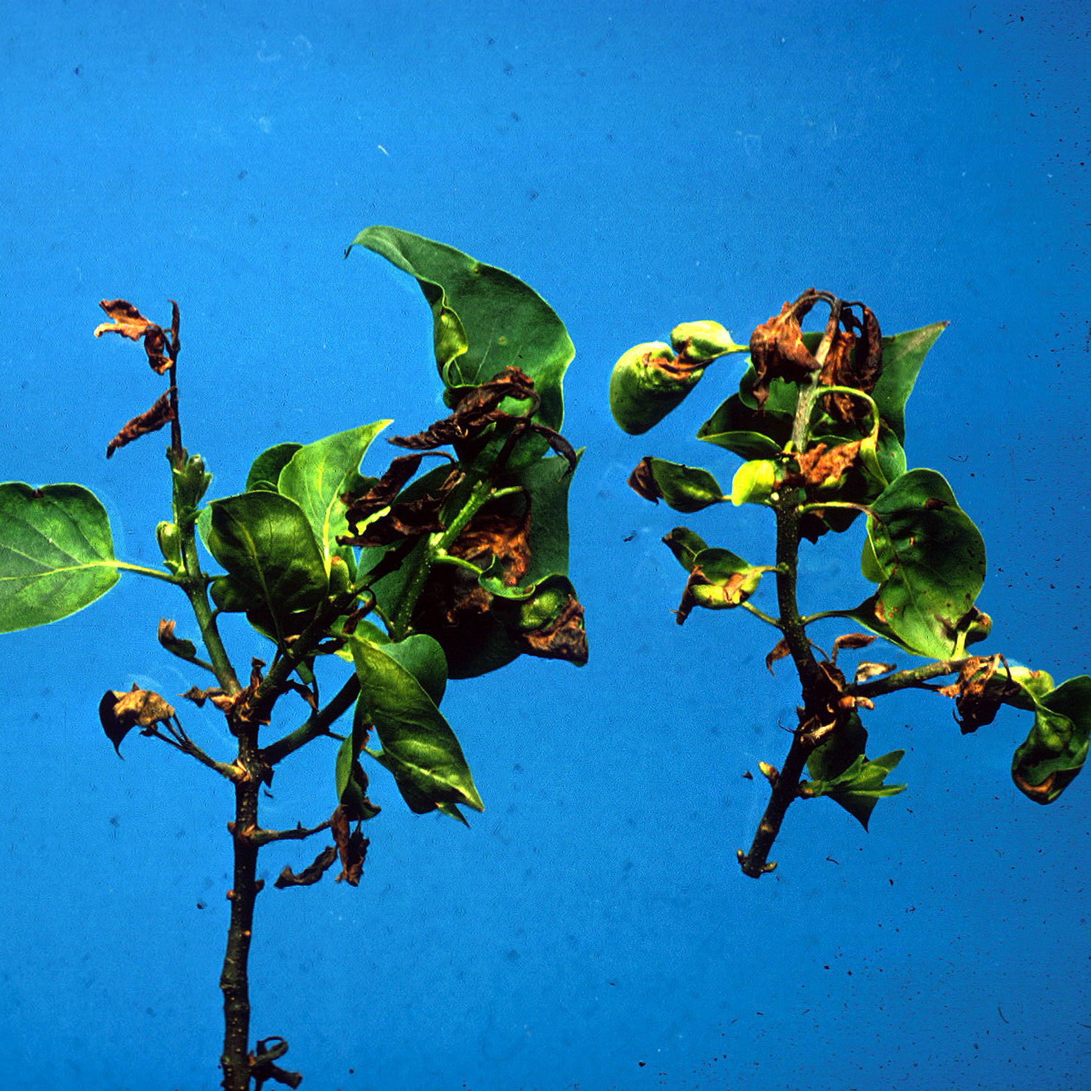
What does bacterial blight look like? Initial symptoms of bacterial blight may include dark brown necrotic (dead) leaf spots with yellow halos. If leaf spots develop before leaves are fully expanded, leaf curling and twisting may result. More advanced symptoms include necrotic blotches starting at the leaf margins and advancing inward, as well as black streaking on twigs. In its most severe form, bacterial blight can result in the death of branch tips, leaves and blossoms.
Death of lilac branch tips and leaves due to bacterial blight.

Where does bacterial blight come from? Bacterial blight is caused by the bacterium Pseudomonas syringae pv. syringae (Pss), which survives in diseased stem tissue (cankers), plant debris, and soil. Pss can be spread by insects and on pruning tools, but is more commonly spread by wind and rain. Often Pss is found on the surface of healthy plants and does not cause disease. Infections can occur when the bacterium enters tissue through natural openings, or through wounds caused by insects, pruning, wind damage or hail.

How do I save a plant with bacterial blight? Prune diseased twigs 10 to 12 inches below the point of visible symptoms, and dispose of the branches by burning or burying them. Always prune in dry weather, and after each cut, disinfest pruning shears by dipping them for at least 30 seconds in a 10% bleach solution, or alcohol (spray disinfectants that contain at least 70% alcohol can also be used).

How do I avoid problems with bacterial blight in the future? When planting lilacs, provide adequate spacing between shrubs. Thin individual shrubs each winter to promote good air circulation (see UW Garden Facts XHT1015 for pruning tips). Properly fertilize, water and mulch shrubs to avoid stress that may predispose them to disease. Avoid overhead watering that may keep leaves wet. If you have had problems with bacterial blight, you may want to use a combination of copper and mancozeb-containing fungicides for control. Apply fungicides two to three times at seven to 10 day intervals as leaves emerge, but before symptoms develop. Read and follow all label instructions of the fungicide that you select to insure that you use the fungicide in the safest and most effective manner possible.

For more information on bacterial blight: See UW-Extension Bulletin A2538, or contact your county Extension agent.

*Completed as partial fulfillment of the requirements for Plant Pathology 875 – Plant Disease Diagnostics Clinic Internship at the University of Wisconsin Madison.

© 2002 by the Board of Regents of the University of Wisconsin System doing business as the division of Cooperative Extension of the University of Wisconsin Extension.

Revised

May 31, 2005

An EEO/Affirmative Action employer, University of Wisconsin Extension provides equal opportunities in employment and programming, including Title IX and ADA requirements. This document can be provided in an alternative format by calling Brian Hudelson at (608) 262-2863 (711 for Wisconsin Relay).

References to pesticide products in this publication are for your convenience and are not an endorsement or criticism of one product over similar products. You are responsible for using pesticides according to the manufacturer’s current label directions. Follow directions exactly to protect the environment and people from pesticide exposure. Failure to do so violates the law.

Thanks to Ann Joy, Kristin Kleeberger and Mike Maddox for reviewing this document.

A complete inventory of University of Wisconsin Garden Facts is available at the University of Wisconsin-Extension Horticulture website: wihort.uwex.edu.

