
University of Wisconsin Garden Facts

Provided to you by:
XHT1244

Bacterial Spot of Tomato
Michelle Marks*, UW-Madison Plant Pathology

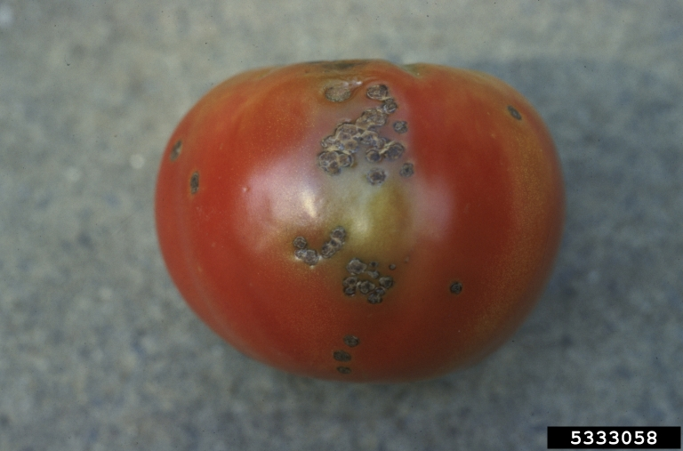
What is bacterial spot? Bacterial spot of tomato is a potentially devastating disease that, in severe cases, can lead to unmarketable fruit and even plant death. Bacterial spot can occur wherever tomatoes are grown, but is found most frequently in warm, wet climates, as well as in greenhouses. The disease is often an issue in Wisconsin.
Sunken, scabby bacterial spot lesions on ripening tomato fruit. (Photo courtesy of Mary Ann Hansen, Virginia Polytechnic Institute and State University)

What does bacterial spot look like? Bacterial spot can affect all above ground parts of a tomato plant, including the leaves, stems, and fruit. Bacterial spot appears on leaves as small (less than ⅛ inch), sometimes water-soaked (i.e., wet-looking) circular areas. Spots may initially be yellow-green, but darken to brownish-red as they age. When the disease is severe, extensive leaf yellowing and leaf loss can also occur. On green fruit, spots are typically small, raised and blister-like, and may have a yellowish halo. As fruit mature, the spots enlarge (reaching a maximum size of ¼ inch) and turn brown, scabby and rough. Mature spots may be raised, or sunken with raised edges. Bacterial spot symptoms can be easily confused with symptoms of another tomato disease called bacterial speck. For more information on this disease, see University of Wisconsin Garden Facts XHT1250.

Where does bacterial spot come from? Bacterial spot of tomato is caused by Xanthomonas vesicatoria, Xanthomonas euvesicatoria, Xanthomonas gardneri, and Xanthomonas perforans. These bacterial pathogens can be introduced into a garden on contaminated seed and transplants, which may or may not show symptoms. The pathogens enter plants through natural openings (e.g., stomates), as well as through wounds. Disease development is favored by warm (75° to 86°F), wet weather. Wind-driven rain can contribute to more severe disease as the pathogens are splashed and spread to healthy leaves and fruit. Bacterial spot pathogens can survive well in tomato debris, but they survive very poorly in soil when not associated with debris.

How do I save plants with bacterial spot? A plant with bacterial spot cannot be cured. Remove symptomatic plants from your garden or greenhouse to prevent the spread of bacteria to healthy plants. Burn, bury or hot compost the affected plants and DO NOT eat symptomatic fruit. Although bacterial spot

Revised

Feb. 20, 2017

University of Wisconsin Garden Facts

pathogens are not human pathogens, the fruit blemishes that they cause can provide entry points for human pathogens that could cause illness.

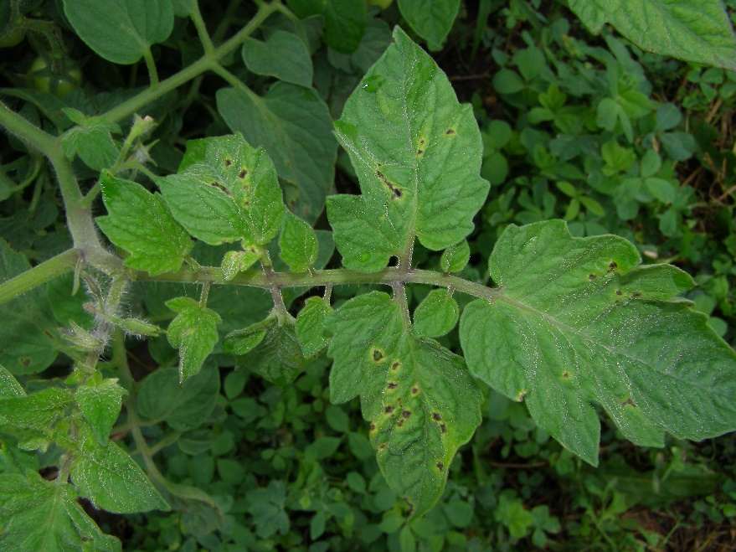
How can I prevent bacterial spot in the future? Plant pathogen-free seed or transplants to prevent the introduction of bacterial spot pathogens on contaminated seed or seedlings. If a clean seed source is not available or you suspect that your seed is contaminated, soak seeds in water at 122°F for 25 min. to kill the pathogens. To keep leaves dry and to prevent the spread of the pathogens, avoid overhead watering (e.g., with a wand or sprinkler) of established plants and instead use a drip-tape or soaker-hose. Also to prevent spread, DO NOT handle plants when they are wet (e.g., from dew) and routinely sterilize tools with either 10% bleach solution or (better) 70% alcohol (e.g., rubbing alcohol). Where bacterial spot has been a recurring problem, consider using preventative applications of copper-based products registered for use on tomato, especially during warm, wet periods. Keep in mind however, that if used excessively or for prolonged periods, copper may no longer control the disease. Be sure to read and follow all label instructions of the product that you select to ensure that you use it in the safest and most effective manner possible. Burn, bury or hot compost tomato debris at the end of the season. Wait at least one year before planting tomatoes in a given location again, and remove and burn, bury or hot compost any volunteer tomatoes that come up in your garden.
On tomato leaves, bacterial spot leads to small, angular (i.e., straight-edged) spots with yellow haloes. (Photo courtesy of Michelle Grabowski, University of Minnesota Extension)

For more information on bacterial spot of tomato: Contact your county Extension agent.

*Completed as partial fulfillment of the requirements for Plant Pathology 558 at the University of Wisconsin Madison.

© 2017 by the Board of Regents of the University of Wisconsin System doing business as the division of Cooperative Extension of the University of Wisconsin Extension.

An EEO/Affirmative Action employer, University of Wisconsin Extension provides equal opportunities in employment and programming, including Title IX and ADA requirements. This document can be provided in an alternative format by calling Brian Hudelson at (608) 262-2863 (711 for Wisconsin Relay).

References to pesticide products in this publication are for your convenience and are not an endorsement or criticism of one product over similar products. You are responsible for using pesticides according to the manufacturer’s current label directions. Follow directions exactly to protect the environment and people from pesticide exposure. Failure to do so violates the law.

Thanks to Amanda Gevens, Gary Marks, Jessamyn Perlus, Carol Shirk, Bryan Webster and Ken Williams for reviewing this document.

A complete inventory of University of Wisconsin Garden Facts is available at the University of Wisconsin-Extension Horticulture website: http://pddc.wisc.edu.

