
University of Wisconsin Farm Facts

Provided to you by:
XGT1012

Brown Stem Rot of Soybean

Carol Groves and Damon Smith, UW-Madison Plant Pathology

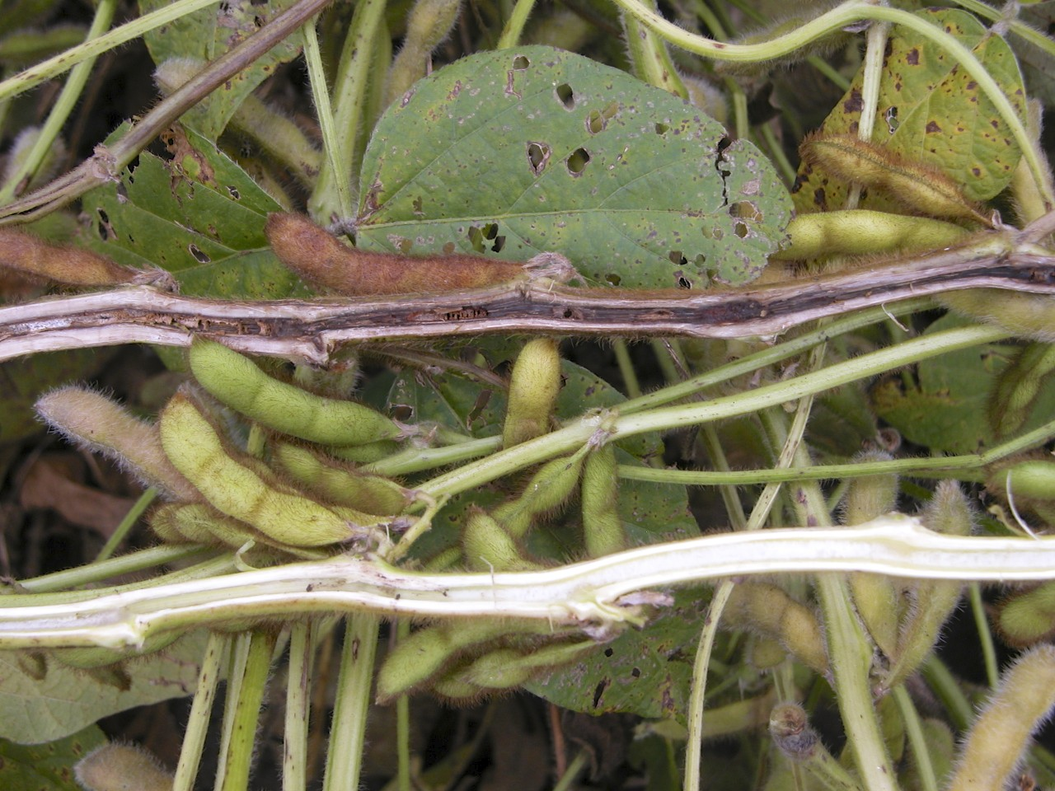
What is brown stem rot? Brown stem rot (BSR) is a disease of soybean that was first observed in central Illinois in 1944 and is now prevalent throughout the North Central States of the US, and Canada. BSR has been identified as the third most important disease of soybeans in Wisconsin, attributable to the expansion of soybean acreage and shorter crop rotations used in the state. The agronomic impact of BSR is greatest in high yield potential environments. BSR negates the benefits of management practices intended to increase yield potential.
Brown pith discoloration of soybeans suffering from brown stem rot (top) compared with the white pith of a healthy soybean plant (bottom). (photo courtesy of Craig Grau)

What does brown stem rot look like? Symptoms of BSR are usually not evident until late in the growing season and may be confused with signs of crop maturity or the effect of dry soils. The most characteristic symptom of BSR is the brown discoloration of the pith especially at and between nodes near the soil line. This symptom is best scouted for at full pod stage. Foliar symptoms, although not always present, typically occur after air temperatures have been at to below normal during growth stages R3-R4, and often first appear at stage R5, peaking at stage R7. Foliar symptoms include interveinal chlorosis and necrosis (i.e., yellowing and browning of tissue between leaf veins), followed by leaf wilting and curling. Yield loss as a result of BSR is generally greatest when foliar symptoms develop. The severity of BSR symptoms increases when soil moisture is near field capacity (i.e., when conditions are optimal for crop development).

Foliar symptoms of BSR can be confused with those of sudden death syndrome (see University of Wisconsin Farm Facts XGT1015, “Sudden Death Syndrome of Soybean”). However, in the case of sudden death syndrome (SDS), the pith of affected soybean plants will remain white or cream-colored. In addition, roots and lower stems of plants suffering from SDS (but not those suffering from BSR) often have light blue patches indicative of spore masses of the fungus that causes SDS.

Where does brown stem rot come from? BSR is caused by the soilborne fungus Phialophora gregata. There are two distinct types (or genotypes) of the fungus, denoted Type A and Type B. Type A is the more aggressive strain and causes more internal damage and plant defoliation than Type B. P. gregata Type A also is associated with higher yield loss.
Revised
Apr. 5, 2013

P. gregata survives in soybean residue, with survival time directly related to the length of time that it takes for soybean residue to decay. Thus, P. gregata survives longer when

University of Wisconsin Farm Facts

soybean residue is left on the soil surface (e.g., in no till settings) where the rate of residue decay is slow. P. gregata infects soybean roots early in the growing season. It then moves up into the stems, invading the vascular system (i.e., the water-conducting tissue) and interfering with the movement of water and nutrients.

Several factors can influence BSR severity. Research from the University of Wisconsin has shown that the incidence and severity of BSR is greatest in soils with low levels of phosphorus and potassium, and a soil pH below 6.3. In addition, P. gregata and soybean cyst nematode (Heterodera glycines) frequently occur in fields together, and there is evidence that BSR is more severe in the presence of this nematode.

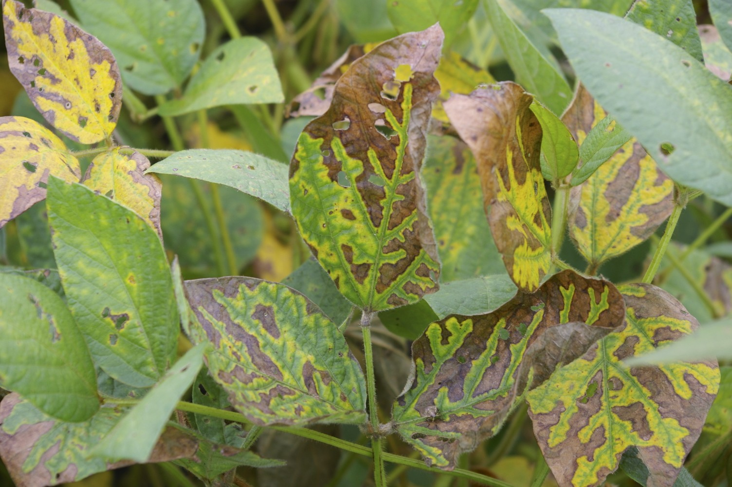
How can I save a soybean crop with brown stem rot? BSR cannot be controlled once plants have been infected. Foliar fungicides and fungicide seed treatments have no effect on the disease.
Interveinal chlorosis and necrosis typical of brown stem rot. (photo courtesy of Craig Grau)

How can I avoid problems with brown stem rot in the future? Use crop rotations of two to three years away from soybean with a non-host crop (e.g., small grains, corn, or vegetable crops), as well as tillage methods that incorporate plant residue into the soil. Both of these techniques will help reduce pathogen populations by promoting decomposition of soybean residue. Also, make sure that soil fertility and pH are optimized for soybean production to avoid overly low phosphorus and potassium levels, as well as overly low soil pH. Finally, grow soybean varieties with resistance to BSR. Complete resistance to BSR is not available in commercial varieties. However several sources of partial resistance that provide moderate to excellent BSR control are available. Also, some, but not all, varieties of soybean cyst nematode (SCN) resistant soybeans also are resistant to BSR. Most soybean varieties with SCN resistance derived from PI 88788 express resistance to BSR. However, the same is not true of varieties with SCN resistance derived from Peking. Therefore growers should consult seed company representatives about BSR resistance when selecting a variety with SCN resistance derived from this source.

For more information on brown stem rot of soybean: Contact your county Extension agent.

© 2013 by the Board of Regents of the University of Wisconsin System doing business as the division of Cooperative Extension of the University of Wisconsin Extension.

An EEO/Affirmative Action employer, University of Wisconsin Extension provides equal opportunities in employment and programming, including Title IX and ADA requirements.

References to pesticide products in this publication are for your convenience and are not an endorsement or criticism of one product over similar products. You are responsible for using pesticides according to the manufacturer’s current label directions. Follow directions exactly to protect the environment and people from pesticide exposure. Failure to do so violates the law.

Thanks to Craig Grau, Bryan Jensen and Ken Williams for reviewing this document.

