
University of Wisconsin Garden Facts

Provided to you by:
XHT1198

Cicada Killer Wasps
Phil Pellitteri, UW Insect Diagnostic Lab

Cicada killer wasps have become very common in the southern half of Wisconsin. These solitary wasps are up to 1½ inches long, and their black and yellow coloring makes them look like giant yellow jackets.
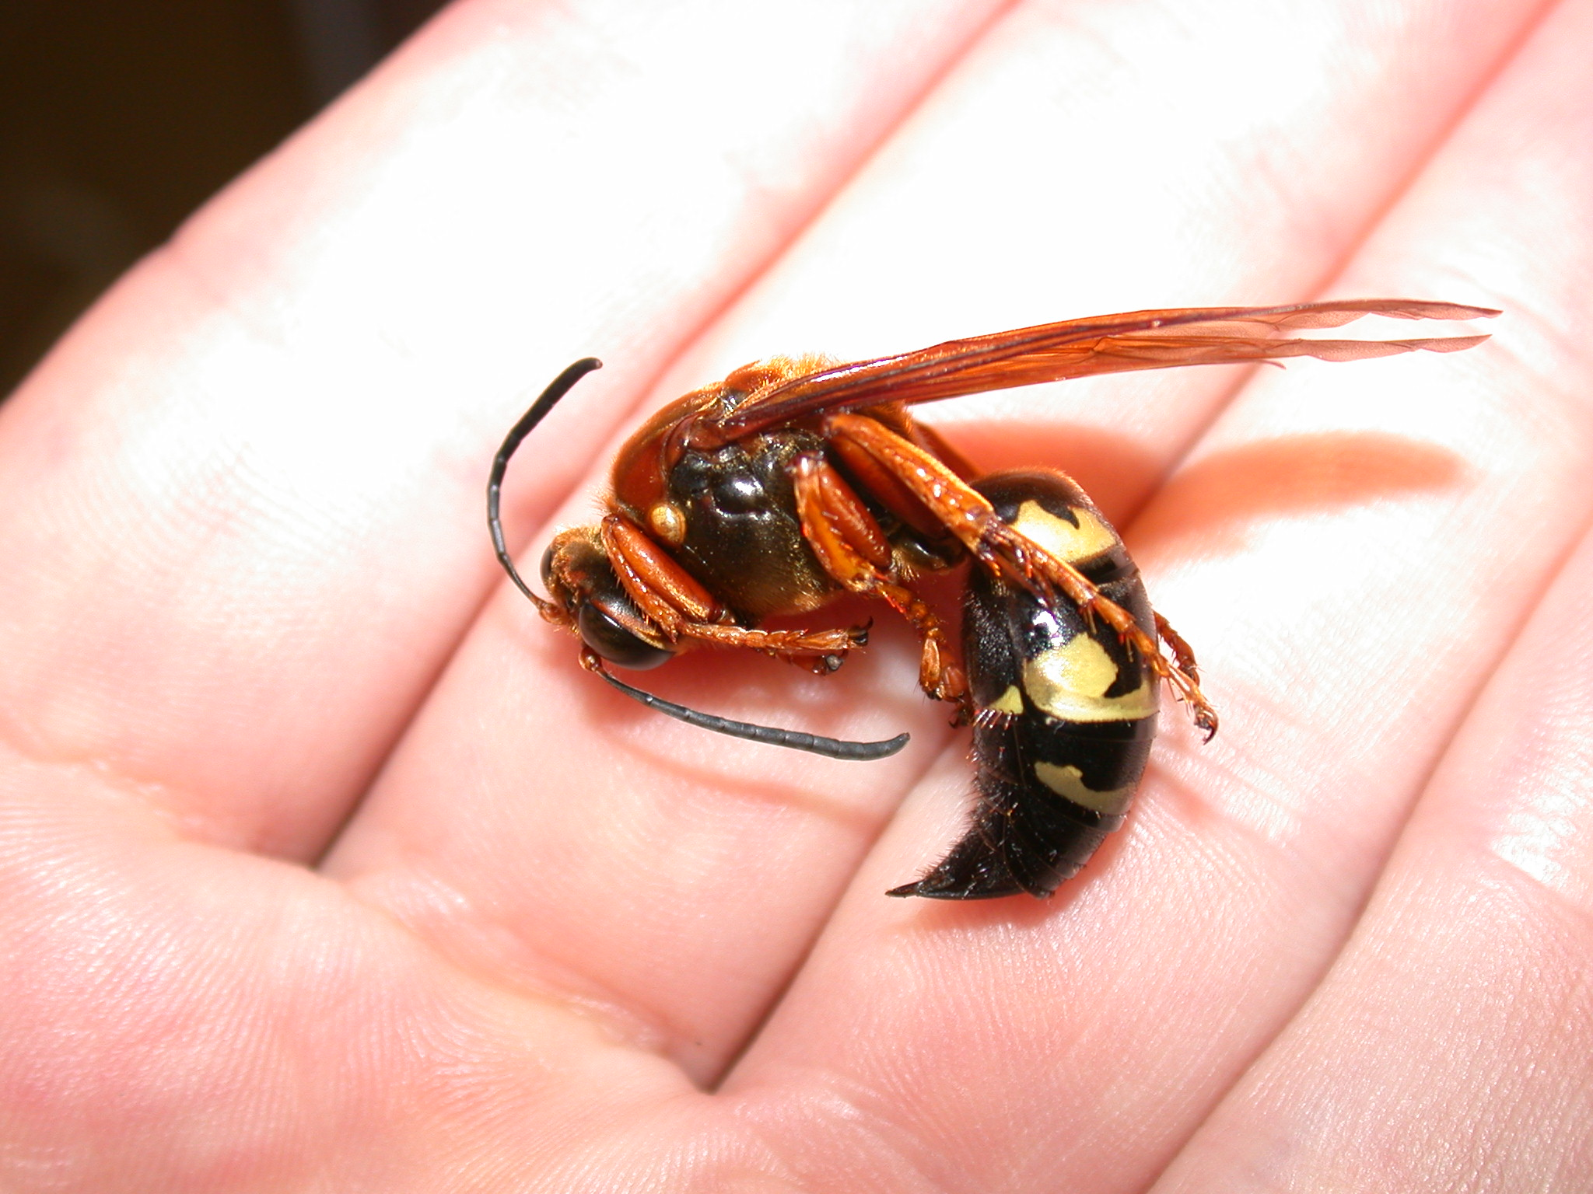
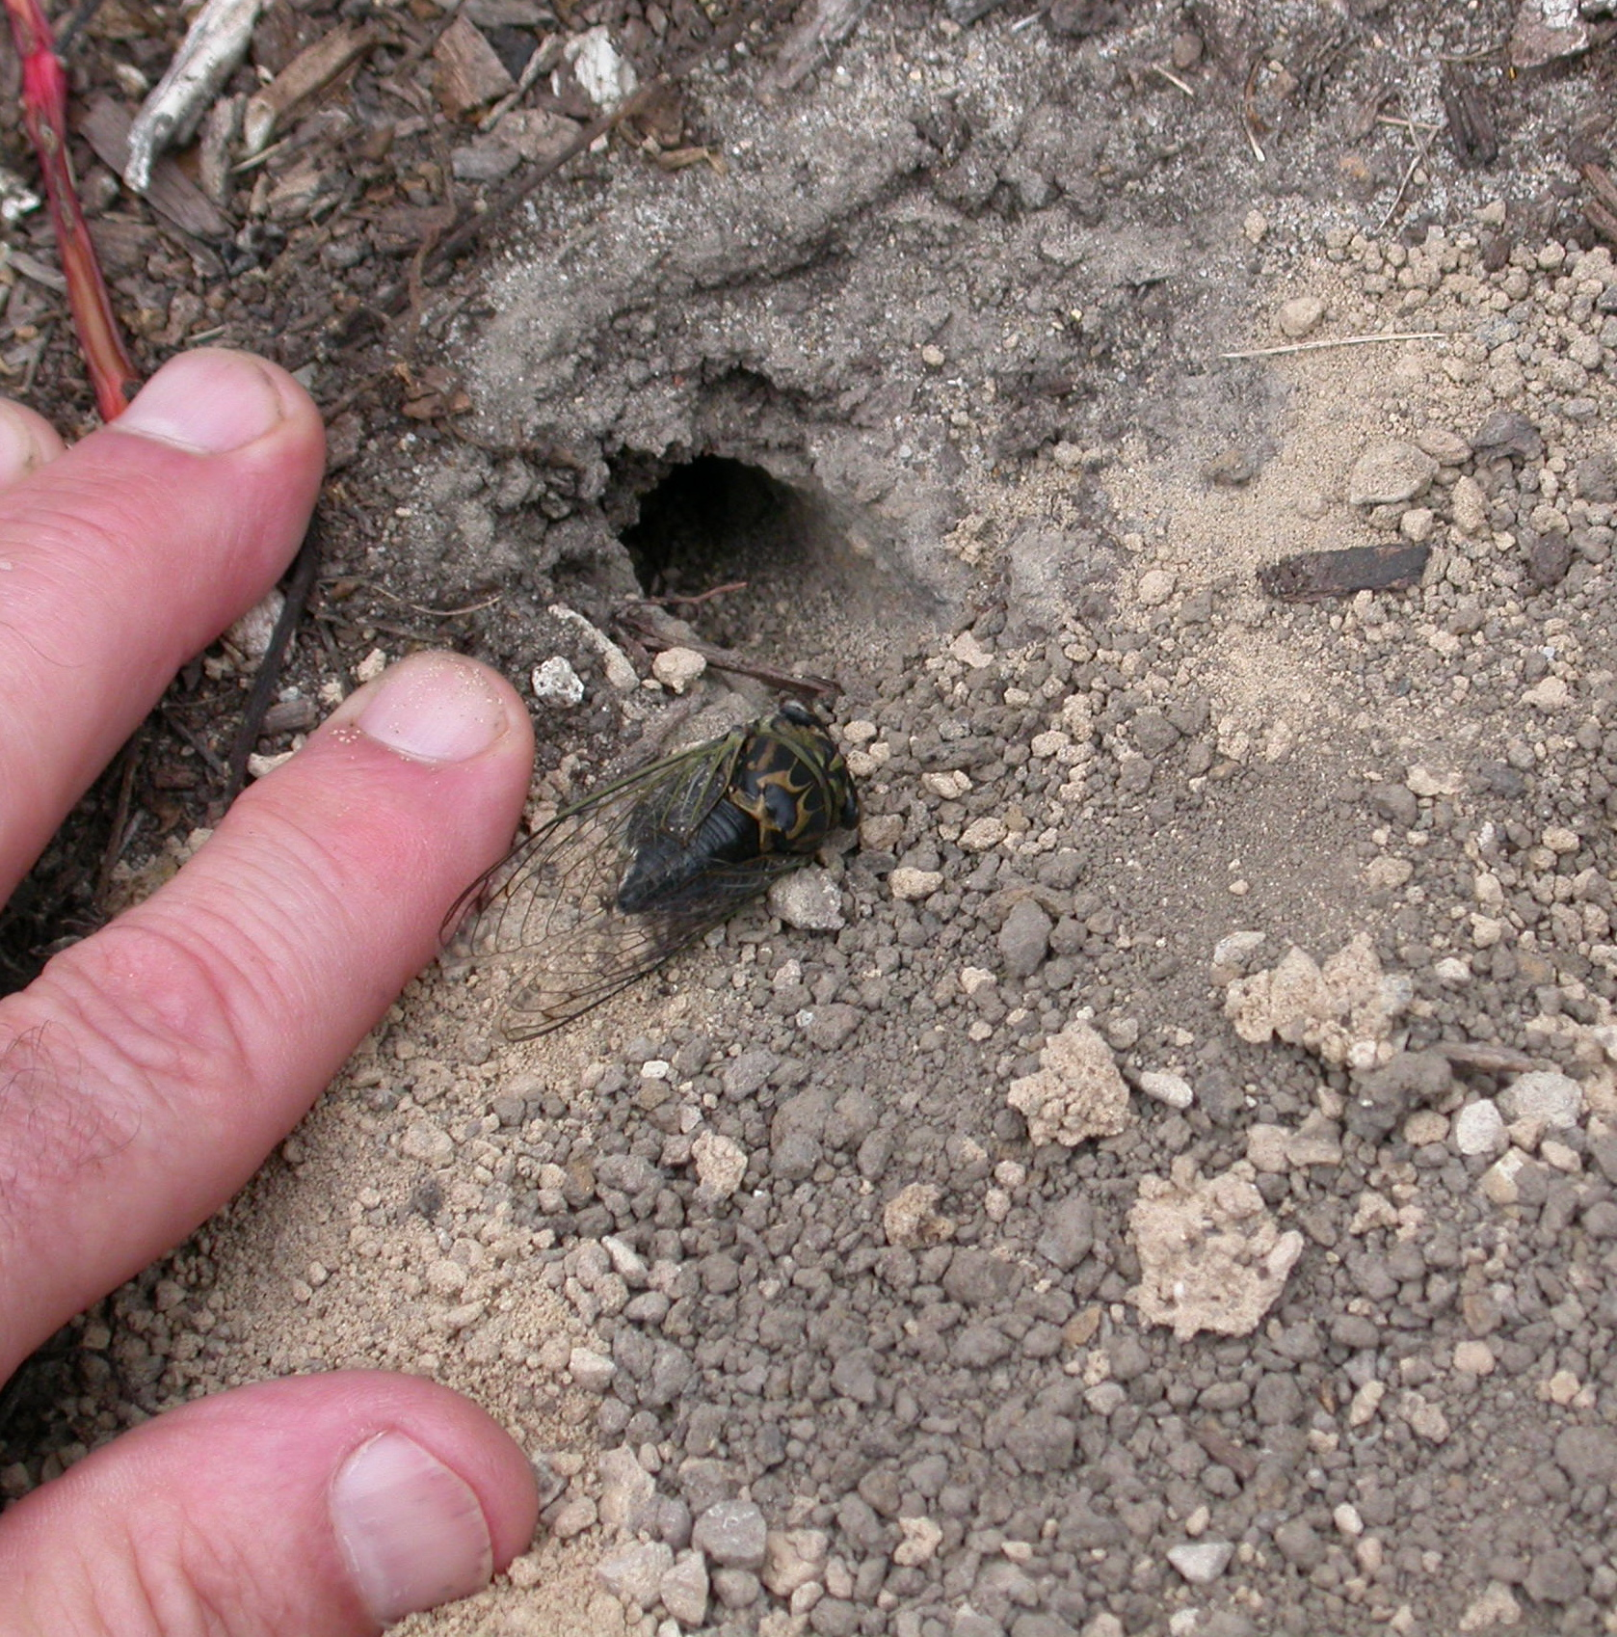
Cicada killer wasps are solitary wasps that resemble giant yellow jackets (left). They dig burrows in which they place paralyzed cicadas for their larvae to use as food (right).
Life Cycle: Adult cicada killer wasps appear from mid-July until early September. Males are territorial and often patrol a specific area in the landscape. Adults dig burrows in areas with bare ground (such as flower beds), or under shrubs. Burrows are ½ inch in diameter and up to 10 inches deep. Female cicada killer wasps locate cicadas and paralyze them by stinging them. They place one or two paralyzed cicadas in each burrow that they dig, and deposit an egg on one paralyzed cicada per burrow. Cicada killer wasp larvae develop without adult help.

Control: Solitary wasps such as cicada killer wasps are non-aggressive by nature. Male wasps cannot sting, and in general, female wasps will only sting if handled. Because cicada killer wasps dig burrows in loose, exposed soils, discourage their activity by using mulch or landscape fabric in areas where they are active. If you must treat, put insecticide dusts or granules containing carbaryl, cyfluthrin, deltamethrin or permethrin down any active burrows. These dusts will kill the wasps as they enter or exit a burrow.
For more information on cicada killer wasps: Contact your county Extension agent.

© 2011 by the Board of Regents of the University of Wisconsin System doing business as the division of Cooperative Extension of the University of Wisconsin Extension.

Revised

Jan. 4, 2011
An EEO/Affirmative Action employer, University of Wisconsin Extension provides equal opportunities in employment and programming, including Title IX and ADA requirements. This document can be provided in an alternative format by calling Brian Hudelson at (608) 262-2863 (711 for Wisconsin Relay).

References to pesticide products in this publication are for your convenience and are not an endorsement or criticism of one product over similar products. You are responsible for using pesticides according to the manufacturer’s current label directions. Follow directions exactly to protect the environment and people from pesticide exposure. Failure to do so violates the law.

Thanks to Lis Friemoth, Donna Henderson and Barb Larson for reviewing this document.

A complete inventory of University of Wisconsin Garden Facts is available at the University of Wisconsin-Extension Horticulture website: wihort.uwex.edu.

