
University of Wisconsin Garden Facts

Provided to you by:
XHT1179

Cupflower
Susan Mahr, UW Horticulture

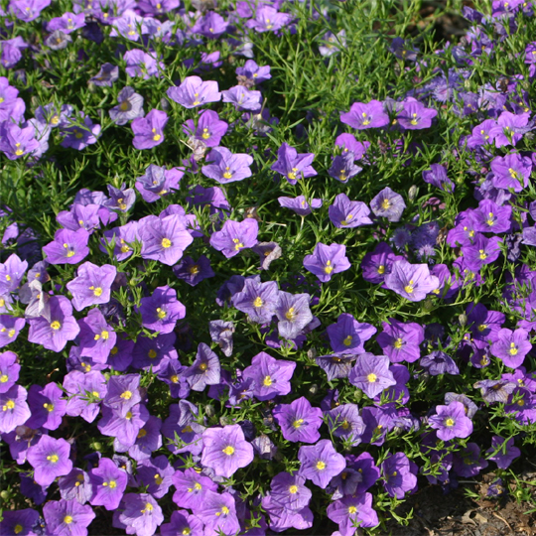
What is cupflower? Nierembergia, commonly known as cupflower, is a genus of tender, heat-loving perennials in the nightshade family (Solanaceae) that is valued for its long blooming period. The genus, which is native to Argentina, is named for Juan Eusebio Nieremberg, a 17th century Spanish Jesuit theologian and naturalist. The taxonomy of Nierembergia is somewhat confused, and the species names for cupflower have been variously listed as N. caerulea, N. frutescens, N. hippomanica or N. scoparia. While hardy only in USDA zones 7 through 10, cupflower can easily be grown as an annual in colder climates.
Cupflower produces mounds of blue or white, star-shaped, saucer-like flowers.

Cupflower plants form neat, compact, spreading mounds that are approximately 12 to 15 inches in diameter. Plants have multiple stems with fine-textured, stiff, linear, ½ inch-long leaves, and. eventually become covered with one inch diameter, white or bluish-purple star-shaped, saucer-like flowers with lemon yellow centers. The color of cupflower blossoms does not fade even in the brightest sun.

There are several varieties of cupflower that may be available at greenhouses and garden centers in your area.

- ‘Blue Mountain’ grows six to nine inches tall and has azure-blue flowers.
- ‘Mont Blanc’ grows six inches tall and 12 inches wide and is a profuse bloomer with small, brilliant white flowers. This variety was an All-America Selection winner in 1993.
- ‘Purple Robe’ grows six to eight inches tall and has violet-blue flowers. This variety was an AAS winner in 1942.
- ‘Starry Eyes’ grows 10 to 16 inches tall and 15 to 18 inches wide. This variety has white flowers with pale lavender highlights.
- ‘Summer Splash Compact Blue’ grows 10 to 14 inches tall and has large, blue flowers.
- ‘Summer Splash Compact White’ grows 10 to 14 inches tall and has large, white flowers.
- ‘White Robe’ is an early blooming variety that grows six to eight inches tall and approximately eight inches wide, and has white flowers.

Revised

Jan. 20, 2009

University of Wisconsin Garden Facts

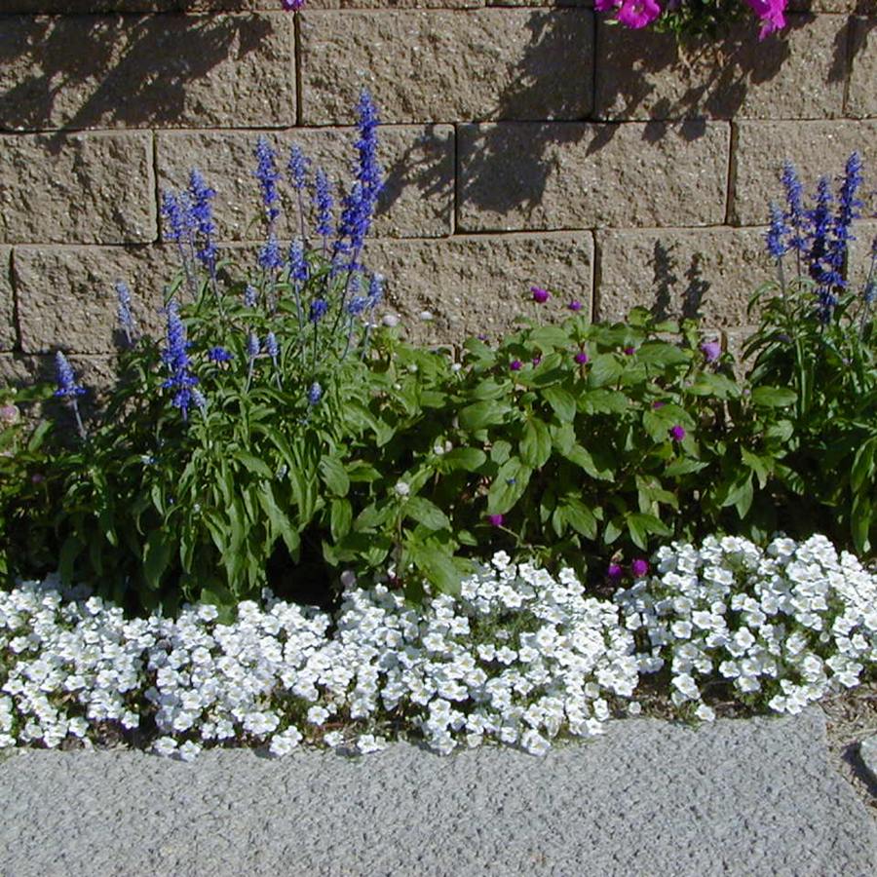
Where do I get cupflower plants? Cupflower plants can be purchased at most commerial greenhouses and garden centers. Alternatively, you can start cupflower plants from seed. Sow seeds indoors eight to 10 weeks before the predicted date of last frost in your area. Barely cover the seeds at planting. Seeds should germinate within two to three weeks if grown at 70°F. Keep the soil slightly moist until the seeds germinate, then water the seedlings only after the soil begins to dry out. Young plants will grow very slowly, but will grow more quickly once transplanted outdoors.
White cupflower combines nicely in the garden with tall blue salvia and pink globe amaranth.

How do I grow cupflower in my garden? Transplant purchased cupflower plants or homegrown cupflower seedlings outdoors after the last spring frost. Be sure to harden off the plants before transplanting. Place plants six to 12 inches apart in organically rich, well-drained soil in full sun. Mulch the plants to help retain moisture and keep the soil cool. Cupflower is drought tolerant once established, typically does not have severe insect pest or disease problems, and usually is not bothered by deer. Stem cuttings can be taken in late summer and rooted to grow plants indoors over the winter.

How do I use cupflower most effectly in my garden? Use cupflower as an edging, and in borders, rock gardens, or containers, including hanging baskets and window boxes. White varieties combine nicely with tall blue salvia (Salvia spp.) and pink globe amaranth (Gomphrena globosa – see University of Wisconsin Garden Facts XHT1171). Cupflower thrives in hot environments, such as along walkways or walls that reflect heat, where it can spill out to soften sharp landscape edges.

For more information on cupflower: Contact your county Extension agent.

© 2009 by the Board of Regents of the University of Wisconsin System doing business as the division of Cooperative Extension of the University of Wisconsin Extension.

An EEO/Affirmative Action employer, University of Wisconsin Extension provides equal opportunities in employment and programming, including Title IX and ADA requirements. This document can be provided in an alternative format by calling Brian Hudelson at (608) 262-2863 (711 for Wisconsin Relay).

References to pesticide products in this publication are for your convenience and are not an endorsement or criticism of one product over similar products. You are responsible for using pesticides according to the manufacturer’s current label directions. Follow directions exactly to protect the environment and people from pesticide exposure. Failure to do so violates the law.

Thanks to Diana Alfuth, Joyce Cielecki and Cathie Mann for reviewing this document.

A complete inventory of University of Wisconsin Garden Facts is available at the University of Wisconsin-Extension Horticulture website: wihort.uwex.edu.

