
University of Wisconsin Garden Facts

Provided to you by:
XHT1003

Cytospora Canker
Brian Hudelson, UW-Madison Plant Pathology

What is Cytospora canker? Cytospora canker is one of the most common fungal diseases of Colorado blue spruce. This disease can also affect Norway spruce (and less frequently other spruces) as well as Douglas-fir and balsam fir. Trees that are 15 years old or older and are at least 20 feet high most typically show symptoms of this disease.

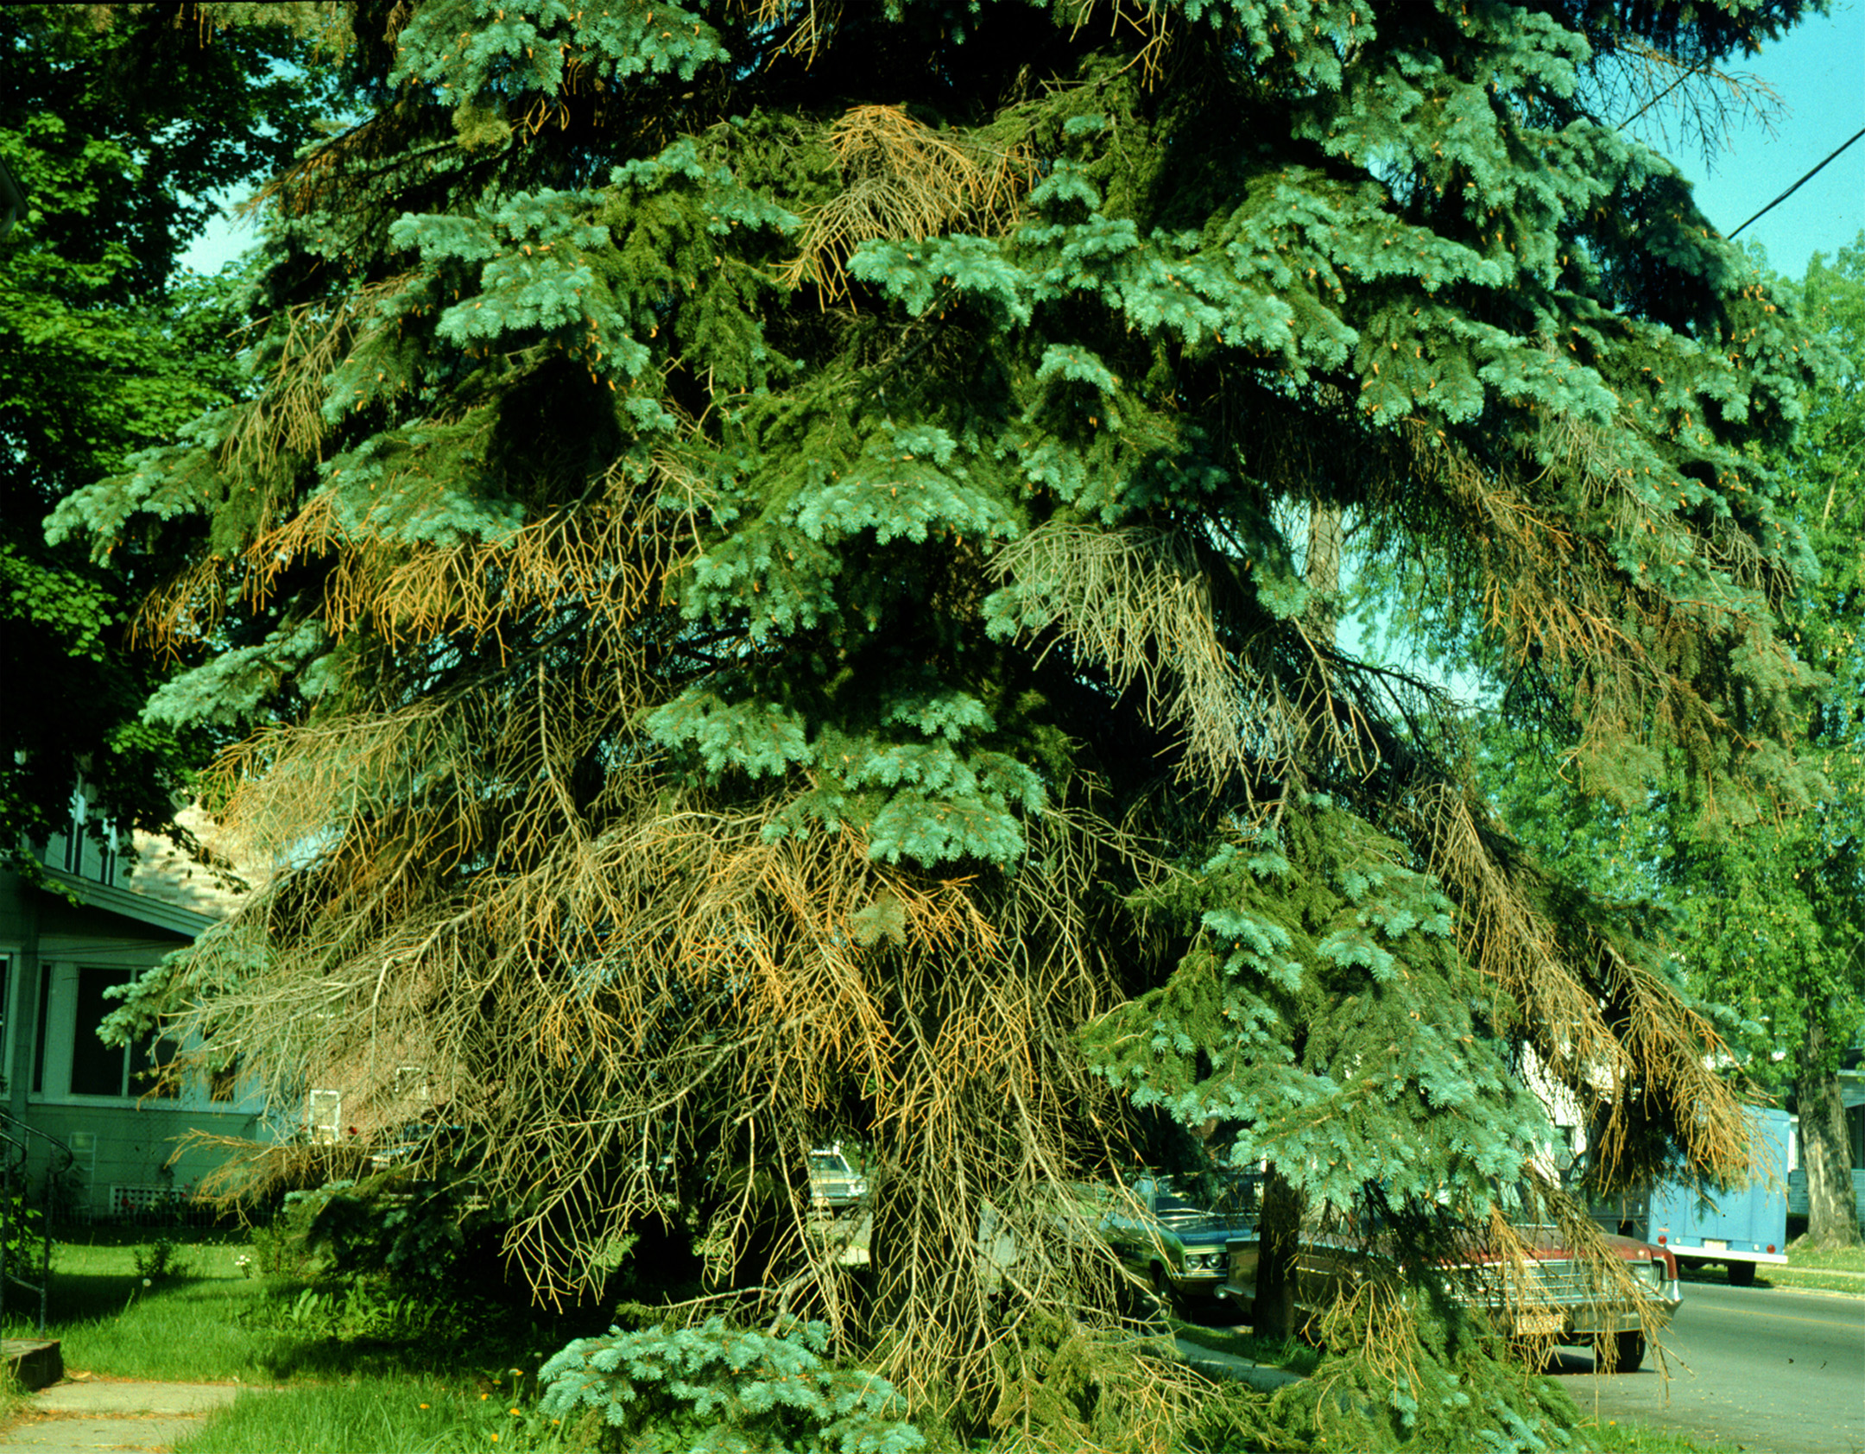
What does Cytospora canker look like? Cytospora canker usually first appears on lower branches and progresses up the tree. Individual upper branches may show symptoms as well. Needles on infected branches turn purple, then brown and die. Diseased needles eventually fall off and the infected branches die. Infected branches often produce a bluish-white sap that oozes somewhere along their length.
Death of lower branches of Colorado blue spruce typical of Cytospora canker.

Where does Cytospora canker come from? Cytospora canker is caused by the fungus Leucocytospora kunzei (also referred to as Leucostoma kunzei), which survives in infected branches. Spores of the fungus are spread by wind, rain splash, insects, birds and mammals.

How do I save a tree or shrub with Cytospora canker? Immediately remove and destroy any diseased branches, by pruning them using the 3-point method of pruning (see University of Wisconsin Garden Facts XHT1014 for details). Prune only in dry weather. Between cuts, be sure to clean your pruning shears by dipping them for at least 30 seconds in a 10% bleach solution or 70% alcohol (spray disinfectants that contain at least 70% alcohol can be used). This will prevent movement of the fungus from branch to branch, or from tree to tree during pruning. DO NOT attempt to use fungicide treatments to control this disease.

How do I avoid problems with Cytospora canker in the future? Perhaps the easiest way to avoid Cytospora canker is to avoid planting Colorado blue spruce. If you do plant blue spruce, allow adequate spacing between trees in new plantings. For established trees, judiciously prune branches to open the trees’ canopies. Proper spacing and pruning promote increased airflow, which leads to a less favorable environment for infection and disease development. In addition, minimize any stress to your trees. Prevent water stress by avoiding soil compaction, and by making sure there is adequate soil drainage. During dry periods, water your trees adequately (approximately one inch of water per week) using a soaker or drip hose. Proper mulching (one to two inches on a heavier, clay soil; three to four inches on a lighter, sandy soil) can help moderate your trees’ moisture levels. Prevent nutrient stress by properly fertilizing your conifers based on a soil fertility test. The University of Wisconsin Soil Testing Laboratories (http://uwlab.soils.wisc.edu/) can assist with soil and plant tissue fertility testing.
For more information on Cytospora canker: See UW-Extension Bulletin A2639 (available at http://learningstore.uwex.edu), or contact your county Extension agent.

© 1999-2012 by the Board of Regents of the University of Wisconsin System doing business as the division of Cooperative Extension of the University of Wisconsin Extension.

An EEO/Affirmative Action employer, University of Wisconsin Extension provides equal opportunities in employment and programming, including Title IX and ADA requirements. This document can be provided in an alternative format by calling Brian Hudelson at (608) 262-2863 (711 for Wisconsin Relay).

Revised

Mar. 11, 2012

Thanks to Jean Ferdinandsen, Amy Sausen and Ann Wied for reviewing this document.

A complete inventory of University of Wisconsin Garden Facts is available at the University of Wisconsin-Extension Horticulture website: http://hort.uwex.edu.

