
University of Wisconsin Garden Facts

Provided to you by:
XHT1204

Field Ants
Phil Pellitteri, UW Insect Diagnostic Lab

One of the most common ants in Wisconsin is the field ant (Formica spp.). This ant is noted for producing large mounds that can ruin the aesthetics of home lawns, make lawn mowing difficult, and interfere with the growth of herbaceous and woody ornamentals.

Appearance: Field ants are medium to large ants, ranging in size from ¹⁄5 to ⅜ inches in length. Their color can vary. Some species are black, while others are a combination of black and red.

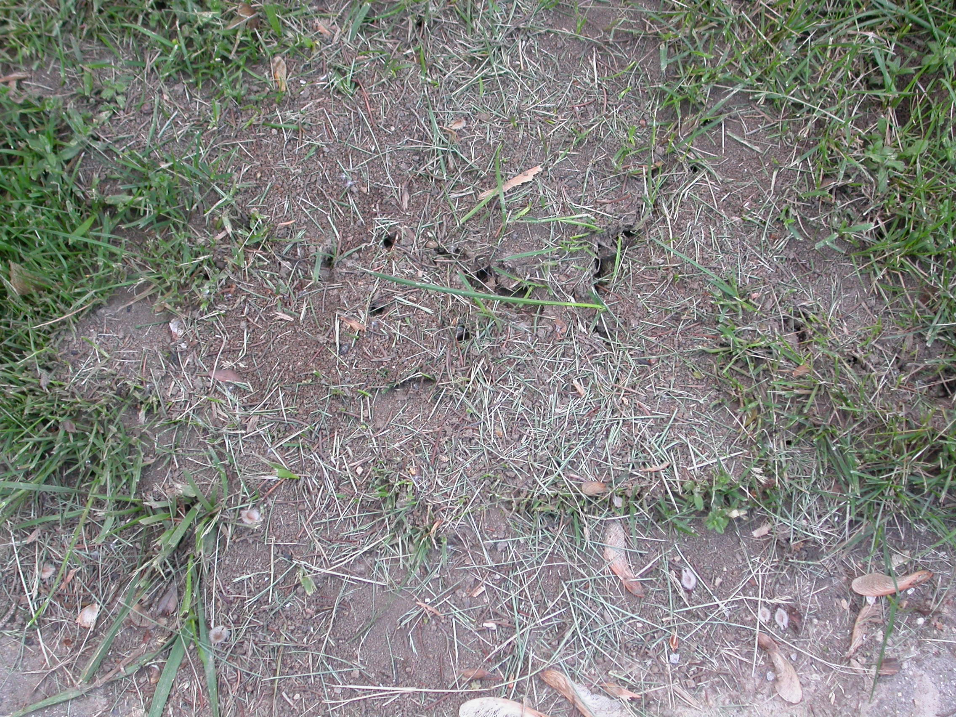
Damage/Effects: Field ants most commonly cause problems when they produce mounds, the aboveground portions of their colonies/nests. Mounds can be three to four feet wide and over two feet tall. Mounds are unsightly, can prevent turf growth and can be a hazard when lawns are mowed. In addition, some species of field ants can kill herbaceous and woody plants that shade their mounds by injecting formic acid into the plants’ roots. Finally, if disturbed, field ants can give painful, pinch–like bites to people and pets.
Field ants can produce mounds that are three to four feet wide and over two feet tall.

Life Cycle: Field ant colonies can survive for 10 or more years. Each colony contains a queen ant that lays all of the eggs that develop into sterile females (workers) and males (drones). Field ants DO NOT come indoors for food. They exclusively collect food outdoors and feed on live and dead insects, as well as on aphid honeydew.

Control: There is no need to control field ants in areas where there is no human activity. If colonies occur in landscape settings, the only way to eliminate the colony is to kill the queen. The challenge is that in large mounds, the queen can be as deep as two to three feet underground. Thus, surface insecticide treatments will not be effective. To control field ants, use a liquid insecticide containing cyfluthrin, deltamethrin, bifenthrin, carbaryl (Sevin) or permethrin. To treat the colony, rake away excess surface debris from the mound. Make four to six channels into the nest by pushing a metal rod or wood dowel as deep as possible. Mix the insecticide that you have chosen in a pail or bucket according to label directions, and then pour (drench) the mixture into the channels so that it penetrates as deeply into the soil as possible. After the insecticide has been applied, cover the treated area with the debris that you initially raked away. Note that hot water and borax are not effective for control of field ants.
For more information on field ants, as well as other ants: See University of Wisconsin Garden Facts XHT1160 (“Pavement Ants”) and XHT1161 (“Citronella Ants”), University of Wisconsin-Extension bulletin A3641 (“Controlling Carpenter Ants”), University of Minnesota-Extension bulletin M1166 (“Household Ants”), or contact your county Extension agent.

© 2011 by the Board of Regents of the University of Wisconsin System doing business as the division of Cooperative Extension of the University of Wisconsin Extension.

Revised

Jan. 24, 2011
An EEO/Affirmative Action employer, University of Wisconsin Extension provides equal opportunities in employment and programming, including Title IX and ADA requirements. This document can be provided in an alternative format by calling Brian Hudelson at (608) 262-2863 (711 for Wisconsin Relay).

References to pesticide products in this publication are for your convenience and are not an endorsement or criticism of one product over similar products. You are responsible for using pesticides according to the manufacturer’s current label directions. Follow directions exactly to protect the environment and people from pesticide exposure. Failure to do so violates the law.

Thanks to Mark Kopecky, Patti Nagai and Ann Wied for reviewing this document.

A complete inventory of University of Wisconsin Garden Facts is available at the University of Wisconsin-Extension Horticulture website: hort.uwex.edu.

