
University of Wisconsin Garden Facts

Provided to you by:
XHT1063

Gypsy Moth
R. Chris Williamson, UW Turf and Ornamental Specialist

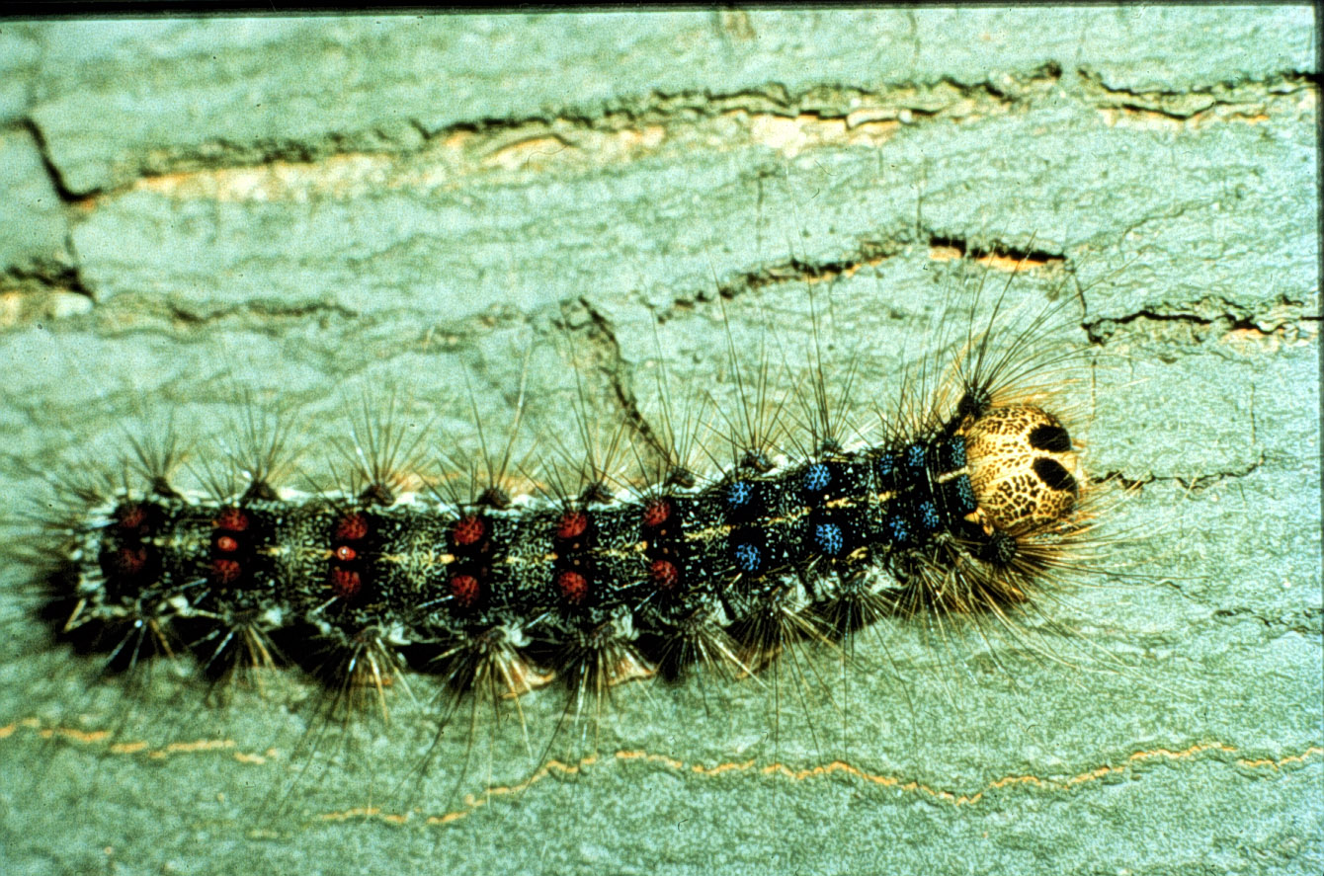
The gypsy moth is native to Europe, Asia and North Africa. It was inadvertently introduced into North America in 1869 in a misguided attempt to breed a hardy silkworm. Since that time, the gypsy moth has escalated into the most important insect pest of forest and shade trees in the eastern U.S. The gypsy moth caterpillar is the destructive life stage that defoliates entire trees and forests. Repeated defoliation often weakens trees resulting in greater susceptibility to disease and other insect pests.
A gypsy moth larva.

Gypsy moth caterpillars can also be nuisance problems because they typically aggregate on the sides of buildings and homes, and produce large quantities of frass (i.e., fecal pellets) that fall from trees onto lawns and patios. Some people may experience an allergic reaction when they contact the many hairs covering the body of caterpillars.

Plants Attacked and Damage: Gypsy moth caterpillars have been reported to feed on over 600 species of trees and shrubs. Preferred hosts include aspen, birch, crabapple, hawthorn, linden, mountain ash, oak, sweet gum, and willow. Some deciduous trees (e.g., dogwood, green ash, honey locust, silver and red maple, tulip tree, and white ash) are resistant. Typically, most evergreen trees are also resistant. However, blue spruce and white pine are susceptible. Feeding damage frequently results in severe and/or complete defoliation; decreasing the energy reserves of the tree. On rare occasions, trees that are defoliated by gypsy moth are killed. More typically, trees recover and produce new leaves in July.

Life Cycle: The gypsy moth has four distinct developmental stages: egg, larva (caterpillar), pupa, and adult. Each life stage looks and behaves very differently. Adult females lay eggs in masses of up to 1000 or more in August. Egg masses can be attached to most any object and are frequently attached to houses, lawn furniture, mail boxes, rocks and trees. Often, egg masses are well hidden. Approximately one month after eggs are laid, the tiny larvae are fully formed within the eggs and are ready to hatch. However, at this point, the larvae go into an overwintering phase, shutting down metabolic activities and becoming insensitive to temperature. The larvae pass through the winter within the eggs. In the early spring, as temperatures increase, the larvae inside the eggs slowly become more active, and in mid-May, as leaves expand, the eggs hatch.

Newly hatched caterpillars climb into tree canopies and begin feeding. If the first tree is not suitable, they will produce a silken thread that becomes caught in the wind and disperses them to a new host. This process is known as ballooning. Once larvae have completed ballooning, they begin feeding, and continue feeding for approximately five to six weeks. About once per week the larvae grow too large for their exoskeleton and molt. These molts separate the larval period into five or six stages called instars. Early larval instars (one through three) feed during the day. Once larvae reach the fourth instar, they begin feeding at night and hide beneath rough bark or in leaf litter during the day. Approximately 90% of the leaves consumed by larvae are eaten in the last two instars. After they have completed feeding, caterpillars enter the pupal life stage from which the adult moths emerge sometime in July. The adults are not damaging because they do not feed and only live long enough to mate and produce eggs.

Revised

Apr. 25, 2004

University of Wisconsin Garden Facts

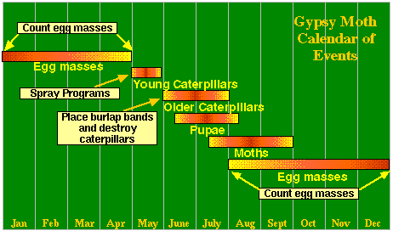
Control: Successful management of gypsy moth requires an integrated approach that includes several strategies. When population densities are high, or in outbreak situations, the most effective approach for preventing widespread defoliation, and reducing the gypsy moth population, is aerial applications of a biologically derived insecticide called Bacillus thuringiensis var. kurstaki, commonly known as Bt. Bt sprays are only effective on the caterpillar life stage, and are essentially harmless to other animals, including birds, fish, humans, and pets. However, Bt can affect other, non-target butterfly and moth species. Insect growth regulators (IGR's) such as dimilin are viable alternative controls available for both commercial and homeowner use. IGR's mimic insect hormones, and target specific insects. In areas where the gypsy moth has been established for a few years, natural controls can help maintain populations below damaging levels. Natural enemies include insect parasites that attack eggs and caterpillars, predators such as birds, and disease organisms. A fungal pathogen of gypsy moth called Entomophaga maimaiga is currently being used by researchers, and is a promising control for gypsy moth.
The gypsy moth calendar of events.

Homeowners can impact gypsy moth populations in the trees on their properties by removing and destroying egg masses in the fall and winter. In spring, they can wrap bands covered in sticky material around the trunks of trees to entangle climbing caterpillars. Older larvae can be collected and destroyed daily from under burlap skirts placed around tree trunks. Such control methods can reduce gypsy moth numbers on isolated trees, but can not prevent defoliation over wider areas.

For more information on gypsy moth: See UW-Extension bulletin A3597, or contact your county Extension agent.

© 1999 by the Board of Regents of the University of Wisconsin System doing business as the division of Cooperative Extension of the University of Wisconsin Extension.

An EEO/Affirmative Action employer, University of Wisconsin Extension provides equal opportunities in employment and programming, including Title IX and ADA requirements. This document can be provided in an alternative format by calling Brian Hudelson at (608) 262-2863 (711 for Wisconsin Relay).

References to pesticide products in this publication are for your convenience and are not an endorsement or criticism of one product over similar products. You are responsible for using pesticides according to the manufacturer’s current label directions. Follow directions exactly to protect the environment and people from pesticide exposure. Failure to do so violates the law.

Thanks to Karen Delahaut and Phil Pellitteri for reviewing this document.

A complete inventory of University of Wisconsin Garden Facts is available at the University of Wisconsin-Extension Horticulture website: wihort.uwex.edu.

