
University of Wisconsin Garden Facts

Provided to you by:

XHT1004

Herbicide Damage
Brian Hudelson, UW-Madison Plant Pathology

What is herbicide damage? Herbicide damage is any adverse, undesired effect on a plant that is caused by exposure of that plant to a pesticide designed for weed control (i.e., a herbicide). Any plant can be subject to this problem.

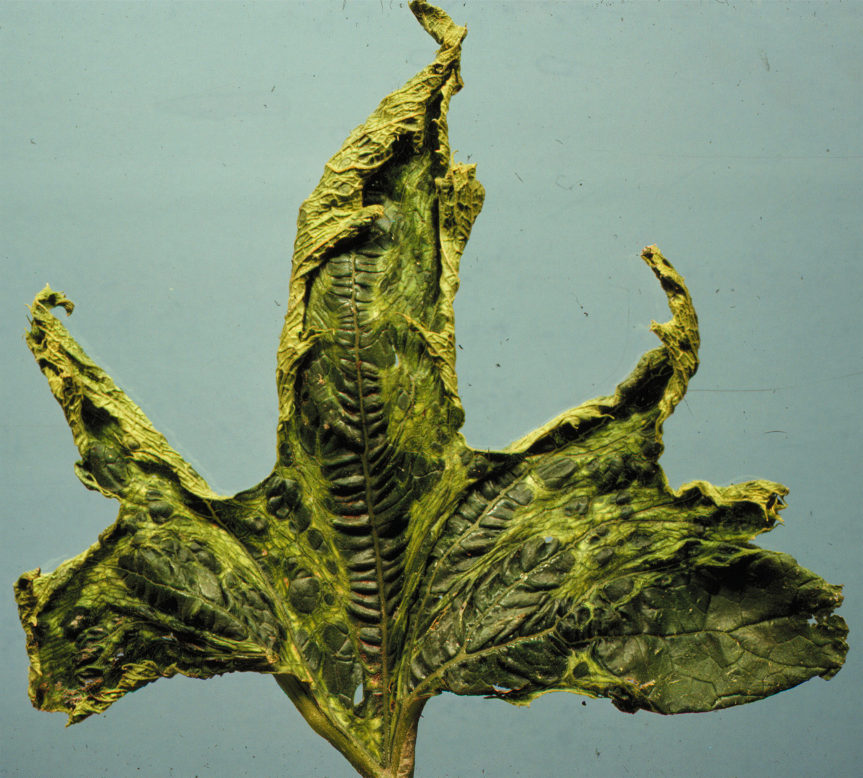
What does herbicide damage look like? Symptoms of herbicide damage vary depending upon the plant affected and the herbicide used. Common symptoms include stems that are flattened, or that twist or corkscrew. Leaves may have abnormal shapes, sizes or textures. In addition, leaves or leaf veins may yellow or redden. In severe cases, plants may brown and die. Some plants, such as tomatoes and grapes, are particularly susceptible to herbicide damage and can be used as indicators of unwanted herbicide exposure.
Squash leaf distorted due to exposure to a common lawn herbicide.

How does herbicide damage occur? Herbicide damage results when an herbicide is misapplied. Herbicides for control of broadleaf weeds are occasionally applied with fertilizers as part of a lawn care program. If these products are applied too close to ornamentals or vegetables, or are applied when there is too much wind, then the herbicide can drift (move) from the area of application into an untreated area. Often, drifting herbicides are difficult to detect by eye because they are extremely fine mists and can better be detected by smell. Some herbicides readily produce vapors that can begin to drift several hours after application.

How do I save a plant that has been damaged by herbicides? Don’t panic! There is nothing you can do after plants have been exposed. However, most plants accidentally exposed to broadleaf herbicides applied with lawn fertilizers do not receive a high enough dose to kill them. Young growth exposed to the herbicide will be distorted and discolored, but subsequent growth will be normal.

How do I avoid problems with herbicide damage in the future? When using a lawn herbicide, follow the application directions exactly. Don’t apply the product too close to, or in a manner that will cause exposure to, non-target ornamentals or vegetables. To avoid drift, apply the herbicide when there is as little wind as possible (< 5 mph). Apply the herbicide at low pressure to minimize production of fine mists. Finally use amine forms rather than ester forms of herbicides as amine forms are less likely to produce vapors.
For more information on herbicide damage: See UW-Extension Bulletin A3286 or contact your county Extension agent.

© 1999 by the Board of Regents of the University of Wisconsin System doing business as the division of Cooperative Extension of the University of Wisconsin Extension.

Revised

Apr. 25, 2004

An EEO/Affirmative Action employer, University of Wisconsin Extension provides equal opportunities in employment and programming, including Title IX and ADA requirements. This document can be provided in an alternative format by calling Brian Hudelson at (608) 262-2863 (711 for Wisconsin Relay).

References to pesticide products in this publication are for your convenience and are not an endorsement or criticism of one product over similar products. You are responsible for using pesticides according to the manufacturer’s current label directions. Follow directions exactly to protect the environment and people from pesticide exposure. Failure to do so violates the law.

Thanks to Sharon Morrisey, John Stier, Ann Wied and Chris Williamson for reviewing this document.

A complete inventory of University of Wisconsin Garden Facts is available at the University of Wisconsin-Extension Horticulture website: wihort.uwex.edu.

