
University of Wisconsin Garden Facts

Provided to you by:
XHT1019

Leaf Color Change in Autumn
William Hoch, UW- Horticulture

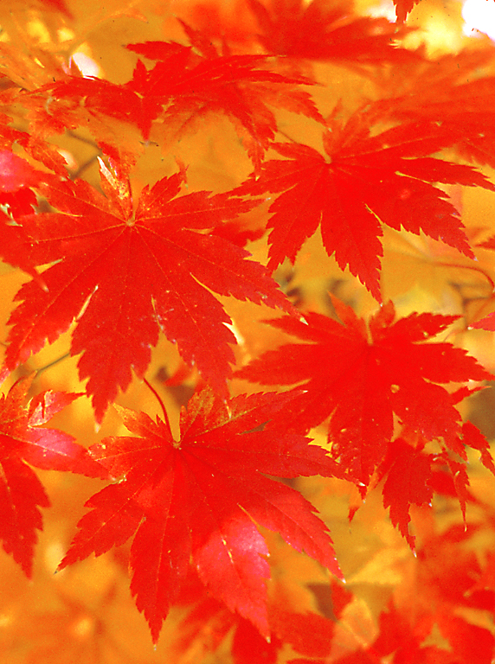
The bright yellow, orange and red colors of autumn leaves are one of nature’s most beautiful spectacles. Although a familiar annual event, much of our understanding of autumn leaf coloration has, until recently, been based primarily on random observation and speculation. Recent research has done much to explain the functions of this phenomenon.
Carotenoids and anthocyanins give leaves their bright fall colors.

During summer, the majority of a plant’s nutrients are contained within the leaves. These nutrients, in particular nitrogen and phosphorus, are components of proteins, pigments and other compounds necessary for photosynthesis, the process by which plants use the sun’s energy to manufacture sugars from water and carbon dioxide. These nutrients are valuable resources in nature, and the amount of nutrients a plant possesses directly affects the plant’s capacity to grow and reproduce. Thus, it is important for plants to recover as many of these nutrients as possible before the leaves are discarded in autumn.

The shortening days and cooler temperatures of autumn signal plants to begin a process by which a leaf’s photosynthetic components are disassembled and the nutrients contained within them are moved to stems and roots for storage and re-use the following year. The disassembly of leaf components in autumn is highly organized and complex. However, much of this process takes place before any visible color change in leaves, and thus this surge of activity goes largely unnoticed. It is only during the latter stages of this process that the showy colors of autumn appear.

Chlorophyll is the pigment that gives plants their green color and is used by plants to capture the sun’s energy. Throughout autumn, plants are actively breaking down chlorophyll along with the many other photosynthetic components, and as levels of chlorophyll decline, the brightly colored pigments we associate with autumn leaves become visible. There are two types of pigments that give leaves their bright autumn colors: carotenoids and anthocyanins.

Carotenoids are a class of pigments responsible for the bright yellow colors of fall leaves. Carotenoids are present in leaves throughout the growing season, and are visible only when chlorophyll levels become very low in autumn. These pigments protect leaves from a variety of harmful compounds that are normal by-products of photosynthesis. Without carotenoids, leaf photosynthetic components literally destroy themselves.

Anthocyanins are responsible for many of the reds, oranges, pinks, purples and blues in flowers and fruits, but also produce the brilliant red and orange hues of autumn foliage.

Revised

Apr. 25, 2004

University of Wisconsin Garden Facts

Unlike the yellow carotenoids, anthocyanins are made by plants midway through the autumn disassembly process, when a significant amount of chlorophyll is still present within the leaves. At first, the presence of both the red pigments and chlorophyll results in a dark burgundy appearance, but the brightly colored anthocyanins become increasingly visible as chlorophyll levels continue to decline. Red leaves contain similar amounts of carotenoids as yellow leaves, but in red leaves, the yellow carotenoids are masked by the intensely colored anthocyanins.

Red pigments are produced during autumn to help shade leaf photosynthetic systems from bright sunlight. In many plants, the disassembly of leaf components in fall results in susceptibility to damage from bright light, particularly as temperatures decline. Protection from bright light during autumn is important because damage to the photosynthetic components during this time will reduce a plant’s capacity to recover nutrients from leaves. Plants that do not turn red in autumn are generally more resistant to the effects of bright light during this time, and therefore do not need to produce red pigments. The shading function of the red pigments explains why leaves exposed to direct sunlight are the brightest red, while leaves shaded within the canopy of a plant often show little or no accumulation of these pigments.

While many factors can affect the quality and duration of autumn leaf colors, the single most important factor influencing this phenomenon is the weather during the time that leaves are changing color. Cool, sunny weather will result in the brightest foliage colors. Because plants use the red pigments to shade leaves from bright light, sunny autumn days will result in plants producing more of these pigments.

While cool autumn weather is best for the development of brightly colored foliage, hard freezes may irreparably damage leaves before the disassembly process is complete and the brightest colors have emerged. Conversely, very warm autumn temperatures accelerate the processes within leaves and thus shorten the length of time that the colorful leaves remain on plants. Warm temperatures will also reduce the amount of red pigments produced in leaves.

Other factors can also affect leaf color change in autumn. In general, stresses such as drought, nutrient deficiency and even diseases can increase the production of red pigments, and therefore may improve the color display of autumn leaves. Drought is a common stress in many environments, and unless the water deficiency is so severe that leaves are killed before autumn (a very rare occurrence), drought conditions will generally improve the quality of fall leaf colors.

For more information on leaf color change in autumn: Contact your county Extension agent.

© 2004 by the Board of Regents of the University of Wisconsin System doing business as the division of Cooperative Extension of the University of Wisconsin Extension.

An EEO/Affirmative Action employer, University of Wisconsin Extension provides equal opportunities in employment and programming, including Title IX and ADA requirements. This document can be provided in an alternative format by calling Brian Hudelson at (608) 262-2863 (711 for Wisconsin Relay).

References to pesticide products in this publication are for your convenience and are not an endorsement or criticism of one product over similar products. You are responsible for using pesticides according to the manufacturer’s current label directions. Follow directions exactly to protect the environment and people from pesticide exposure. Failure to do so violates the law.

Thanks to Karen Delahaut and Susan Mahr for reviewing this document.

A complete inventory of University of Wisconsin Garden Facts is available at the University of Wisconsin-Extension Horticulture website: wihort.uwex.edu.

