
University of Wisconsin Farm Facts

Provided to you by:

XGT1010

Leaf and Glume Blotch of Small Grains

Damon Smith, UW-Madison Plant Pathology

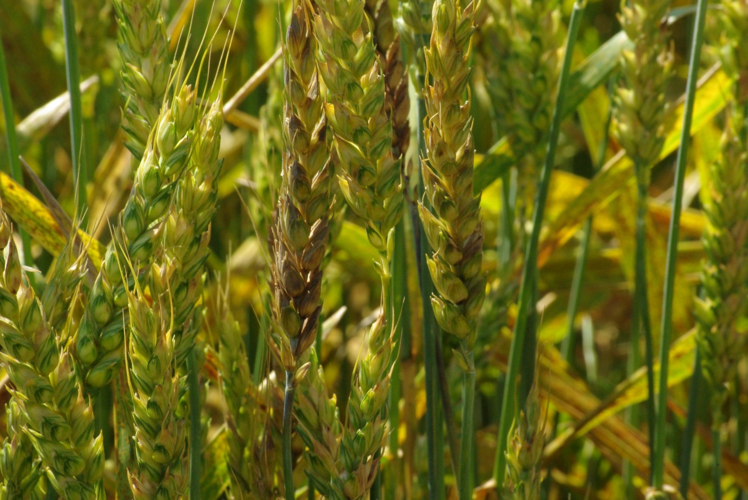
What is leaf and glume blotch? Leaf and glume blotch is a common disease of wheat, and to a lesser extent barley and rye. While the impact of the disease is typically relatively minor (usually 5% or less of a wheat crop is affected), under favorable environmental conditions, leaf and glume blotch can destroy upwards of 20% of a wheat crop.
Blotchy brown to purple discolorations on grain heads are characteristic of leaf and glume blotch of wheat. Photo courtesy of Craig Grau.

What does leaf and glume blotch look like? Leaf and glume blotch on leaves appears initially as small yellow flecks that enlarge to form brown, lens-shaped lesions, often surrounded by yellow halos. These regions can merge, leading to large necrotic (i.e., dead) areas on leaves. The disease can also affect stems and grain heads resulting in smaller brown to purple lesions on tillers and botchy brown to purple areas on glumes (i.e., the leafy, husk tissue that surrounds developing seeds). As the disease develops, small, dark, pimple-like dots (reproductive structures of the fungus that causes the disease) form in the discolored tissue. When the humidity is high, gelatinous masses of fungal spores are exuded from these tiny dots giving leaves, stems and grain heads a shiny, wet appearance.

Where does leaf and glume blotch come from? Leaf and glume blotch is caused by the fungus Stagonospora nodorum which can survive in wheat debris, as well as in wheat seed. Spores of the fungus are produced on wheat debris and on infected plants during periods of high humidity and moderate temperatures (optimally around 68°F), and are easily moved within a wheat planting by splashing due to heavy rains.

How can I save plants with leaf and glume blotch? Once plants are infected with the leaf and glume blotch fungus, curative treatments are not available. Luckily, under weather conditions typical for small grain production in Wisconsin, damage due to leaf and glume blotch is not severe (at most perhaps 5% of an overall wheat crop in a typical growing season). However, under weather conditions favorable for leaf and glume blotch to develop, early detection of the disease is important to provide greater flexibility in applying fungicide treatments that can limit disease development (see details below). In particular, fungicide treatments that protect the flag leaves of wheat plants (i.e., the leaves just under the grain heads) can be important in preventing significant losses due to leaf and glume blotch.

Revised

Apr. 15, 2015

Revised
Mar. 15, 2015

University of Wisconsin Farm Facts

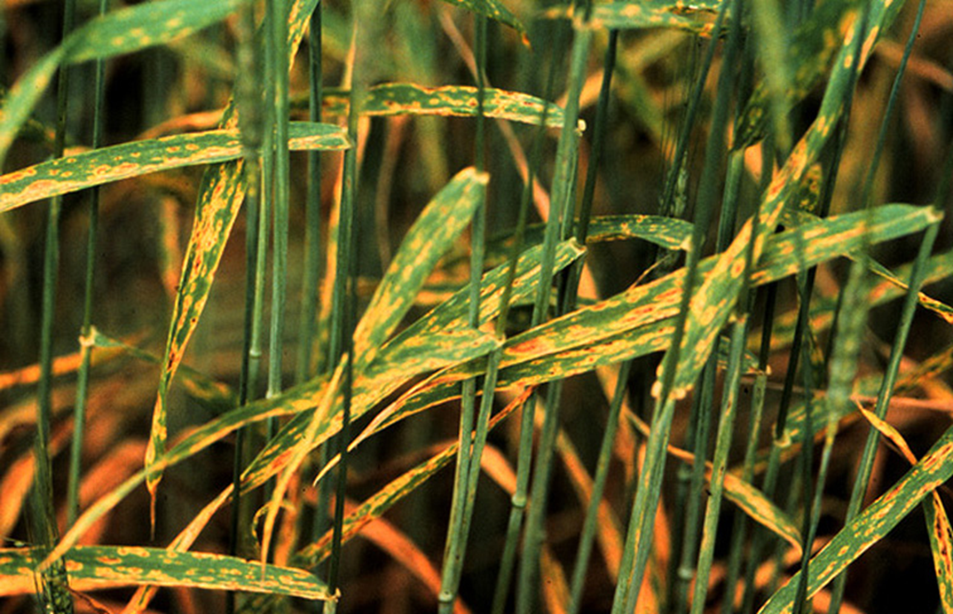
How can I avoid problems with leaf and glume blotch in the future? The best method for managing leaf and glume blotch is through the use of appropriate crop rotation. Rotate wheat and other small grains with nonsusceptible crops (e.g., soybeans, corn, or vegetable crops) for at least one year. Where feasible, also consider using tillage practices that partially or fully bury wheat debris, and avoid planting wheat excessively early. Rotation, proper tillage and delayed planting all provide time for wheat debris to decay which in turn eliminates the primary source of spores of the leaf and glume blotch pathogen. Also, use wheat seed that was produced in leaf and glume blotch-free fields to avoid introducing the fungus on contaminated seed.
On wheat leaves, leaf and glume blotch leads to brown, lens-shaped lesions with yellow halos. Photo courtesy of Craig Grau.

Where leaf and glume blotch has been a chronic problem, use leaf and glume blotch-resistant wheat cultivars and reduce seeding rates to allow better air penetration and more rapid drying of plants. Avoid overuse of nitrogen fertilizers as this will promote excessive leaf growth that will slow leaf drying. Finally scout wheat fields routinely and consider using preventative fungicide treatments at the emerging flag leaf stage of development (Feekes 8). Many strobilurin fungicides (FRAC group 11) and demethylation inhibitor fungicides (FRAC group 3), as well as mixes of active ingredients with these modes of action provide very good control of leaf and glume blotch. Use fungicides containing a strobilurin only prior to heading; avoid using these products after wheat has flowered. Demythylation inhibitor fungicides can be applied both before and after wheat has flowered. Be sure to read and follow all label instructions of the fungicide(s) that you select to ensure that you use the material(s) in the safest and most effective manner possible.

For more information on leaf and glume blotch: Contact your county Extension agent.

© 2015 by the Board of Regents of the University of Wisconsin System doing business as the division of Cooperative Extension of the University of Wisconsin Extension.

An EEO/Affirmative Action employer, University of Wisconsin Extension provides equal opportunities in employment and programming, including Title IX and ADA requirements.

References to pesticide products in this publication are for your convenience and are not an endorsement or criticism of one product over similar products. You are responsible for using pesticides according to the manufacturer’s current label directions. Follow directions exactly to protect the environment and people from pesticide exposure. Failure to do so violates the law.

Thanks to Nick Baker, Bryan Jensen and George Koepp for reviewing this document.

A complete inventory of University of Wisconsin Farm Facts is available at the Plant Disease Diagnostics Clinic website: http://pddc.wisc.edu.

