
University of Wisconsin Garden Facts

Provided to you by:
XHT1027

Lichens

Ken Frost* and Brian Hudelson, UW-Madison Plant Pathology

What are lichens? Lichens are organisms that arise from mutually beneficial interactions between certain fungi and algae. The fungi provide the physical structures of the lichens, as well as protection for the algae. The algae, in turn, produce food for the fungi via photosynthesis.
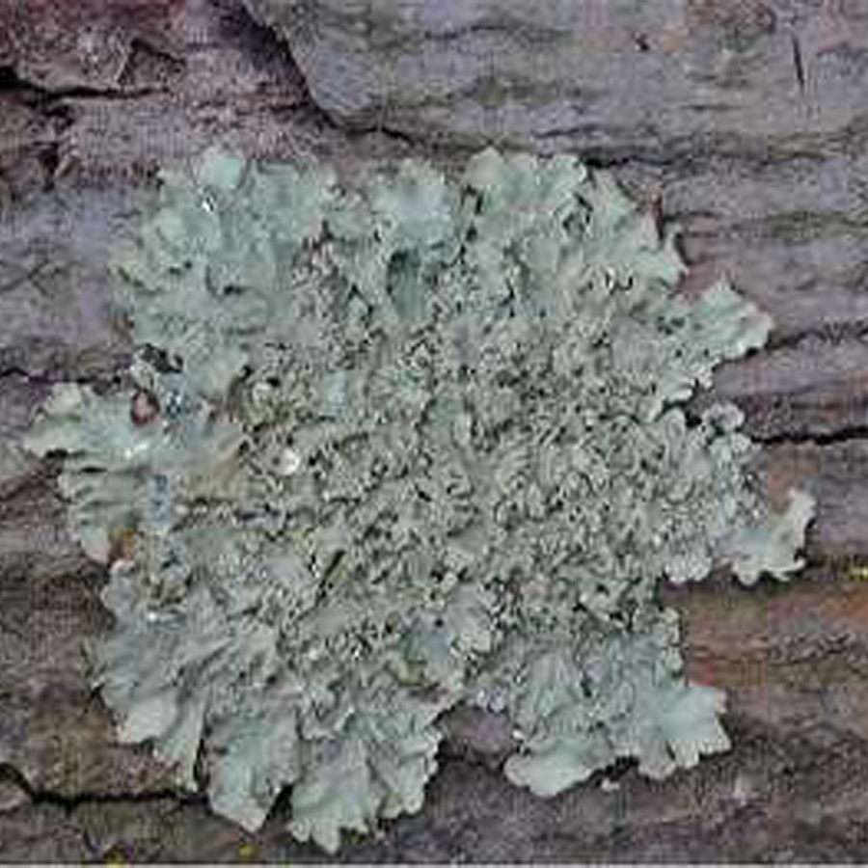
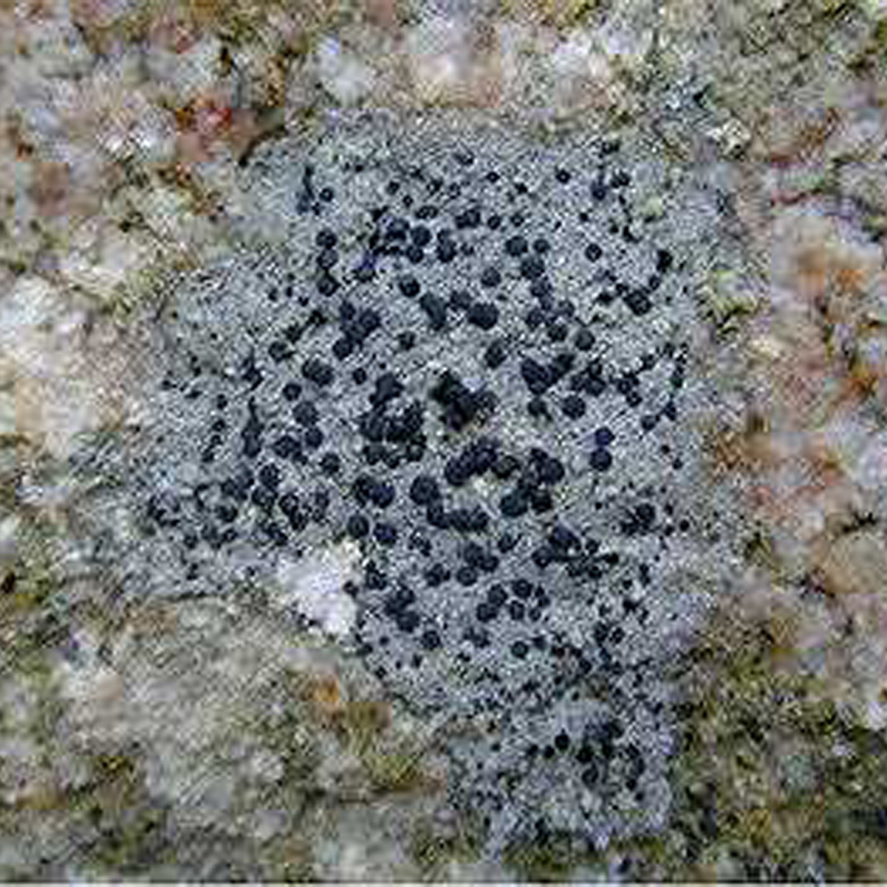
What do lichens look like? Lichens come in four basic growth forms. Crustose lichens are crust-like and adhere tightly to the surface upon which they grow. Foliose lichens are leaf-like and composed of flat sheets of tissue that are not tightly bound together. Squamulose lichens are composed of scale-like parts. Fruticose lichens are composed of free-standing branching tubes.
There are many types of lichens. Crustose lichens (left) are crust-like and adhere tightly to the surface upon which they grow. Foliose lichens (right) are leaf-like and composed of flat sheets of tissue that are not tightly bound.

Where do lichens come from? Lichens are everywhere. There are an estimated 13,500 to 17,000 species of lichens, and lichens can be found growing in tropical, temperate and polar regions throughout the world. Lichens will grow on almost any surface that is stable and reasonably well-lit. In temperate regions, lichens can often be found growing on the bark of trees or old fence posts. Others lichens grow in less hospitable places, such as bare rock surfaces or old headstones in graveyards, where they aid in the breakdown of rocks and the formation of soil.

Revised

Apr. 28, 2012

University of Wisconsin Garden Facts

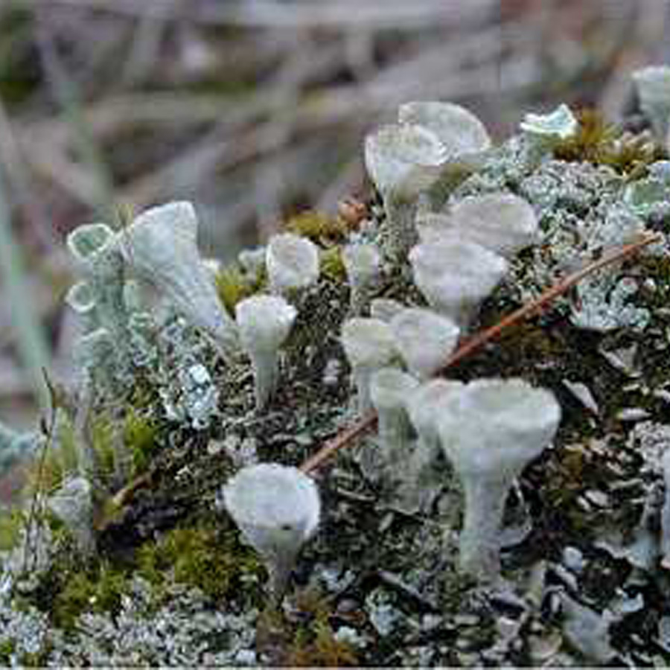
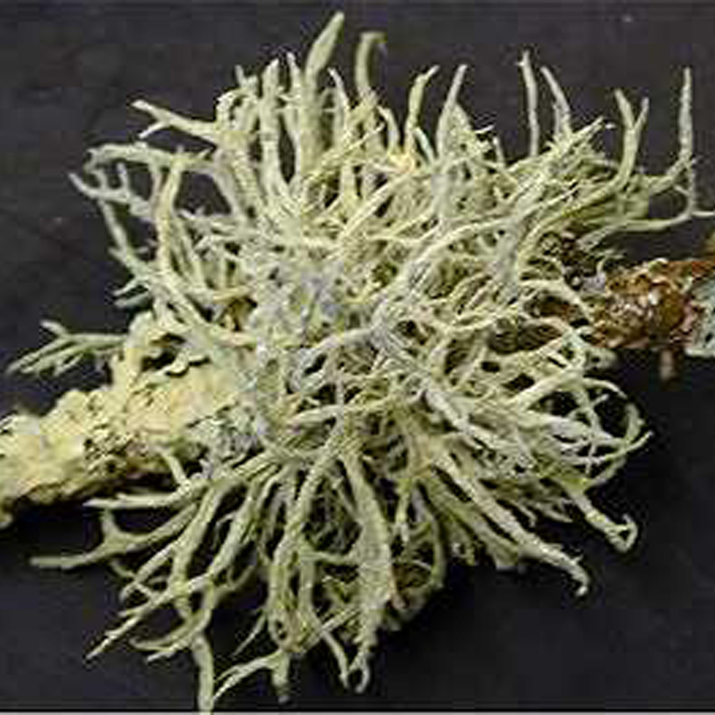
How do I save a tree with lichens? DO NOT PANIC! Lichens do not harm trees; they are not pathogens or parasites, and do not cause disease. Lichens are self-reliant, with the algal component of the lichen producing food for the organism via photosynthesis. Lichens absorb water and minerals from rainwater and the atmosphere, and because of this, they are extremely sensitive to air pollution. As a result, the presence or absence of certain lichen species can be used as an indicator of levels of atmospheric pollutants. Information on the abundance and species of lichens growing in an area can give a good indication of the local air quality.
There are many types of lichens. Squamulose lichens are composed of scale-like parts. Fruticose lichens are composed of free-standing branching tubes.

For more information on lichens: Contact your county Extension agent.

*Completed as partial fulfillment of the requirements for Plant Pathology 875 – Plant Disease Diagnostics Clinic Internship at the University of Wisconsin Madison.

© 2005-2011 by the Board of Regents of the University of Wisconsin System doing business as the division of Cooperative Extension of the University of Wisconsin Extension.

An EEO/Affirmative Action employer, University of Wisconsin Extension provides equal opportunities in employment and programming, including Title IX and ADA requirements.

Thanks to Lisa Johnson, Barb Larson and Mike Maddox for reviewing this document. Thanks also to the Wisconsin State Herbarium and Marie Trest for providing the photo.

A complete inventory of University of Wisconsin Garden Facts is available at the University of Wisconsin-Extension Horticulture website: http://hort.uwex.edu.

