
University of Wisconsin Garden Facts

Provided to you by:
XHT1072

Root Rots in the Garden
Brian Hudelson, UW-Madison Plant Pathology and Laura Jull, UW-Madison Horticulture

What is root rot? Root rot is a general term that describes any disease where the pathogen (causal organism) attacks and leads to the deterioration of a plant’s root system. Most plants are susceptible to root rots, including both woody and herbaceous ornamentals. Root rots can be chronic diseases or, more commonly, are acute and can lead to the death of the plant.

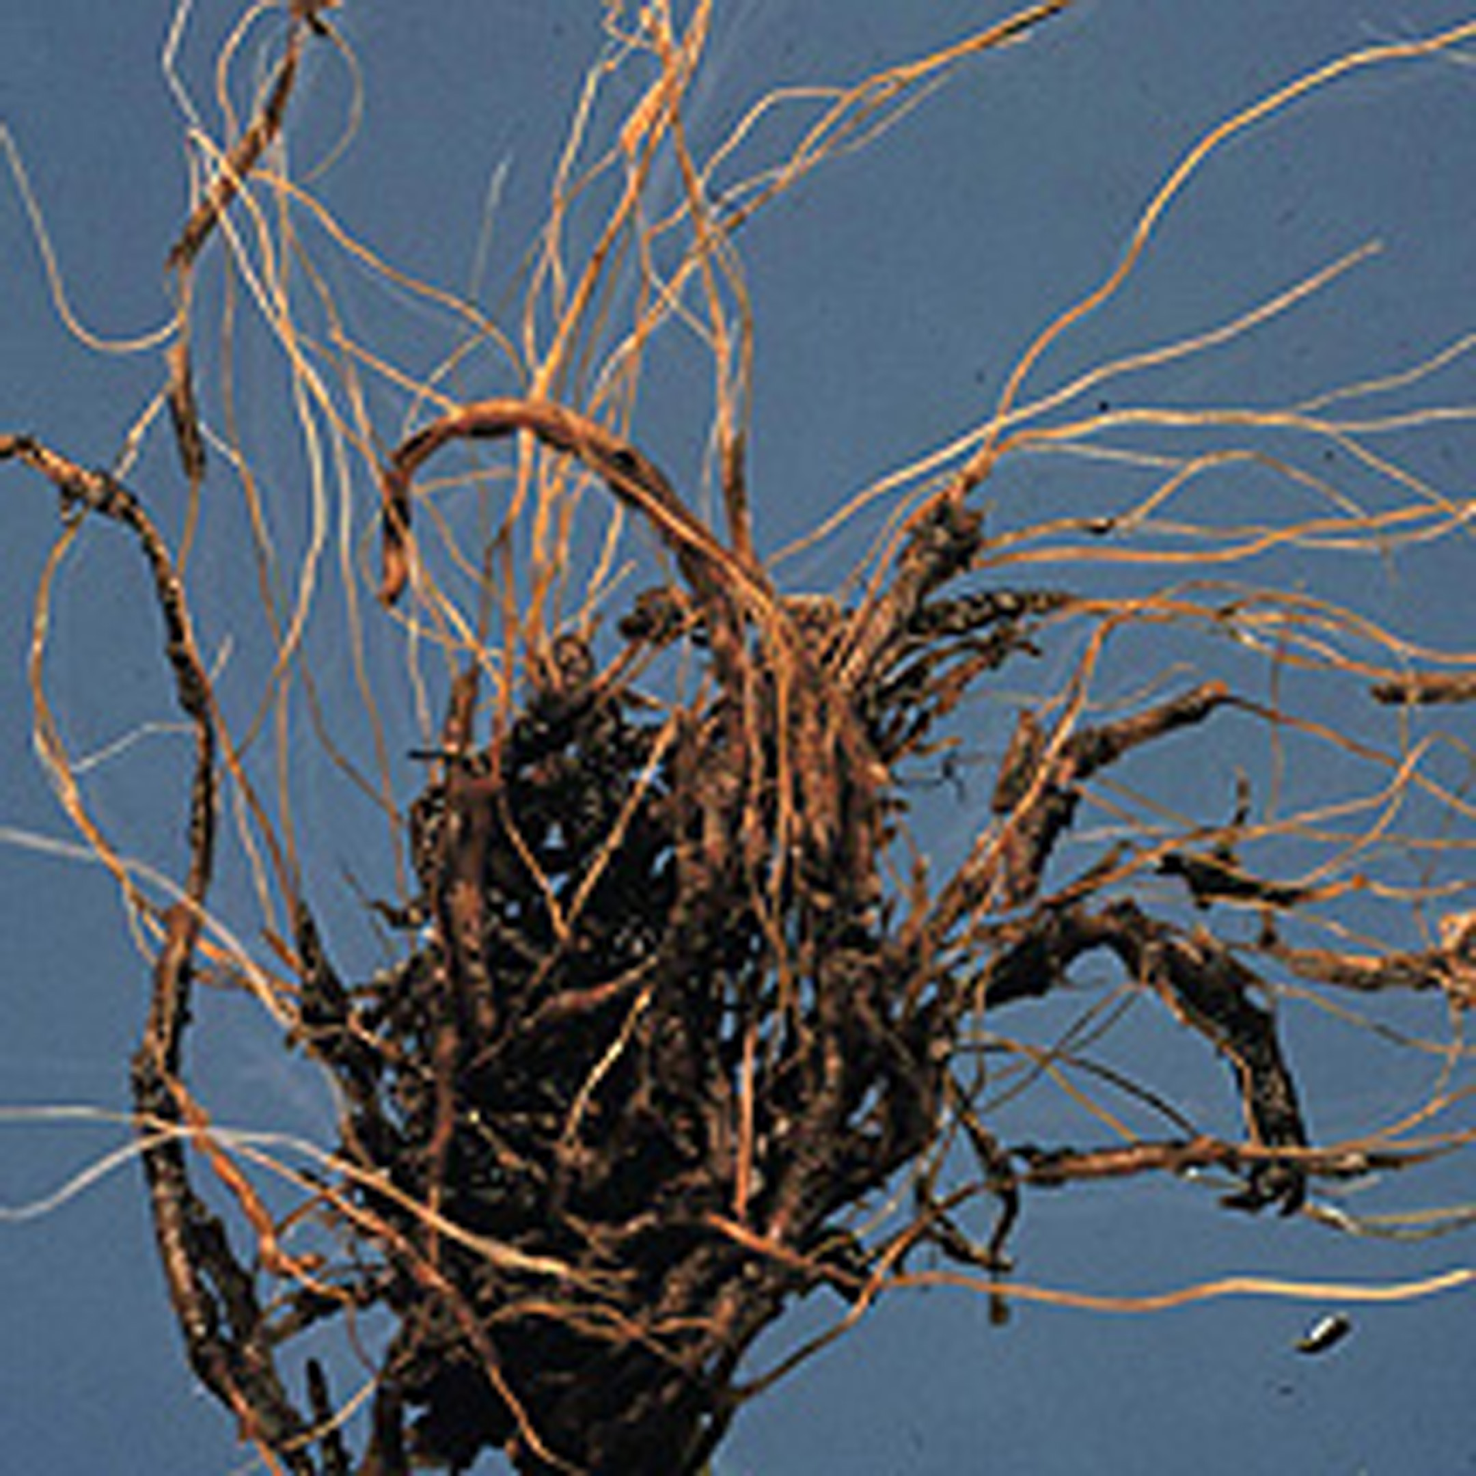
How do you know if your plant has a root rot? Gardeners often become aware of root rot problems when they see above ground symptoms of the disease. Plants with root rot are often stunted or wilted, and may have leaves with a yellow or red color, suggesting a nutrient deficiency. Examination of the roots of these plants reveals tissue that is soft and brown.
Brown discoloration of roots typical of root rots.

Where does root rot come from? A large number of soil-borne fungi cause root rots. Pythium spp., Phytophthora spp., Rhizoctonia solani, and Fusarium spp. are the most common root rot fungi. These fungi have wide host ranges, and thus can cause root rots on a wide variety of plants. Most root rot fungi prefer wet soil conditions and some, such as Pythium and Phytophthora, produce spores that can survive for long periods in soil.

How do I save a plant with root rot? REDUCE SOIL MOISTURE! Provide enough water to fulfill a plant’s growth needs and prevent drought stress, but DO NOT over-water. Remove excess mulch (greater than four inches) that can lead to overly wet soils. Chemical fungicides (PCNB, mefenoxam, metalaxyl, etridiazole, thiophanate-methyl and propiconazole) and biological control agents (Gliocladium, Streptomyces, and Trichoderma) are labeled for root rot control. However, DO NOT use these products unless you know exactly which root rot pathogen is affecting your plants. Contact your county Extension agent for details on obtaining an accurate root rot diagnosis and for advice on which, if any, fungicides you should consider using.

How do I avoid problems with root rots? Buy plants from a reputable source and make sure they are root rot-free prior to purchase. Establish healthy plants in a well-drained site. Moderate soil moisture. Add organic material (e.g., leaf litter or compost) to heavy soils to increase soil drainage. DO NOT over-water. Provide just enough water to fulfill the plants’ needs for growth and prevent drought stress. Also, DO NOT apply more than three inches of mulch in flowerbeds. REMEMBER, root rot fungi grow and reproduce best in wet soils. Finally, minimize movement of root rot fungi in your garden. DO NOT move soil or plants from areas with root rot problems. DO NOT water plants with water contaminated with soil (and thus potentially with root rot fungi). After working with plants with root rot problems, disinfest tools and footwear with a 10% bleach or detergent solution, or alcohol.
For more information on root rots: Contact your county Extension agent.

5

© 2000 by the Board of Regents of the University of Wisconsin System doing business as the division of Cooperative Extension of the University of Wisconsin Extension.

An EEO/Affirmative Action employer, University of Wisconsin Extension provides equal opportunities in employment and programming, including Title IX and ADA requirements. This document can be provided in an alternative format by calling Brian Hudelson at (608) 262-2863 (711 for Wisconsin Relay).

Revised

Apr. 25, 2004
References to pesticide products in this publication are for your convenience and are not an endorsement or criticism of one product over similar products. You are responsible for using pesticides according to the manufacturer’s current label directions. Follow directions exactly to protect the environment and people from pesticide exposure. Failure to do so violates the law.

Thanks to Karen Delahaut, Ann Joy and Sharon Morrisey for reviewing this document.

A complete inventory of University of Wisconsin Garden Facts is available at the University of Wisconsin-Extension Horticulture website: wihort.uwex.edu.

