
University of Wisconsin Garden Facts

Provided to you by:
XHT1007b

Scab
Brian Hudelson, UW-Madison Plant Pathology

What is scab? Scab is a potentially serious fungal disease of ornamental and fruit trees in the rose family. Trees that are most commonly and severely affected include crabapple, hawthorn, mountain ash, apple and pear. This disease is most severe in years with cool, wet weather.

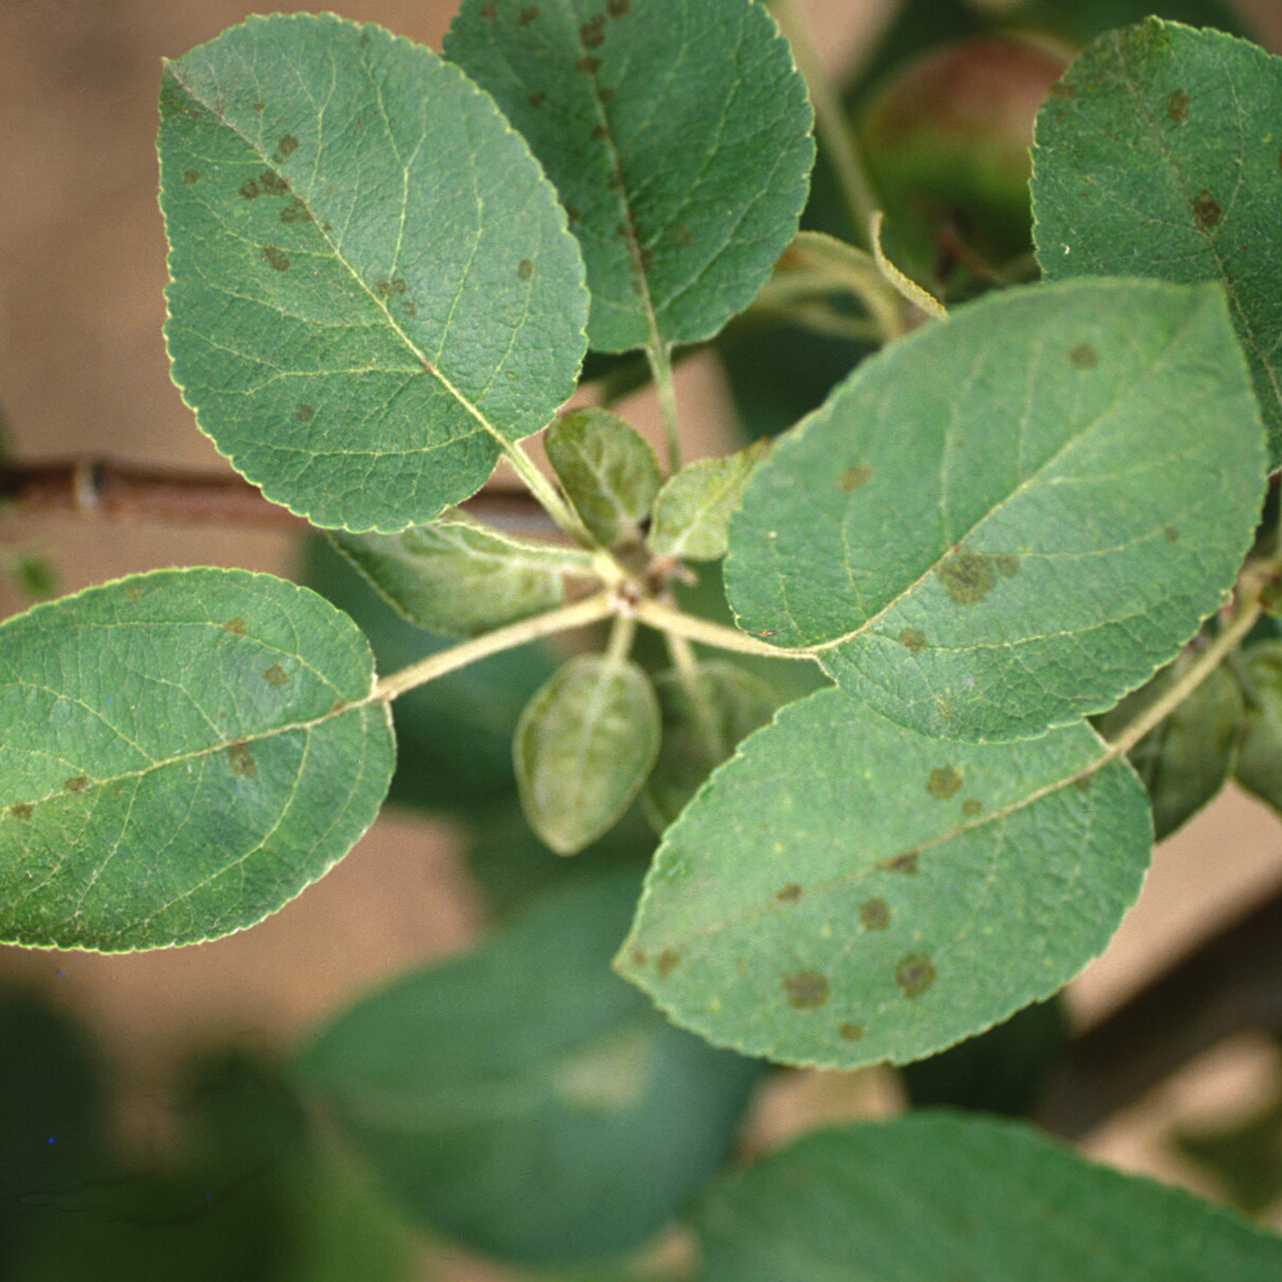
What does scab look like? Scab lesions (diseased areas) are often first noticed on leaves, where they most commonly occur on the upper leaf surface. Fruits are also very susceptible to infection. Lesions on both leaves and fruits are roughly circular with feathery edges, and have an olive green to black color. They can be as small as the size of a pinhead or as large a ¹∕2 inch in diameter. When disease is severe, lesions can merge and cover a large portion of the leaf or fruit surface. Defoliation of the tree often follows.
Leaf spots typical of apple scab on apple. Similar lesions occur on fruits.

Where does scab come from? Scab is caused primarily by the fungus Venturia inaequalis. Other species of Venturia can be involved as well. These fungi survive the winter in leaf litter from infected trees.

How do I save a tree or shrub with scab? If your tree is lightly affected with little or no defoliation and dry weather conditions prevail, then no treatment is necessary. If your tree has a history of severe scab and the weather is cool and wet, then consider applying fungicide treatments. Mancozeb, chlorothalonil, myclobutanil, propiconazole, or thiophanate methyl, are available for scab control. For most products, you will need to treat every seven to 14 days from bud break until wet weather subsides. Be sure to read and follow all label instructions of the fungicide that you select to insure that you use the fungicide in the safest and most effective manner possible.

How do I avoid problems with scab in the future? Remove and discard fallen, infected leaves that are a major source of spores that cause scab infections. Most importantly, consider replacing susceptible crabapples, apples and pears with resistant varieties available at your local garden center.
For more information on scab: See UW-Extension Bulletins A2173, A2594 and A8NYDS01, or contact your county Extension agent,

© 1999 by the Board of Regents of the University of Wisconsin System doing business as the division of Cooperative Extension of the University of Wisconsin Extension.

Revised

Apr. 25, 2004

An EEO/Affirmative Action employer, University of Wisconsin Extension provides equal opportunities in employment and programming, including Title IX and ADA requirements. This document can be provided in an alternative format by calling Brian Hudelson at (608) 262-2863 (711 for Wisconsin Relay).

References to pesticide products in this publication are for your convenience and are not an endorsement or criticism of one product over similar products. You are responsible for using pesticides according to the manufacturer’s current label directions. Follow directions exactly to protect the environment and people from pesticide exposure. Failure to do so violates the law.

Thanks to Paul Hartman, Laura Jull, Patti Nagai and Scott Reuss for reviewing this document.

A complete inventory of University of Wisconsin Garden Facts is available at the University of Wisconsin-Extension Horticulture website: wihort.uwex.edu.

