
University of Wisconsin Farm Facts

Provided to you by:

XGT1018

Sclerotinia Stem Rot of Soybean

Quinn Watson and Damon Smith, UW-Madison Plant Pathology

What is Sclerotinia stem rot? Sclerotinia stem rot (SSR), also known as white mold, is a serious and often lethal fungal disease that affects a wide range of agricultural crops in the U.S. including many broadleaf vegetable crops (e.g., carrots, cruciferous plants, peas, potatoes, snap beans) and field crops, especially soybean. SSR is most severe on soybeans in high-yielding environments that have dense, fast-growing canopies.

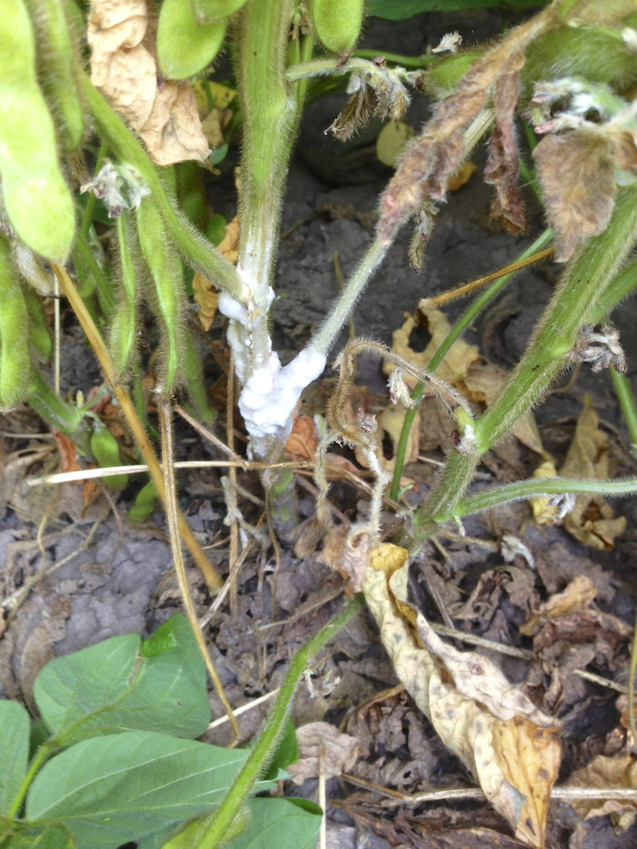
What does Sclerotinia stem rot look like? SSR causes sudden wilting of soybean leaves and rapid plant death. Lower stems of affected plants become bleached and under moist conditions (e.g., high humidity, frequent rain), become covered with a cottony white fungal growth. Small, black structures that look like rat or mouse droppings (called sclerotia) form on and inside the stems and pods of affected plants.
Cottony white growth of the Sclerotinia stem rot fungus on a soybean plant.

Where does Sclerotinia stem rot come from? Sclerotinia stem rot is caused by the fungus Sclerotinia sclerotiorum which survives as sclerotia in dead plant tissue. Sclerotia can survive for five years or more in soil. A cool, moist environment favors Sclerotinia stem rot development. Under these conditions, sclerotia germinate to produce small, mushroom-like structures (called apothecia) that produce spores. These spores can be spread by wind, insects, or rain splash. In soybeans, most infections occur via open or senescing (i.e., withering) flowers. Occasionally, the fungus will spread from plant-to-plant via direct contact of roots or other plant parts.

How can I save plants with Sclerotinia stem rot? SSR is difficult to control once the disease has occurred. If affected plants are limited to a small area in a field, removal and destruction of plants may help to limit production of sclerotia that can further contaminate and cause long-term problems in the field; however, this strategy usually is not feasible on a large scale. If affected plants are removed, they should be burned. DO NOT compost plants or till them into the soil.

How can I avoid problems with Sclerotinia stem rot in the future? To prevent introduction of the SSR fungus into soybean fields, be sure to plant sclerotia-free soybean seed. Also, harvest fields with SSR last to avoid spreading sclerotia of the SSR fungus from field to field on combines.

Revised

Mar. 3, 2015

University of Wisconsin Farm Facts

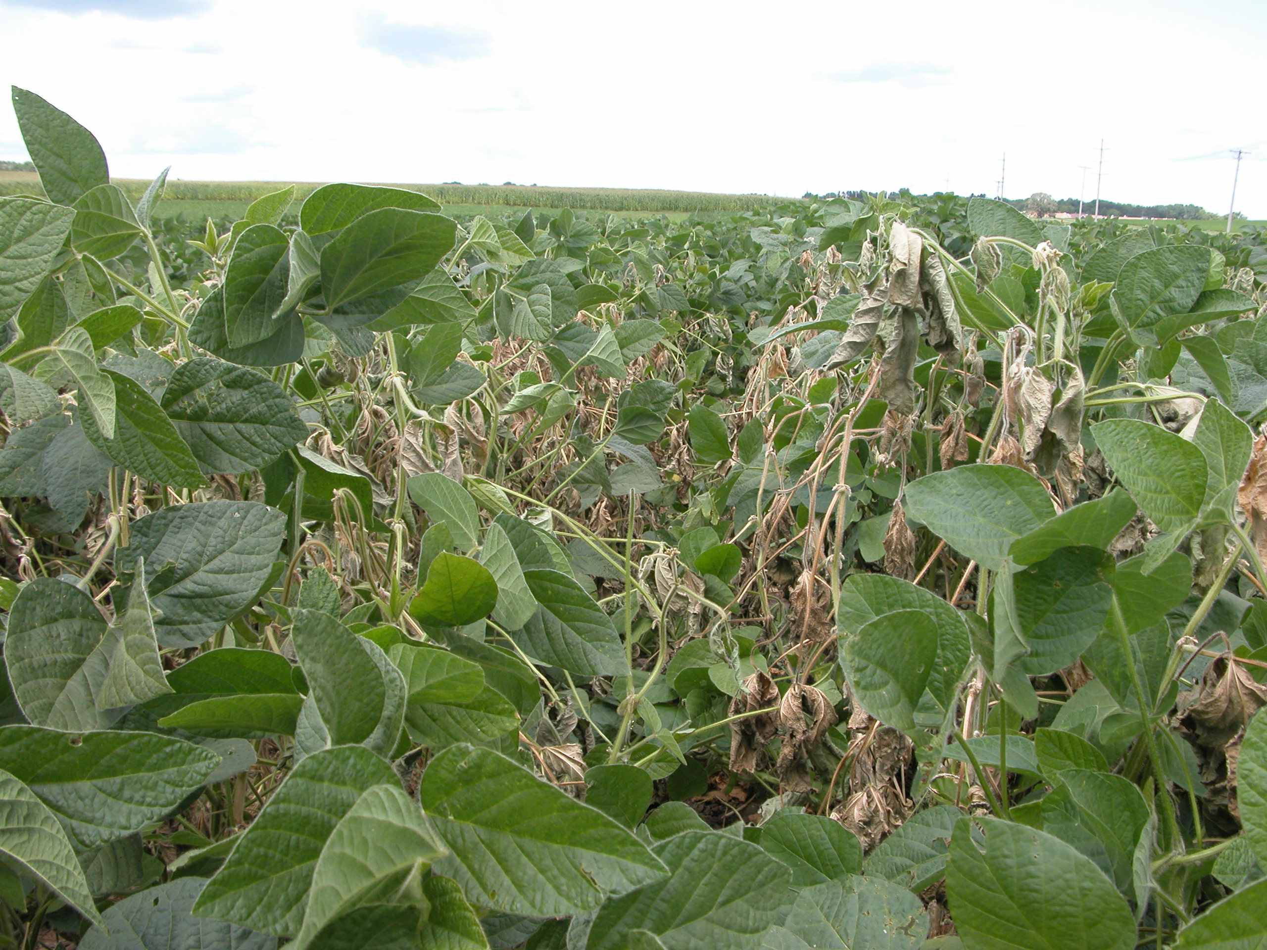
In fields with a history of SSR, grow soybean cultivars that have been bred for SSR resistance. This is the most economical and successful long-term strategy for SSR control. In addition, consider using no-till production for three to four years as this will reduce the number of viable sclerotia near the soil surface. Rotate soybeans with small grain crops that are not susceptible to SSR (e.g., wheat, barley, oats) to further reduce the number of viable sclerotia in the soil. Increase row spacing and reduce soybean seeding rates to promote a more open canopy that will have better air circulation and thus dry more rapidly. Also, make sure fields are well drained and avoid excessive irrigation especially during flowering. Remember that the SSR fungus prefers wetter conditions; under drier conditions the fungus is less likely to infect. Maintain good broadleaf weed control. Weeds not only decrease air circulation and promote wetter conditions, but can also be hosts for the SSR fungus.
Sclerotinia stem rot can cause widespread plant death and substantial yield loss.

Finally, there are fungicides and biological control products available for SSR management. Fungicides containing an active ingredient that is a succinate dehydrogenase inhibitor (SDHI), such as boscalid, are often effective in SSR control. The active ingredient picoxystrobin (a type of strobilurin fungicide) has also been shown to be effective in SSR control in university research trials. Timing of fungicide applications is critical. Fungicides should be applied during early flowering (R1) to early pod development (R3) growth stages. Fungicide applications made at the full pod (R4) growth stage or later will NOT be effective. In addition, applying fungicide treatments after symptoms are visible will not be effective. Several biocontrol agents (the most effective being one that contains a fungus called Coniothyrium minitans) have been shown to be effective in controlling SSR. Be sure to read and follow all label instructions of the fungicide/biological control product(s) that you select to ensure that you use the materials in the safest and most effective manner possible.

For more information on Sclerotinia stem rot: Contact your county Extension agent.

© 2015 by the Board of Regents of the University of Wisconsin System doing business as the division of Cooperative Extension of the University of Wisconsin Extension.

An EEO/Affirmative Action employer, University of Wisconsin Extension provides equal opportunities in employment and programming, including Title IX and ADA requirements.

References to pesticide products in this publication are for your convenience and are not an endorsement or criticism of one product over similar products. You are responsible for using pesticides according to the manufacturer’s current label directions. Follow directions exactly to protect the environment and people from pesticide exposure. Failure to do so violates the law.

Thanks to Ted Bay, Bryan Jensen and Julie Scharm for reviewing this document.

A complete inventory of University of Wisconsin Farm Facts is available at the Plant Disease Diagnostics Clinic website: http://pddc.wisc.edu.

