
University of Wisconsin Garden Facts

Provided to you by:
XHT1148

Swiss Needle Cast

Ann Joy and Brian Hudelson, UW-Madison Plant Pathology

What is Swiss needle cast? Swiss needle cast is a fungal disease of Douglas-fir. This tree is native to the Rocky Mountains and the Pacific Coast, but has traditionally been grown in Wisconsin as a landscape ornamental and as a Christmas tree. Swiss needle cast can limit the aesthetic appeal of Douglas-fir grown in landscape settings, as well as the marketability of Douglas-fir grown in Christmas tree production.

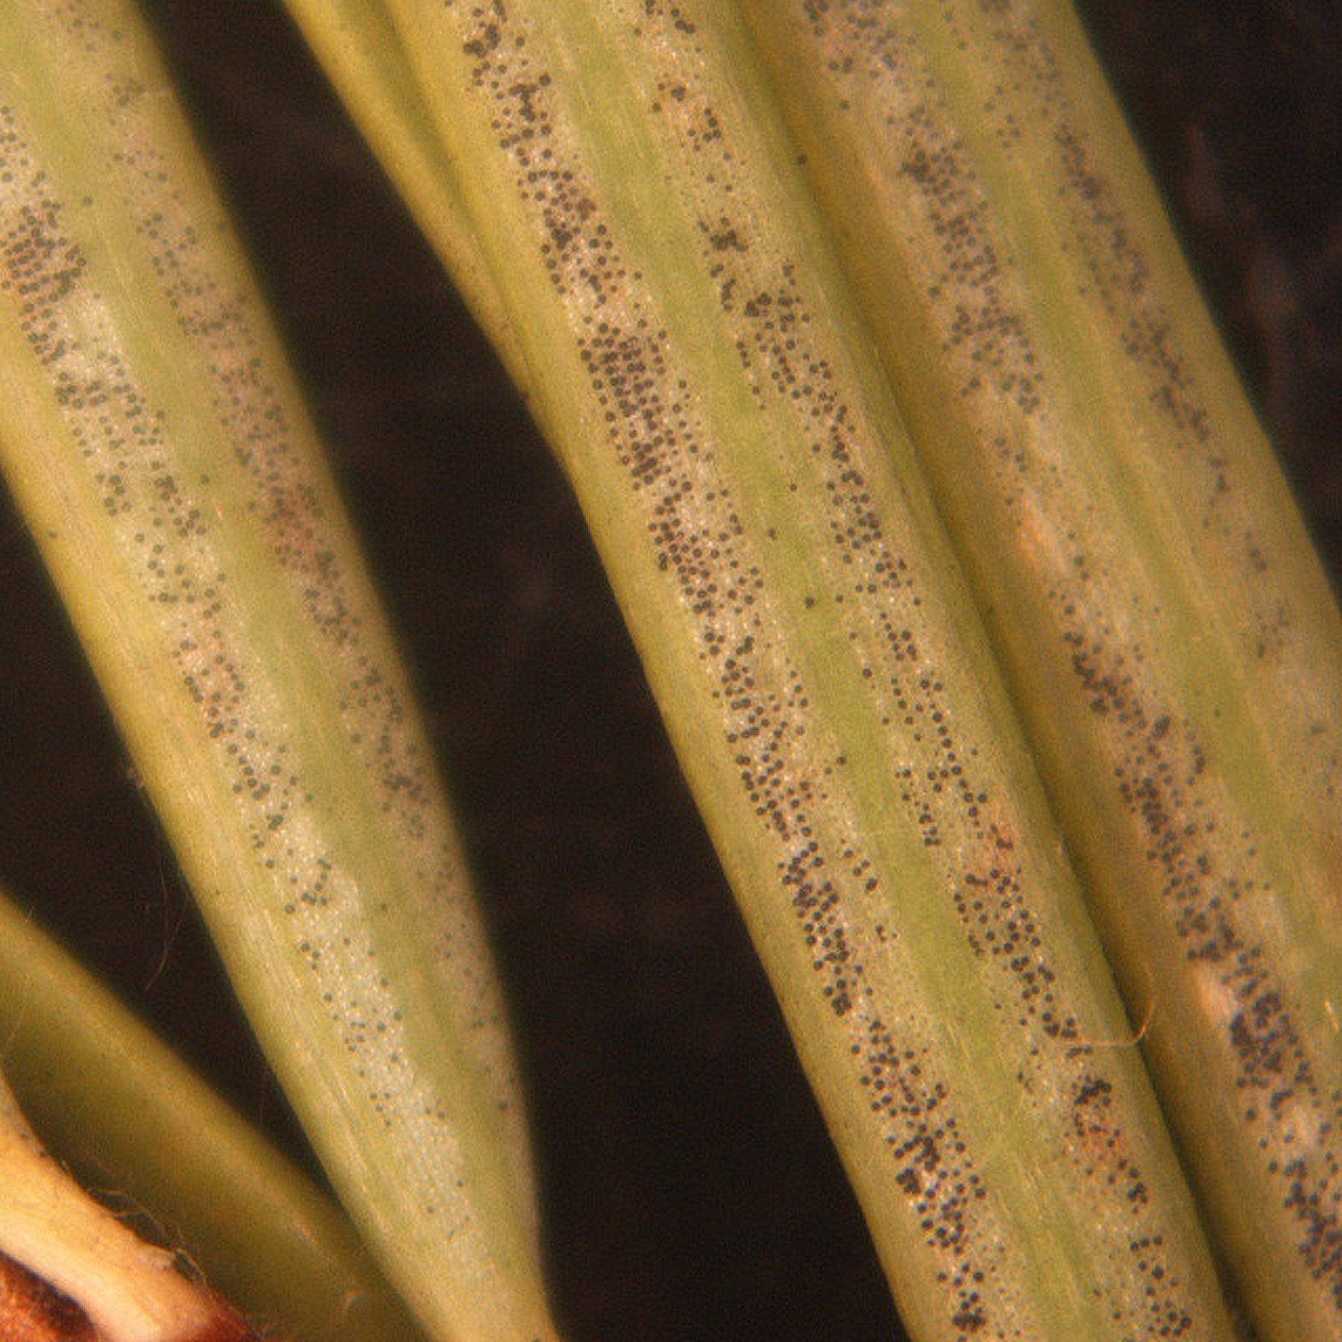
What does Swiss needle cast look like? Infected needles become discolored, turning a blotchy yellow-green or yellow, and then browning from the tips. Older needles are more severely affected than younger needles. Brown needles drop prematurely, leaving twigs with only the newest growth. Using a hand lens, small, black reproductive structures of the Swiss needle cast fungus can be seen in two diffuse bands on the undersurface of infected needles.
Fruiting bodies of the Swiss needle cast fungus on the undersides of needles.

Where does Swiss needle cast come from? Swiss needle cast is caused by the fungus Phaeocryptopus gaeumannii. This fungus tends to produce spores, infect needles, and cause more severe disease during rainy weather. Infections occur primarily on new shoots as they expand in the spring. Fully expanded needles are less susceptible to infection. Once infection has occurred, fruiting bodies form and produce spores even on green needles. Spores may be produced for several seasons before needles drop.

How can I save a tree with Swiss needle cast? Infected needles cannot be cured. However, fungicide sprays containing chlorothalonil or mancozeb may help prevent additional infections on small trees where complete, uniform coverage is possible. Fungicide treatments are not recommended for large trees. For plantation and landscape trees, two spray applications are recommended, the first when buds are ¹/2 to two inches long, and the second about three weeks later. In the more stressful environment of nurseries, trees may require sprays every two weeks through mid-August. Using preventive treatments, infected trees may regain their lush, full look within two years. Be sure to read and follow all label instructions of the fungicide that you select to insure that you use the fungicide in the safest and most effective manner possible.

How can I prevent Swiss needle cast in the future? Use Douglas-firs grown from seed originating in Pacific Coast areas rather than those grown from seed originating in the Rocky Mountains. Pacific Coast trees appear to be less susceptible to Swiss needle cast. Also, use resistant and tolerant varieties where available. Purchase stock from a reputable nursery; Phaeocryptopus gaeumannii is often spread through infected nursery stock. When planting Douglas-firs, choose a site that has well-drained, but moist soil with a neutral to slightly acidic pH and allow adequate spacing between trees to promote increased airflow and quicker drying of needles, which is less favorable for infection and disease development. Make sure trees have sufficient water and are fertilized properly (based on a soil and tissue nutrient test) to reduce stress that may increase trees’ susceptibility to Swiss needle cast.
For more information on Swiss needle cast: Contact your county Extension agent.

© 2005 by the Board of Regents of the University of Wisconsin System doing business as the division of Cooperative Extension of the University of Wisconsin Extension.

Revised

Feb. 5, 2008

An EEO/Affirmative Action employer, University of Wisconsin Extension provides equal opportunities in employment and programming, including Title IX and ADA requirements. This document can be provided in an alternative format by calling Brian Hudelson at (608) 262-2863 (711 for Wisconsin Relay).

References to pesticide products in this publication are for your convenience and are not an endorsement or criticism of one product over similar products. You are responsible for using pesticides according to the manufacturer’s current label directions. Follow directions exactly to protect the environment and people from pesticide exposure. Failure to do so violates the law.

Thanks to Diana Alfuth, Thad Kohlenberg, and Judy Reith-Rozelle for reviewing this document.

A complete inventory of University of Wisconsin Garden Facts is available at the University of Wisconsin-Extension Horticulture website: wihort.uwex.edu.

