
University of Wisconsin Garden Facts

Provided to you by:
XHT1141

Tatters
Rachel Leisso* and Brian Hudelson, UW-Madison Plant Pathology

What is tatters? Tatters is a leaf disorder affecting primarily members of the white oak group of oaks (i.e., oaks with leaves with rounded lobes) including bur, white and swamp white oaks. Members of the red oak group of oaks (i.e., oaks with leaves with pointed lobes), including red, black, pin and shingle oaks, as well as other types of trees, rarely display the disorder. Tatters was first documented in Iowa, Indiana and Ohio in the 1980’s, and since then has been documented throughout much of the Midwest.

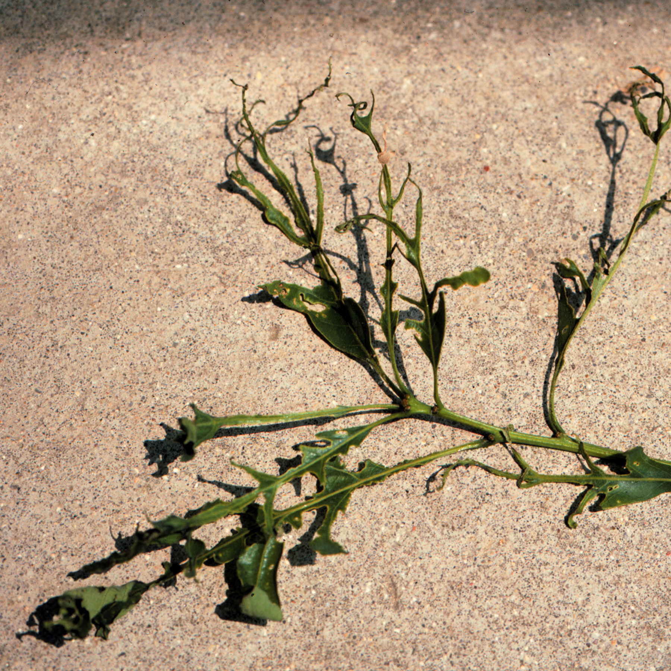
What does tatters look like? Trees with tatters have leaves that are lacy and shredded. Some leaves may appear as though the tissue between veins has been neatly ripped out, while other leaves have an irregular pattern of damage. The amount of damage may vary from leaf to leaf and branch to branch. Adjacent oak trees may show different amounts of damage due to genetic variability, variation in environmental conditions, or other external factors. Tatters is commonly confused with anthracnose (see University of Wisconsin Garden Facts XHT1001), or damage by leaf-feeding insects.
Leaves with tatters appear shredded, or as if damaged by leaf-feeding insects.

Where does tatters come from? The cause of tatters has not been precisely determined. Tatters is thought to be a physiological disorder caused by damage to leaf tissue in the bud-stage, or during the opening of buds in the spring. Suggested causes of tatters include cold or herbicide injury or, much more rarely, injury due to insect feeding or egg-laying.

How do I save a tree with tatters? DO NOT panic. Trees affected with tatters often produce replacement leaves within two to three weeks after tattered leaves appear. However, producing new leaves weakens trees and may make them more susceptible to other diseases and drought stress. If your trees suffer from tatters, make sure they receive sufficient water (approximately one inch per week for established trees). If rainfall is insufficient, use a drip hose or soaker hose to apply supplemental water. To prevent competition for water and nutrients, remove lawn grass within the drip line of your trees and replace it with shredded hardwood, pine or cedar mulch. On heavy clay soils, use three inches of mulch. On other soils, use three to four inches of mulch. Be sure to keep mulch two inches from the main trunks of the trees. Fertilize trees as needed, but be sure to base any fertilization on a soil nutrient test.

How do I avoid problems with tatters in the future? There is no known method for preventing tatters. However, the occurrence of tatters one year does not guarantee that the same trees will suffer from tatters in subsequent years.
For more information on tatters: Contact your county Extension agent.

*Completed as partial fulfillment of the requirements for Plant Pathology 699 – Plant Pathology Special Topics at the University of Wisconsin-Madison.

© 2005-2011 by the Board of Regents of the University of Wisconsin System doing business as the division of Cooperative Extension of the University of Wisconsin Extension.

An EEO/Affirmative Action employer, University of Wisconsin Extension provides equal opportunities in employment and programming, including Title IX and ADA requirements. This document can be provided in an alternative format by calling Brian Hudelson at (608) 262-2863 (711 for Wisconsin Relay).

Revised

Dec. 27, 2011

References to pesticide products in this publication are for your convenience and are not an endorsement or criticism of one product over similar products. You are responsible for using pesticides according to the manufacturer’s current label directions. Follow directions exactly to protect the environment and people from pesticide exposure. Failure to do so violates the law.

Thanks to Diana Alfuth, Phil Pellitteri and Ann Wied for reviewing this document.

A complete inventory of University of Wisconsin Garden Facts is available at the University of Wisconsin-Extension Horticulture website: http://hort.uwex.edu.

