
University of Wisconsin Garden Facts

Provided to you by:
XHT1066

Webworms
R. Chris Williamson, UW Turf and Ornamental Specialist

The term webworm is used to describe several insects whose caterpillars use silk to join plant parts together to form protective nests. Two common insects that create nests in fruit and woody ornamental trees are the eastern tent caterpillar and the fall webworm. These insects should not to be confused with the forest tent caterpillar, whose name is a misnomer, because it does not make a tent. Both eastern tent caterpillars and forest tent caterpillars are often mistaken for gypsy moth larvae because of their similar appearance.

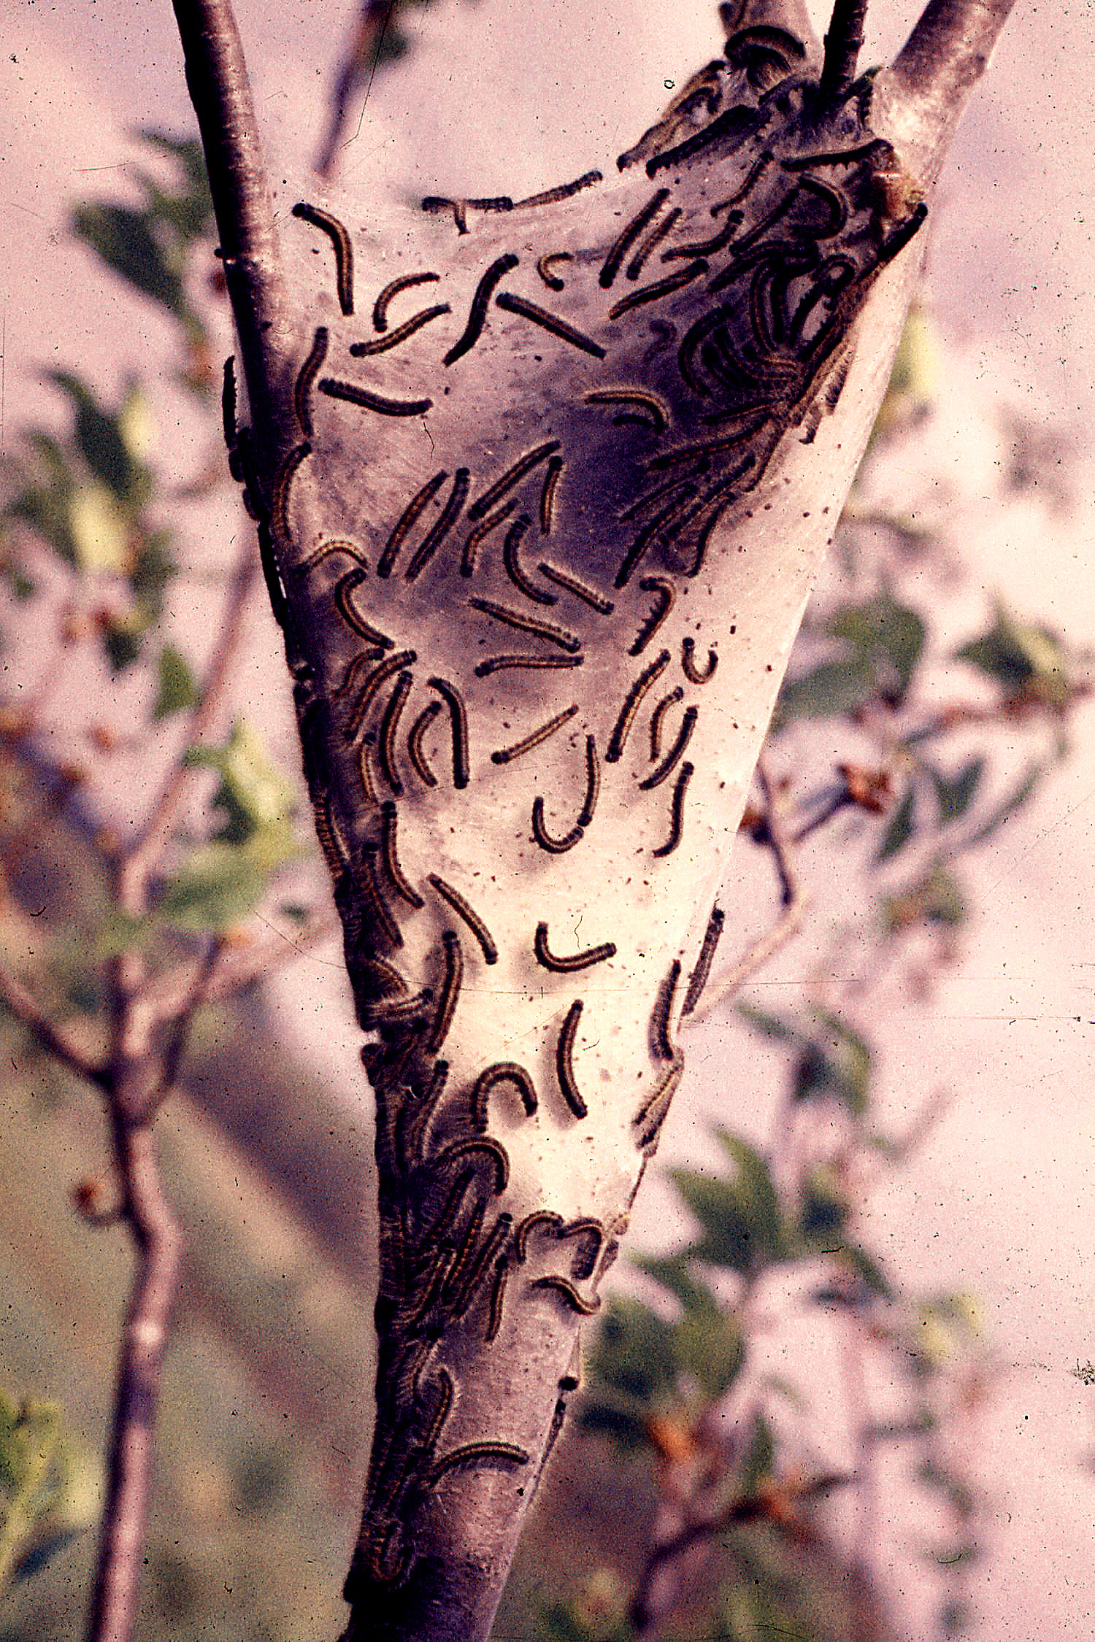
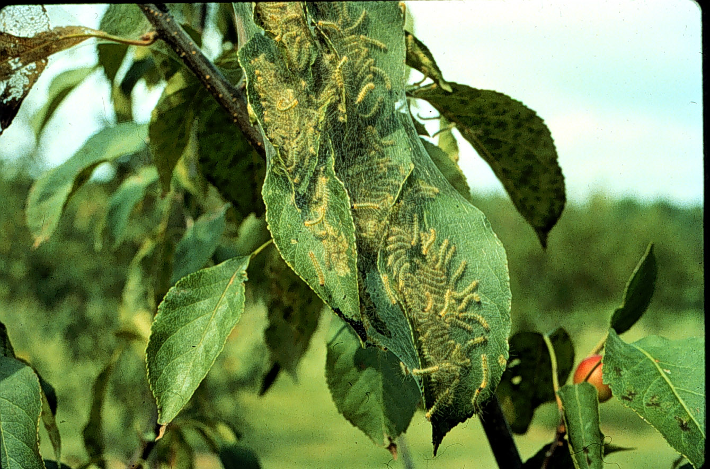
Plants Attacked and Damage: Hosts of the eastern tent caterpillar, fall webworm, and forest tent caterpillar are similar. Eastern tent caterpillars prefer plants in the rose family (Rosaceae) such as wild and landscape cherry, apple, crabapple, plum, and peach, but have also been found in ash, birch, willow, maple, oak, and poplar. Eastern tent caterpillars are generally active from April until early June, and they typically make their nests in the forks of branches when leaves are newly developing. Fall webworms feed on almost all shade, fruit, and ornamental trees except conifers. They are active from July through September, and typically make their nests in branch tips. Forest tent caterpillars prefer wild cherry, but also feed on oak, maple, hawthorn, and numerous other shade trees. Forest tent caterpillars do not make nests, but feed in the upper portion of trees on expanding flowers, leaf buds, and eventually foliage.
Eastern tent caterpillar (left) and fall webworm (right). (Fall webworm photo courtesy of David J. Shetlar.)

Control: Eastern tent caterpillars, fall webworms and forest tent caterpillars rarely reach large enough populations in ornamental trees to cause serious damage. Typically, trees can recover from feeding damage. However, nest and feeding damage can lower the aesthetic value of a tree. In addition, repeated defoliation year after year may contribute to tree decline. On small trees, webworm nests can be removed or pruned out. Simply scrape or prune the nest off onto the ground and crush to destroy the caterpillars. Remove nests in the early morning or late afternoon because more caterpillars are located in nests at these times. In larger trees, insecticide treatments may be necessary. Treat small, young caterpillars while they are inside the nest in the morning or late afternoon.
For pesticide recommendations: See UW-Extension Bulletin A3597, or contact your county Extension agent.

© 1999 by the Board of Regents of the University of Wisconsin System doing business as the division of Cooperative Extension of the University of Wisconsin Extension.

Revised

Apr. 25, 2004

An EEO/Affirmative Action employer, University of Wisconsin Extension provides equal opportunities in employment and programming, including Title IX and ADA requirements. This document can be provided in an alternative format by calling Brian Hudelson at (608) 262-2863 (711 for Wisconsin Relay).

References to pesticide products in this publication are for your convenience and are not an endorsement or criticism of one product over similar products. You are responsible for using pesticides according to the manufacturer’s current label directions. Follow directions exactly to protect the environment and people from pesticide exposure. Failure to do so violates the law.

Thanks to Karen Delahaut and Phil Pellitteri for reviewing this document.

A complete inventory of University of Wisconsin Garden Facts is available at the University of Wisconsin-Extension Horticulture website: wihort.uwex.edu.

