
University of Wisconsin Garden Facts

Provided to you by:
XHT1115

White Mold
Ann Joy and Brian Hudelson, UW-Madison Plant Pathology

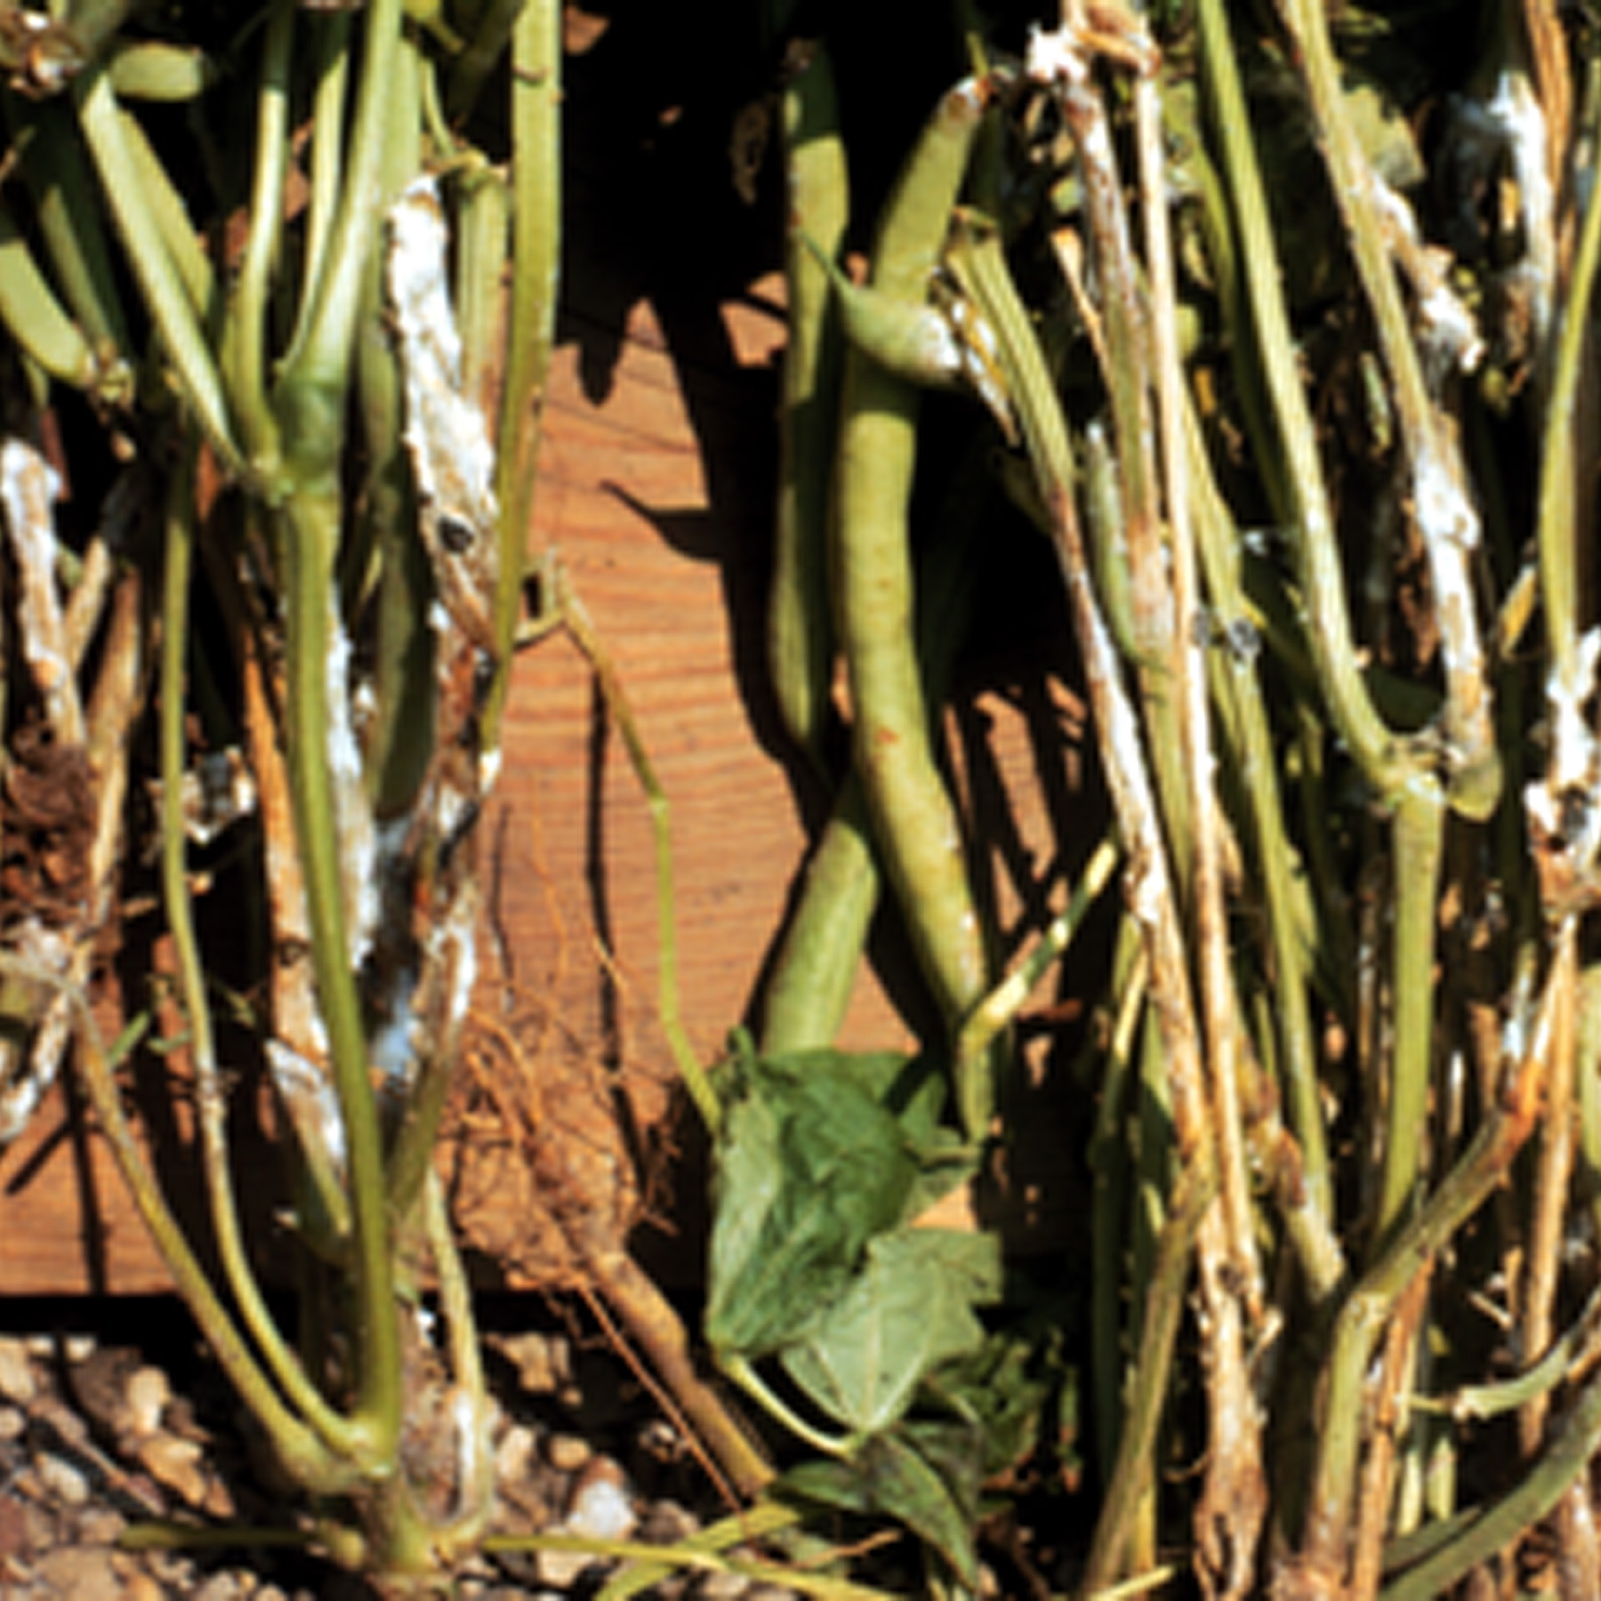
What is white mold? White mold, also known as Sclerotinia stem rot, is a serious and often lethal fungal disease that affects over 400 species of plants in many plant families. White mold causes severe damage in commercial snap, kidney and lima bean production, as well as commercial sunflower production. White mold also can be a serious problem in home vegetable gardens on tomatoes, potatoes, cucurbits (e.g., cucumber, pumpkin and squash), carrots, lettuce, celery, brassicas (e.g., cabbage, broccoli, and cauliflower), basil, and rosemary. White mold is a common disease on many annual and perennial ornamentals as well.
Stem cankers, cottony mycelia and sclerotia (see arrows) of white mold on snap beans.

What does white mold look like? Symptoms of white mold vary depending on the plant infected. White mold can lead to crown and stem cankers, root rots, wilts, damping-off of seedlings, and blossom and fruit rots. Plants affected by white mold can wilt rapidly due to stem-girdling cankers at or near the soil line. Brown spots can appear on flower petals and buds. Cottony masses of fungal threads (called mycelia) may appear on stems or on nearby soil. Hard, irregularly-shaped masses (called sclerotia) develop within or on the surface of infected plants. The sclerotia are white at first and then turn dark brown or black as they mature.

Where does white mold come from? White mold is caused by several species of the fungus Sclerotinia, most commonly Sclerotinia sclerotiorum. White mold fungi overwinter as sclerotia in dead plant material or in infested soil. Sclerotia can survive in soil for at least 3 years. During periods of cool, wet or humid weather, sclerotia germinate to form either fungal threads (called hyphae) or tiny, mushroom-like spore-producing structures (called apothecia). Apothecia can release millions of spores over a period of several days. Spores are dispersed primarily by wind, but also by rainsplash and insects. Both spores and hyphae can infect plant tissue, with infection often occurring through dead or declining plant parts (e.g., flowers and leaves), and then spreading to healthy tissue. Infections may also occur through healthy plant parts that are growing near or in contact with the soil. In some plants, seeds can be contaminated by sclerotia or mycelia of white mold fungi.

Revised

Jan. 10, 2013

University of Wisconsin Garden Facts

How do I save plants with white mold? White mold is difficult to manage once infections have occurred. Prune four to five inches below obviously disease tissue or remove entire plants if they are severely affected. DO NOT compost these materials because of the risk of spreading white mold fungi via long-lived sclerotia. Burn these materials instead.

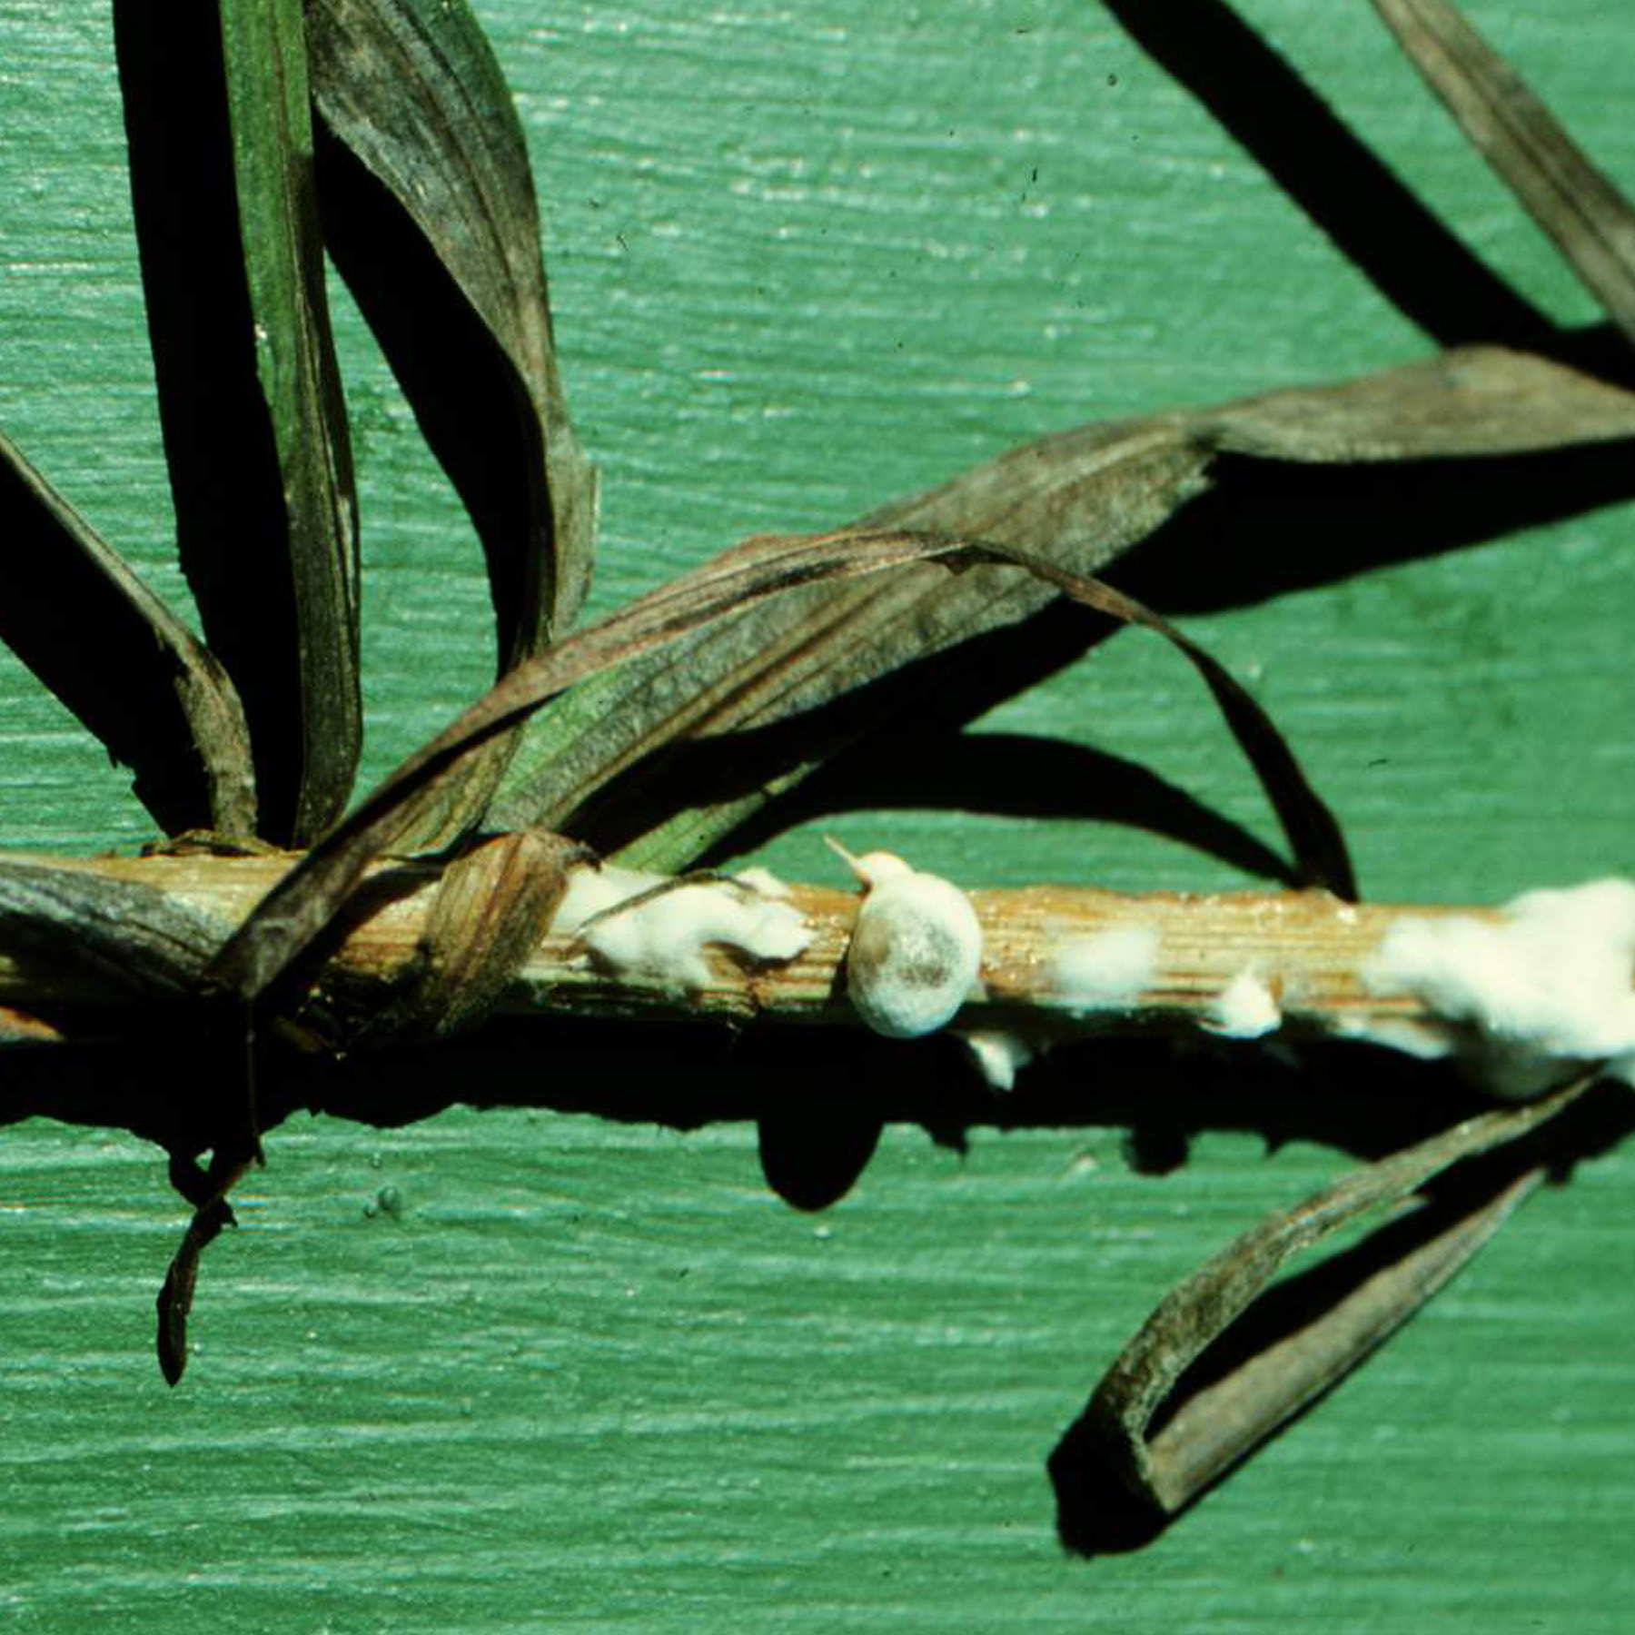
How do I avoid problems with white mold in the future? Check seed for sclerotia and remove these structures if you find them. Make sure your soils are well-drained, and avoid overwatering as well as frequent, light watering. DO NOT overhead water (e.g., with a sprinkler). Instead water deeply early in the day with a drip or soaker hose. Promote good air circulation in your garden so that plants more rapid dry when they do get wet (e.g., from natural rain). Better air circulation can be achieved by choosing cultivars or varieties of plants that have a more open growth form, by spacing plants farther apart, by avoiding excessive use of nitrogen fertilizers (which can promote excessive production of lush, thick foliage), and by keeping weeds under control. Weed control also eliminates potential alternate hosts that white mold fungi can infect. As leaves and flowers or your plants naturally wither and die, remove them, as well as any other plant debris that may harbor white mold fungi. Finally, in beds where severe cases of white mold have occurred, remove and replace infested soil.
White mold can be destructive on ornamentals such as Liatris.

For more information on white mold: Contact your county Extension agent.

© 2003-2013 by the Board of Regents of the University of Wisconsin System doing business as the division of Cooperative Extension of the University of Wisconsin Extension.

An EEO/Affirmative Action employer, University of Wisconsin Extension provides equal opportunities in employment and programming, including Title IX and ADA requirements. This document can be provided in an alternative format by calling Brian Hudelson at (608) 262-2863 (711 for Wisconsin Relay).

References to pesticide products in this publication are for your convenience and are not an endorsement or criticism of one product over similar products. You are responsible for using pesticides according to the manufacturer’s current label directions. Follow directions exactly to protect the environment and people from pesticide exposure. Failure to do so violates the law.

Thanks to R. Vaughan James, Karen Delahaut & Laura Jull for reviewing this document.

A complete inventory of University of Wisconsin Garden Facts is available at the University of Wisconsin-Extension Horticulture website: http://hort.uwex.edu.

