
University of Wisconsin Garden Facts

Provided to you by:
XHT1079

Ash Yellows
Jim Olis* and Brian Hudelson, UW-Madison Plant Pathology

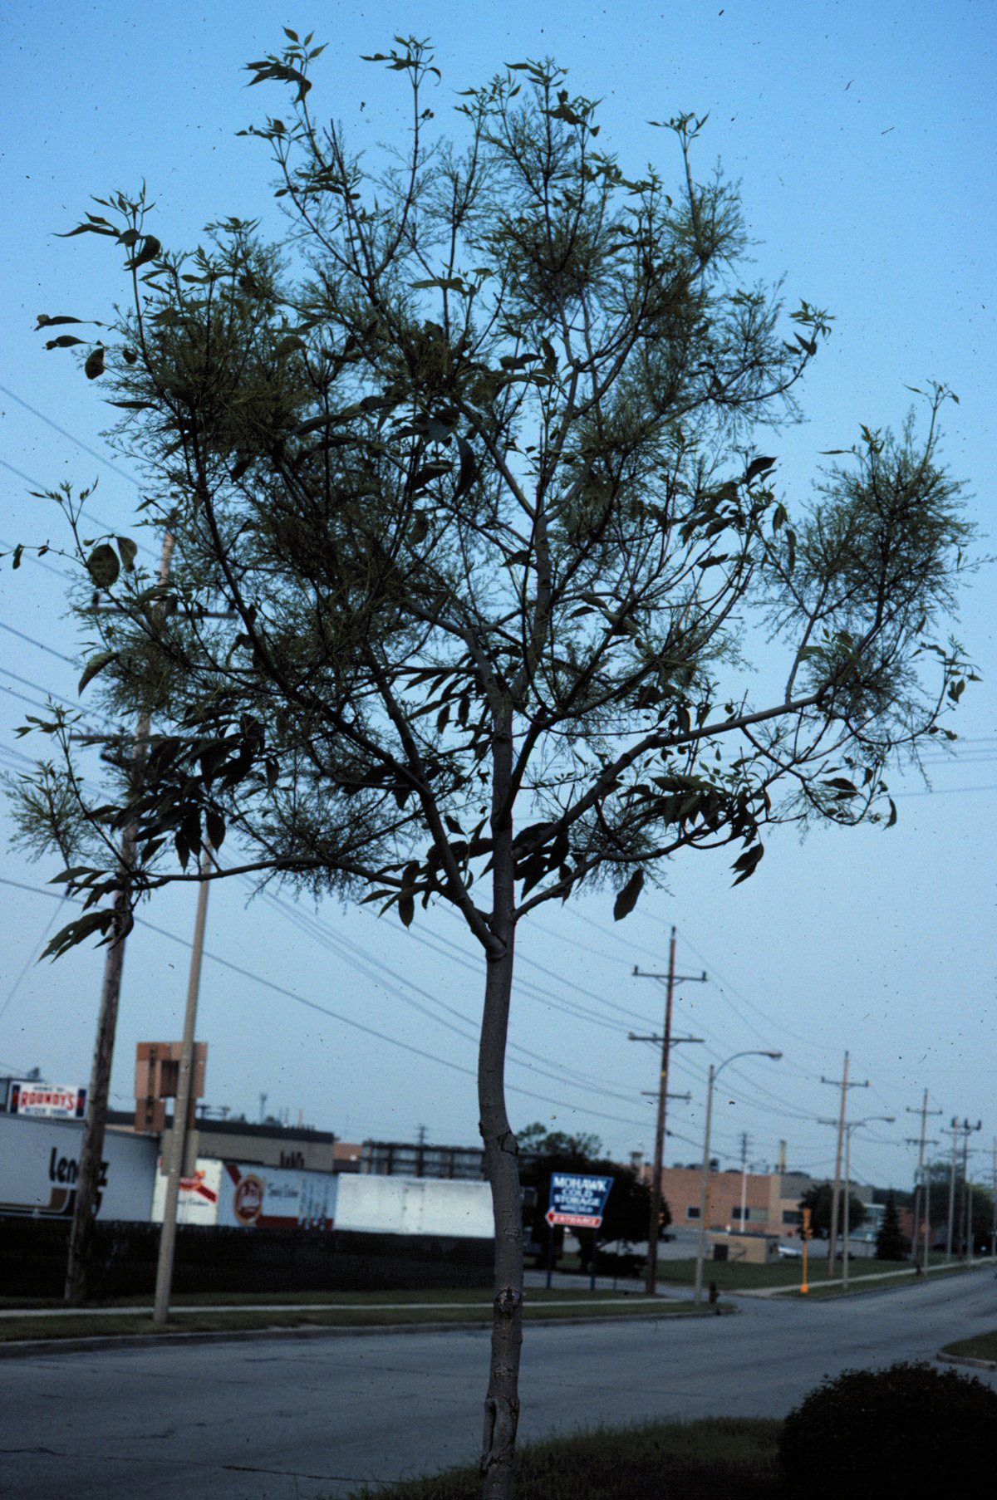
What is ash yellows? Ash yellows is a chronic, systemic disease that affects ash trees of all ages. White ash is particularly susceptible to ash yellows. Ash yellows likely occurs wherever ash is grown and has been reported widely in the United States and southern Canada. The organism that causes ash yellows also causes a disease called lilac witches’-broom.
Brooming symptoms in an ash tree caused by ash yellows.

What does ash yellows look like? Symptoms of ash yellows usually occur within three years of infection. Infected trees typically grow at a much slower rate than non-infected trees, although this may be difficult to detect in a single tree. The rate of growth of an infected tree may be as little as one half that of a healthy tree. Leaves on infected trees are frequently smaller, thinner and lighter green than usual. Often, but not always, affected trees will produce branches in tufts, a symptom that is called “brooming”. Eventually, branches in the crown will die and this die-back can continue until the entire crown is dead.

Where does ash yellows come from? Ash yellows is caused by the phytoplasma, Candidatus Phytoplasma fraxini. Phytoplasmas are bacteria-like organisms that live and survive in the phloem (i.e., the food-conducting tissue) of infected plants. Leafhoppers are thought to be the primary means by which this pathogen is moved from tree to tree.

How do I save a tree with ash yellows? There is no known cure for ash yellows, but some infected trees may live and grow slowly with the disease for many years. Ash trees suspected of having ash yellows should be tested for the disease, and those trees that test positive should be removed immediately to prevent spread of the ash yellows phytoplasma to other trees in the area. Wood harvested from infected trees does not serve as a source of the phytoplasma and can be used for woodworking or firewood, or chipped for mulch.

How do I avoid problems with ash yellows in the future? Avoid growing ash trees in areas where ash yellows is prevalent. When choosing a lilac, select a variety of common lilac as these varieties appear to have tolerance to the ash yellows phytoplasma. Avoid using S. josikaea, S. reticulata and S. sweginzowii, or hybrids of these species with either S. komarowii or S. villosa, as these lilacs appear to be highly susceptible. It is unclear if the use of insecticides (or other means) to control leafhoppers can help control the spread of this pathogen.
For more information on ash yellows and ash yellows testing: Contact your county Extension agent.

*Completed as partial fulfillment of the requirements for a BS in Plant Pathology at the University of Wisconsin Madison.

© 2001-2011 by the Board of Regents of the University of Wisconsin System doing business as the division of Cooperative Extension of the University of Wisconsin Extension.

Revised

Nov. 7, 2011

An EEO/Affirmative Action employer, University of Wisconsin Extension provides equal opportunities in employment and programming, including Title IX and ADA requirements. This document can be provided in an alternative format by calling Brian Hudelson at (608) 262-2863 (711 for Wisconsin Relay).

References to pesticide products in this publication are for your convenience and are not an endorsement or criticism of one product over similar products. You are responsible for using pesticides according to the manufacturer’s current label directions. Follow directions exactly to protect the environment and people from pesticide exposure. Failure to do so violates the law.

Thanks to Lis Friemoth, Ann Joy and Patti Nagai for reviewing this document.

A complete inventory of University of Wisconsin Garden Facts is available at the University of Wisconsin-Extension Horticulture website: http://hort.uwex.edu.

