
University of Wisconsin Garden Facts

Provided to you by:

XHT1089

Black Spot

Adrian Crabb* and Brian Hudelson, UW-Madison Plant Pathology

What is black spot? Black spot is a common and potentially serious leaf spot disease affecting many types of roses. Black spot is found wherever roses are grown.

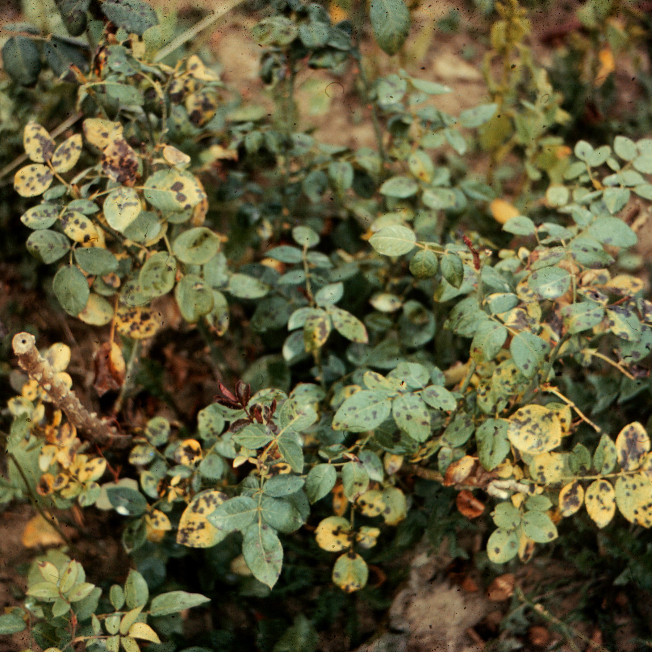
What does black spot look like? Black spot lesions (i.e., infected areas) are roughly circular and may be up to ½ inch in diameter. Lesions often have feathery margins, and are dark brown to black in color. Black spot initially appears during periods of wet weather when rose leaves are first emerging. The disease starts on lower leaves, but will spread to the entire plant. Severe black spot leads to yellowing of leaves and defoliation. Black spot can also develop on one-year old canes leading to raised, purplish-red blotches that blacken and blister.
Typical spotting and yellowing of rose leaves due to black spot.

Where does black spot come from? Black spot is caused by the fungus Diplocarpon rosae, which survives in rose leaf litter and in infected rose canes. Spores of the fungus are easily spread to newly emerging leaves by wind, or splashing rain.

How do I save a rose with black spot? If your rose has little or no defoliation, and dry weather prevails, then no treatment is necessary. If your rose has a history of severe black spot, and the weather is wet, consider applying preventative fungicide treatments. Fungicides containing chlorothalonil, copper sulfate, and myclobutanil can be highly effective in controlling black spot. Neem oil is another organic product (in addition to copper sulfate) that has been shown to provide some black spot control. Treat every seven to 14 days from bud break until wet weather subsides. DO NOT use the same active ingredient for all treatments. Instead, alternate the use of at least two active ingredients to help minimize problems with fungicide-resistant strains of the black spot pathogen. Be sure to read and follow all label instructions of the fungicide(s) that you select to ensure that you use the fungicide(s) in the safest and most effective manner possible.

How do I prevent problems with black spot in the future? Select rose varieties that are hardy in your area and that have a high level of black spot resistance. The hybrid shrub rose Rosa ‘Meipotal’ (Carefree Delight®), rugosa rose varieties such as ‘Blanc Double De Coubert’ and ‘Fru Dagmar Hastrup’, climbing roses such as Rosa × Kordesii ‘William Baffin’ and Rosa × Kordesii ‘Henry Kelsey’, and roses in the Knockout® series all have excellent resistance to black spot. Plant roses in a high light environment, and space shrubs far apart. This will promote good airflow and quick drying of foliage. Promptly remove diseased leaf litter. Prune diseased branches six to eight inches below any obvious infections. Prune only in dry weather. Disinfest pruning tools between cuts by dipping them for at least 30 seconds in a 10% bleach solution or alcohol (spray disinfectants that contain at least 70% alcohol can also be used). Water roses at the base using a soaker or drip hose to minimize wetting of leaves and reduce movement of spores of the black spot pathogen.
For more information on black spot of rose: See UW-Extension Bulletin A2531 (available at http://learningstore.uwex.edu) or contact your county Extension agent.

*Completed as partial fulfillment of the requirements for Plant Pathology 300 - Introduction to Plant Pathology at the University of Wisconsin Madison.

Revised

Dec. 14, 2011

© 2002-2011 by the Board of Regents of the University of Wisconsin System doing business as the division of Cooperative Extension of the University of Wisconsin Extension.

An EEO/Affirmative Action employer, University of Wisconsin Extension provides equal opportunities in employment and programming, including Title IX and ADA requirements. This document can be provided in an alternative format by calling Brian Hudelson at (608) 262-2863 (711 for Wisconsin Relay).

References to pesticide products in this publication are for your convenience and are not an endorsement or criticism of one product over similar products. You are responsible for using pesticides according to the manufacturer’s current label directions. Follow directions exactly to protect the environment and people from pesticide exposure. Failure to do so violates the law.

Thanks to Mike Maddox, Judy Reith-Rozelle and Ann Wied for reviewing this document.

A complete inventory of University of Wisconsin Garden Facts is available at the University of Wisconsin-Extension Horticulture website: http://hort.uwex.edu.

