
University of Wisconsin Garden Facts

Provided to you by:
XHT1009b

Cedar-Apple Rust
Brian Hudelson, UW-Madison Plant Pathology

What is cedar-apple rust? Cedar-apple rust is the name of a group of closely related diseases caused by fungi that infect both junipers and woody rosaceous plants such as apple, crabapple, hawthorn and quince.

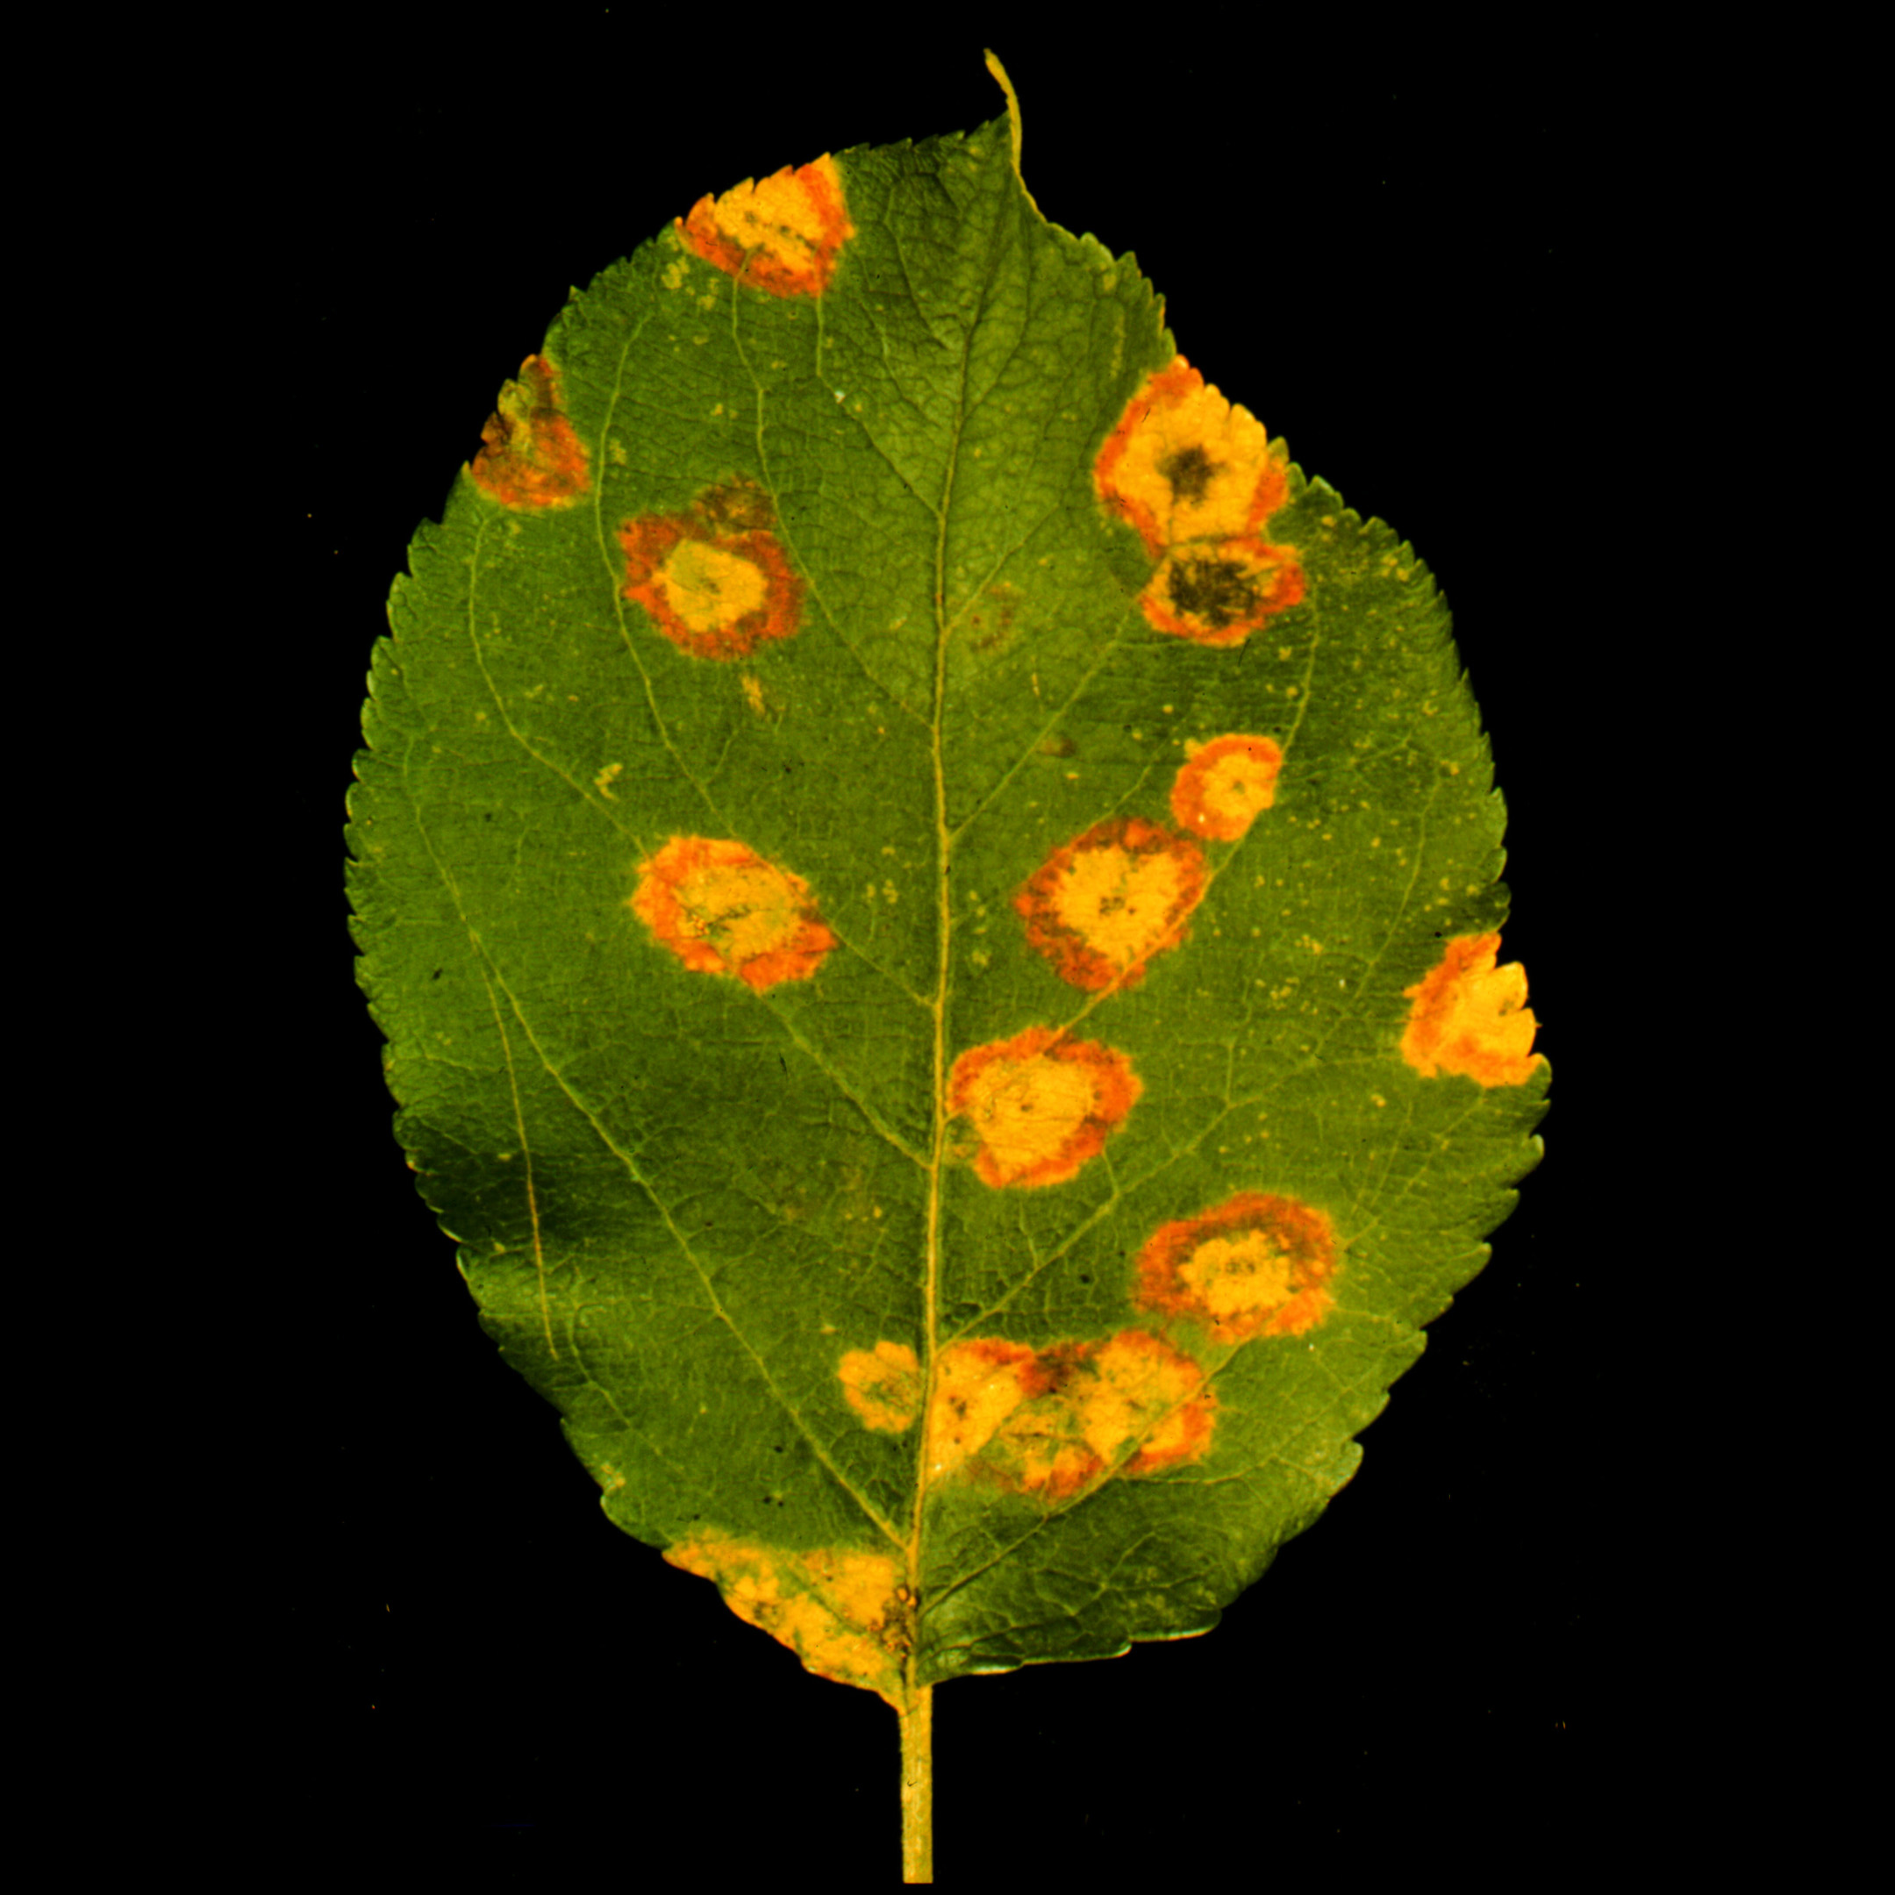
What does cedar-apple rust look like? On junipers, the cedar-apple rust fungus causes formation of irregularly-shaped brown galls (roughly ¹∕2 to two inches in diameter). During moist periods in spring, these galls produce a distinctive orange, gelatinous slime. Symptoms on rosaceous hosts appear in late May as circular, yellow-orange areas on leaves. The undersurfaces of these diseased areas often have a fringed appearance.
Circular, yellow-orange diseased areas typical of cedar-apple rust on apple.

Where does cedar-apple rust come from? Several fungi in the genus Gymnosporangium cause cedar-apple rust. These fungi overwinter as galls on junipers.

How do I save a tree or shrub with cedar-apple rust? Junipers can easily be treated for cedar-apple rust by pruning branches about four to six inches below the galls. Clean pruning shears between cuts by dipping them for at least 30 seconds in a 10% bleach solution or alcohol (spray disinfectants that contain at least 70% alcohol can also be used). This will prevent movement of the fungus from branch to branch, or from plant to plan during pruning. To prevent future infections, you can apply fungicides containing triadimefon or ferbam every seven to 21 days from early July through August. You can control cedar-apple rust on rosaceous hosts using fungicides containing chlorothalonil, ferbam, dithiocarbamates, mancozeb, metiram, sulfur, thiram, triadimefon, triforine, or zineb. Apply treatments when flower buds first show color, when half of the flowers are open, at petal-fall, seven to 10 days after petal fall and again 10 to 14 days later. Be sure to read and follow all label instructions of the fungicide that you select to insure that you use the fungicide in the safest and most effective manner possible.

How do I avoid problems with cedar-apple rust in the future? The best way to avoid cedar-apple rust is to plant trees and shrubs that are resistant to the disease. Check at your local nursery for resistant varieties of juniper, apple, crabapple, hawthorn, and quince that are available in your area and that will satisfy your landscaping needs.
For more information on cedar-apple rust: See UW-Extension Bulletins A2598 and A8KS711 or contact your county Extension agent.

© 1999 by the Board of Regents of the University of Wisconsin System doing business as the division of Cooperative Extension of the University of Wisconsin Extension.

An EEO/Affirmative Action employer, University of Wisconsin Extension provides equal opportunities in employment and programming, including Title IX and ADA requirements. This document can be provided in an alternative format by calling Brian Hudelson at (608) 262-2863 (711 for Wisconsin Relay).

Revised

May 29, 2005

References to pesticide products in this publication are for your convenience and are not an endorsement or criticism of one product over similar products. You are responsible for using pesticides according to the manufacturer’s current label directions. Follow directions exactly to protect the environment and people from pesticide exposure. Failure to do so violates the law.

Thanks to Laura Jull and Sharon Morrisey for reviewing this document.

A complete inventory of University of Wisconsin Garden Facts is available at the University of Wisconsin-Extension Horticulture website: wihort.uwex.edu.

