
University of Wisconsin Garden Facts

Provided to you by:
XHT1068

Cicadas
R. Chris Williamson, UW Turf and Ornamental Specialist

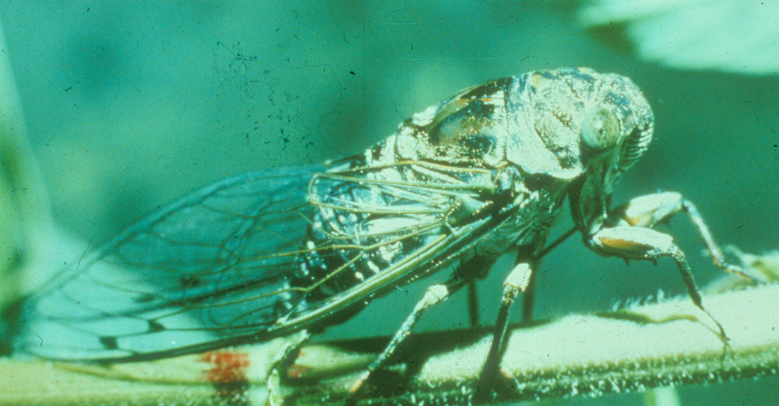
Adult periodical cicadas (Magicicada spp.) are black and have reddish-orange eyes and legs, and have clear wings with orange veins that are positioned over their bodies like a roof or canopy. Male cicadas typically make a loud buzzing noise or squawk when disturbed, often producing a deafening noise when synchronized with other males. Periodical cicadas emerge in specific locations once every 17 years in the northern part of their range and once every 13 years in the southern part. Different groups (called broods) emerge somewhere in the eastern United States nearly every spring, with numbers most abundant from mid-June through early July. The next adult emergence in Wisconsin is expected in 2007. To ensure survival and subsequent reproduction, massive brood emergence occurs, overwhelming predators such as birds.
Dog-day or annual cicada.

The “dog-day” or annual cicadas are considerably larger than periodical cicadas. They have greenish bodies with black markings, and their wings have green veins. Annual cicadas appear during the summer days of July and August. These cicadas have two to five year life cycles, and their broods often overlap at a given location, allowing some to appear every year.

Plants Attacked and Damage: More than 270 plant species have been reported as hosts for cicadas. Some of the tree species preferred by cicadas include apple, ash, beech, cherry, dogwood, hawthorn, hickory, magnolia, maple, oak, peach, and pear. In addition, preferred flowers, vines, and shrubs include arborvitae, black-eyed Susan, grape, hollies, junipers, raspberry, rhododendron, rose of Sharon, spirea, and viburnum.

Periodical cicadas can damage trees both above and below ground. The most obvious damage is caused when cicadas lay eggs on small twigs, leading to a splitting of twigs that eventually causes death to the branches. This injury is called “flagging”. Large, established trees can withstand considerable flagging. However, flagging can be very serious on young trees (< 4 years old), because these trees have many branches that are of a size (¹∕4 to ¹∕2 inch diameter) preferred by cicadas. Damage is also caused by immature cicadas (nymphs) that suck sap from the roots of plants. Prolonged feeding by nymphs may reduce plant growth and fruit production, and ultimately lead to death.

Cicadas do not bite readily or sting, and they have no known toxic chemicals that they release. However, they are considered a nuisance because of their abundance and loud, deafening noise.

Revised

Apr. 25, 2004

University of Wisconsin Garden Facts

Life Cycle: Periodical cicada nymphs develop underground, frequently damaging plant roots by sucking plant juices. After 13 or 17 years below ground, mature nymphs emerge from the soil at night and climb onto nearby vegetation where they pupate (i.e., transform into winged adults). As a result of this process, shed exoskeletons (i.e., outer skins) of cicadas can be readily found attached to trees. Cicada emergence is relatively synchronized, with most nymphs emerging within a few nights. Adult cicadas only live for about two to four weeks, and during this time they feed relatively little. Male cicadas “sing” by vibrating membranes on the ventral or underside of their abdomen. Females are incapable of generating sound. Male courtship songs attract females for mating. After mating, females lay their eggs in twigs ¹∕4 to ¹∕2 inch in diameter. Female cicadas slice into wood and deposit one to several dozen eggs in one branch. Eggs remain in twigs or branches for six to ten weeks before hatching. Upon hatching, ant-like nymphs fall to the ground where they burrow down six to 18 inches to feed on plant roots. As periodical cicadas emerge during the spring, they frequently build mud tubes that project three to five inches above the soil. Such tubes are commonly mistaken for tubes that crayfish construct. Annual cicadas typically emerge from June through August. However, their emergence is scattered throughout this period. Consequently, their emergence often goes unnoticed.

Control: There are several control options available for cicadas. If a periodical cicada emergence is anticipated, then postponing new plantings until late summer or fall, after the cicadas have died, may reduce the likelihood of egg laying and subsequent flagging. Young trees in yards or small orchards can be protected with nylon netting during the egg laying period. Netting should have a mesh size of no greater than ¹∕8 inch, and should be placed over the trees when males are first heard singing. Netting should be tied to the trunk beneath the lower branches, and may be removed after adult activity has ended. If egg laying cannot be avoided, eggs can be removed by pruning out and destroying young twigs in which the eggs have been laid. This control option must be implemented within a three week period after eggs have been laid.

Landscape plantings, nurseries, orchards, and yards should be monitored every two to three days during the cicada egg laying period to detect incoming females. Based on observed egg laying or branch flagging, insecticide sprays targeted against egg laying adults can be used and are typically effective. Because below-ground nymphs typically do not cause meaningful damage, soil applied insecticide applications are not suggested. However, if unacceptable levels of damage occur due to root-feeding, there are insecticides that are labeled, and may be applied, for control of nymphs.

For pesticide recommendations: See UW-Extension bulletin A3597, or contact your county Extension agent.

© 2000 by the Board of Regents of the University of Wisconsin System doing business as the division of Cooperative Extension of the University of Wisconsin Extension.

An EEO/Affirmative Action employer, University of Wisconsin Extension provides equal opportunities in employment and programming, including Title IX and ADA requirements. This document can be provided in an alternative format by calling Brian Hudelson at (608) 262-2863 (711 for Wisconsin Relay).

References to pesticide products in this publication are for your convenience and are not an endorsement or criticism of one product over similar products. You are responsible for using pesticides according to the manufacturer’s current label directions. Follow directions exactly to protect the environment and people from pesticide exposure. Failure to do so violates the law.

Thanks to Karen Delahaut and Phil Pellitteri for reviewing this document.

A complete inventory of University of Wisconsin Garden Facts is available at the University of Wisconsin-Extension Horticulture website: wihort.uwex.edu.

