
University of Wisconsin Garden Facts

Provided to you by:
XHT1161

Citronella Ants
Phil Pellitteri, UW Insect Diagnostic Lab

Citronella ants (Acanthomyops interjectus), also known as larger yellow ants, nest in moist soil along or under foundations. These ants feed on aphid honeydew and have no interest in human food. You may find Citronella ants when digging in the soil or when large numbers of winged reproductive forms of these ants (called swarmers) show up along cement walls or floors. Winged forms are most often seen in early spring (March and April) and in late September to October. They can be reddish to dark brown in color. Worker forms of Citronella ants are yellow to brownish-yellow in color. Citronella ants give off a distinctive lemon or citronella odor when crushed. The odor can be used to identify this species.
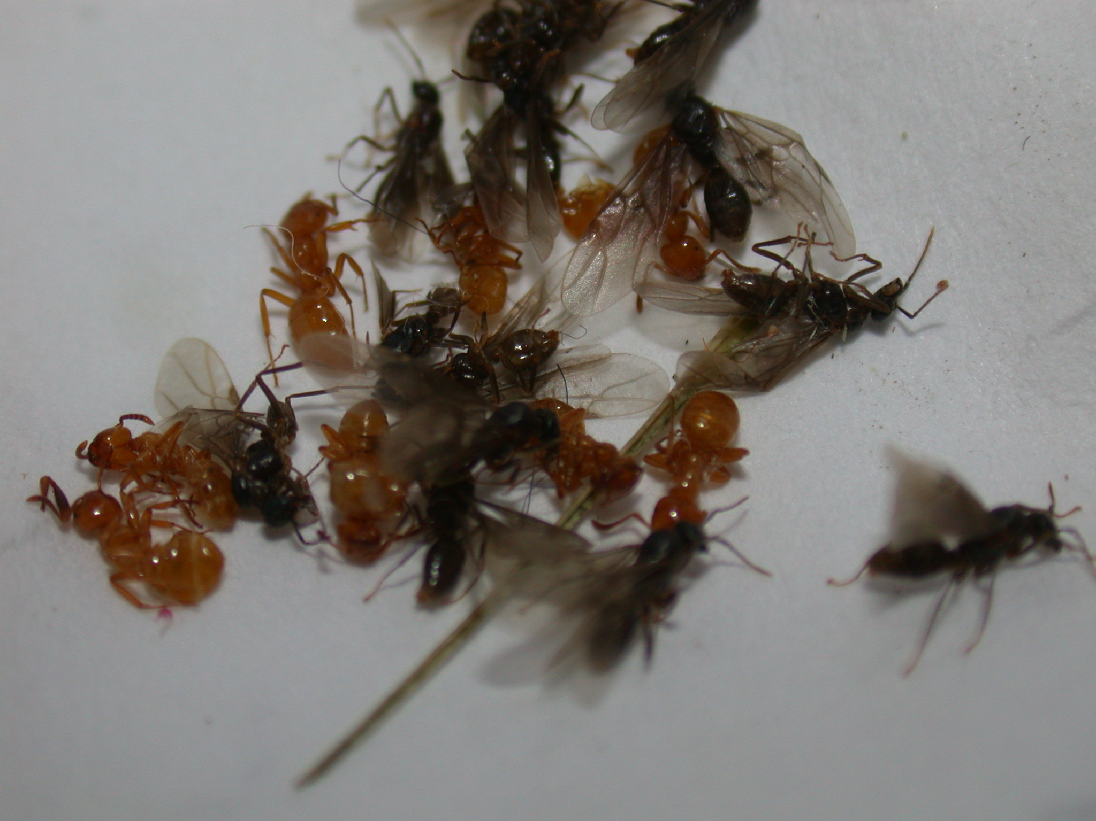
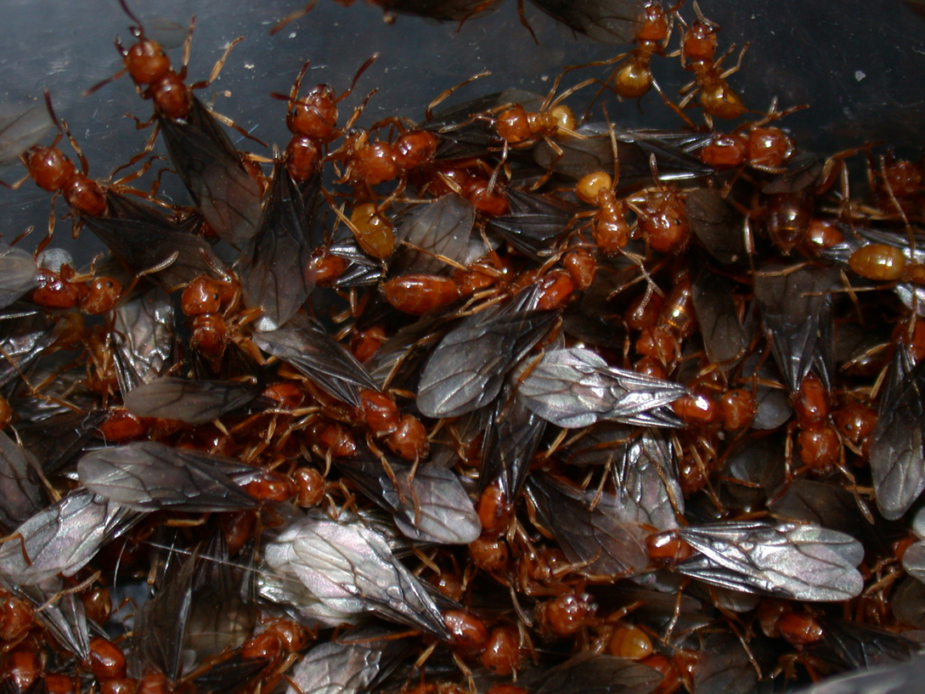
Control: Because Citronella ants are only a nuisance when they swarm, chemical controls are typically neither needed nor recommended. Citronella ants will not respond to normal ant baits. Outdoor nests can be drenched with landscape sprays, but such treatments are hard to justify. Because swarming only lasts for three to four days, the easiest and most environmentally friendly control method is to vacuum up winged forms as they appear. To prevent Citronella ants from entering your home, caulk or otherwise seal any cracks or openings that might serve as entry points.
Citronella ants. Reproductive ants or swarmers (left). Worker and winged ants (right).
For more information on Citronella ants: Contact your county Extension agent.

© 2008 by the Board of Regents of the University of Wisconsin System doing business as the division of Cooperative Extension of the University of Wisconsin Extension.

An EEO/Affirmative Action employer, University of Wisconsin Extension provides equal opportunities in employment and programming, including Title IX and ADA requirements. This document can be provided in an alternative format by calling Brian Hudelson at (608) 262-2863 (711 for Wisconsin Relay).

Revised

Jan. 29, 2008

References to pesticide products in this publication are for your convenience and are not an endorsement or criticism of one product over similar products. You are responsible for using pesticides according to the manufacturer’s current label directions. Follow directions exactly to protect the environment and people from pesticide exposure. Failure to do so violates the law.

Thanks to Steve Huntzicker, Deb Simons and Ann Wied for reviewing this document.

A complete inventory of University of Wisconsin Garden Facts is available at the University of Wisconsin-Extension Horticulture website: wihort.uwex.edu.
Citronella ants. Reproductive ants or swarmers (left). Worker and winged ants (right).

