
University of Wisconsin Garden Facts

Provided to you by:
XHT1170

Creeping Charlie
Susan Mahr and John Stier, UW Horticulture

What is creeping Charlie? Creeping Charlie (Glechoma hederacea) is an herbaceous perennial plant that spreads by seed and by creeping stems (called stolons) that grow along the ground. Creeping Charlie was introduced into North America from Europe by early settlers who thought it would be a good groundcover for shade. A variegated form of the plant is sometimes used in hanging baskets. Creeping Charlie is also known as ground ivy, gill-on-the-ground, and creeping Jenny.

What does creeping Charlie look like? Creeping Charlie produces bright green, round or kidney-shaped leaves that have scalloped edges. The leaves are produced opposite each other on square (i.e., four-sided), creeping stems that root at the nodes. In spring, small, bluish-purple, funnel-shaped flowers appear. When the plant is crushed, it produces a strong mint-like odor. Creeping Charlie is often confused with henbit (Lamium amplexicaule), which is a winter annual.

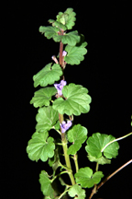
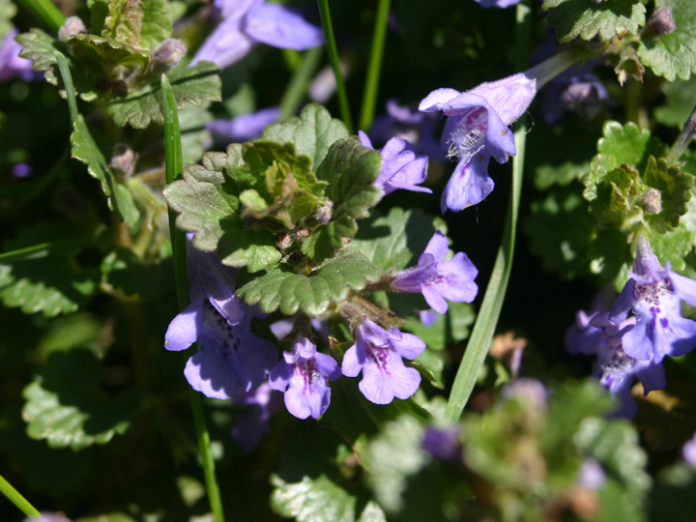
How can I control creeping Charlie? Creeping Charlie thrives in moist, shady spots such as under trees and shrubs, and along the north sides of buildings. Altering these moist, shady conditions can discourage growth of creeping Charlie. If possible, improve soil drainage or water less frequently to dry the soil, and prune trees to open the canopy and increase light levels. If creeping Charlie is invading a thin lawn, try to improve turf health and density to get weeds under control. This can be accomplished by mowing regularly (to a height of two to three and one-half inches), fertilizing and watering appropriately, and overseeding in the fall. Also, make sure to grow the most suitable type of turfgrass for the location (e.g., plant shade tolerant turfgrass varieties under trees). See University of Wisconsin-Extension Bulletin A3700 for additional information on lawn establishment and maintenance. Alternatively, consider removing grass and growing shade-loving plants such as vinca, English ivy, pachysandra or hosta that compete well with weeds.
Creeping Charlie produces kidney-shaped leaves with scalloped edges on creeping stems (left) and small, bluish-purple, funnel-shaped flowers (right).

In areas where creeping Charlie has become established, try removing plants by hand. This is the control method of choice in vegetable or flower gardens. However, this may not be a viable option in heavily infested areas, as the extensive spreading stems of creeping Charlie can be difficult to completely remove. Once plants are pulled, make sure to dispose of the plants in such a way that

Revised

Dec. 3, 2008

University of Wisconsin Garden Facts

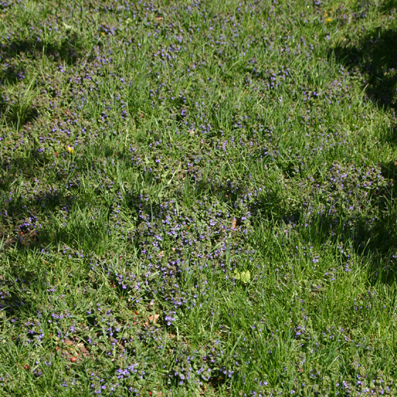
they cannot re-root. An alternative (and oftentimes more effective) means of controlling creeping Charlie is with a postemergence broadleaf herbicide. The best choice for homeowners is a weed killer that contains triclopyr. This active ingredient is found in many commercially available homeowner lawn care products, oftentimes in combination with other herbicides such as dicamba (3, 6-dichloro-o-anisic acid), 2,4-D (2, 4 dichlorophenoxyacetic acid) and mecoprop or MCPP [2-(2-methly-4-chlorophenoxy) propionic acid]. Products containing 2,4-DP can also provide adequate control. All of the products listed above can be used for treating lawns, but cannot be used in vegetable or flower gardens as many common vegetables and ornamentals are broadleaf plants that are very susceptible to these herbicides. In areas of a lawn with an extensive creeping Charlie infestation, it may be easier to use a broad-spectrum herbicide (e.g., glyphosate) to kill all of the vegetation in the area and then reseed the lawn.
Creeping Charlie rapidly invades lawns, crowding out and replacing turf.

When using an herbicide for creeping Charlie control, be sure to read and follow all label instructions of the product that you select to ensure that you use the product in the safest and most effective manner possible. A general rule of thumb is to make applications when temperatures are in the mid 60s to low 80s, there is no rain expected for 24 hours following application, and there is little or no wind. DO NOT mow the treated area for several days before and after an herbicide application.

Dicamba, triclopyr, MCPP, 2,4-D or 2,4-DP applications for creeping Charlie control should be made when plants are actively growing. A mid to late autumn herbicide application (after the first frost) is often particularly effective. During this period, plants are drawing nutrients from their leaves and into their roots for storage over the winter, and herbicides are more effectively moved into the roots as well, resulting in better control. A second application can be made in the fall if needed. Herbicide applications can also be made in the spring, but should be timed to correspond to creeping Charlie’s blooming period (typically April to June). Plants are more sensitive to herbicides during this time. Again, a second application may be necessary to obtain adequate control. Note that any herbicide containing dicamba should not be used in a given area more than twice per year.

Finally, borax has been touted as an organic control for creeping Charlie. However, research at both the University of Wisconsin and Iowa State University has shown that borax does not provide long-term control of creeping Charlie, and can injure turf and other plants, causing stunting and yellowing. Thus borax is not recommended for creeping Charlie (or other broadleaf weed) control.

For more information on creeping Charlie: Contact your county Extension agent.

© 2008 by the Board of Regents of the University of Wisconsin System doing business as the division of Cooperative Extension of the University of Wisconsin Extension.

An EEO/Affirmative Action employer, University of Wisconsin Extension provides equal opportunities in employment and programming, including Title IX and ADA requirements. This document can be provided in an alternative format by calling Brian Hudelson at (608) 262-2863 (711 for Wisconsin Relay).

References to pesticide products in this publication are for your convenience and are not an endorsement or criticism of one product over similar products. You are responsible for using pesticides according to the manufacturer’s current label directions. Follow directions exactly to protect the environment and people from pesticide exposure. Failure to do so violates the law.

Thanks to Mike Maddox, Patti Nagai and Eileen Nelson for reviewing this document.

A complete inventory of University of Wisconsin Garden Facts is available at the University of Wisconsin-Extension Horticulture website: wihort.uwex.edu.

