
University of Wisconsin Garden Facts

Provided to you by:
XHT1082

Invasive Plant Series

Dame’s Rocket
Lisa Johnson, Commercial Horticulture Agent, UW-Extension Milwaukee/Waukesha Counties

What is dame’s rocket? Dame’s rocket (Hesperis matronalis) is a Eurasian biennial belonging to the mustard family. It was introduced to North America in the 1600’s and has naturalized itself in moist, wooded areas, but can also invade open areas. It may be sold in garden centers as a perennial and is often included in “wildflower” seed mixes. The plant’s three-month-long blooming period and ability to set abundant seed have contributed to its spread, as well.

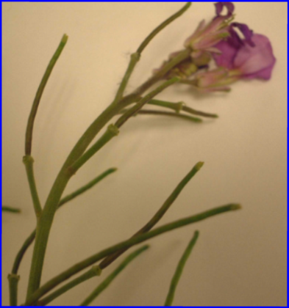
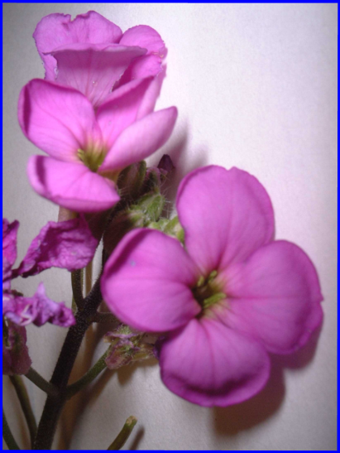
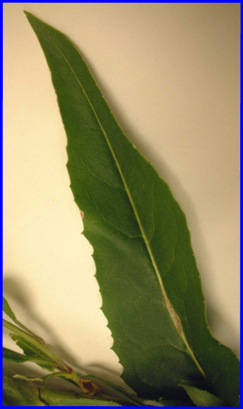
What does dame’s rocket look like? Dame’s rocket bears loose clusters of attractive, fragrant, pinkish-purple to white four-petaled flowers on 2 to 4 ft. stems. Flowers are produced from May–August, and the plant can produce seeds and flowers on any flower cluster at the same time. Leaves are slightly hairy and lance-shaped with toothed margins. Leaves are arranged alternately on the stem, and the basal rosette of leaves remains semi-evergreen through winter. The plants spend their first year as a rosette of basal leaves. They produce a flowering stem the second or third year, bloom, and then die. Seed pods are about 1¹∕2 inches long and very narrow. Dame’s rocket is often confused with garden phlox (Phlox paniculata), because the flower colors, clustered blooms and bloom time are similar. However, garden phlox has flowers with five petals (dame’s rocket has four) and opposite, untoothed leaves (dame’s rocket has alternate, toothed leaves).
Dame’s rocket seed pods.
Dame’s rocket flowers
(enlarged).
Dame’s rocket leaf.

How can I control dame’s rocket? Check any “wildflower” seed packets you may purchase to ensure that they do not contain dame’s rocket seeds. You can cut the flower heads off established plants after bloom so the plants do not set seed, or hand pull the plants. If plants are pulled while in bloom, do not compost them, as the seeds can still ripen and spread. Bag the plants for landfilling, or burn them. Do not allow the plants to dry before burning, as seedpods may burst open and spread seeds when dried. If appropriate, burn infested areas where allowed. Finally, glyphosate-containing herbicides can be applied in late fall when native plants are dormant, but the dame’s rocket basal leaf rosettes are still green and vulnerable to sprays. Avoid getting the herbicide on other plants. Repeat control measures for a few years until seeds in the soil are depleted.
For more information on dame’s rocket: See the DNR publication ER-090-97 - “Wisconsin Manual of Control recommendations for Ecologically Invasive Plants”, or contact your county Extension agent.

© 2001 by the Board of Regents of the University of Wisconsin System doing business as the division of Cooperative Extension of the University of Wisconsin Extension.

Revised

April 27, 2004
An EEO/Affirmative Action employer, University of Wisconsin Extension provides equal opportunities in employment and programming, including Title IX and ADA requirements. This document can be provided in an alternative format by calling Brian Hudelson at (608) 262-2863 (711 for Wisconsin Relay).

References to pesticide products in this publication are for your convenience and are not an endorsement or criticism of one product over similar products. You are responsible for using pesticides according to the manufacturer’s current label directions. Follow directions exactly to protect the environment and people from pesticide exposure. Failure to do so violates the law.

Thanks to Sharon Morrisey, Patti Nagai and Ann Wied for reviewing this document.

A complete inventory of University of Wisconsin Garden Facts is available at the University of Wisconsin-Extension Horticulture website: wihort.uwex.edu.

