
University of Wisconsin Garden Facts

Provided to you by:

XHT1087

Degree Days for Common
Fruit and Vegetable Insect Pests
Karen Delahaut, UW-Madison Fresh Market Vegetable Program

Common vegetable insects that can be monitored
using degree days or indicator plants

Cabbage Maggot
Base temperature = 43ºF
300, 1476, 2652 DD₄₃ for 1st, 2nd, & 3rd generations flies
1st generation eggs are laid when the common lilac is in full bloom

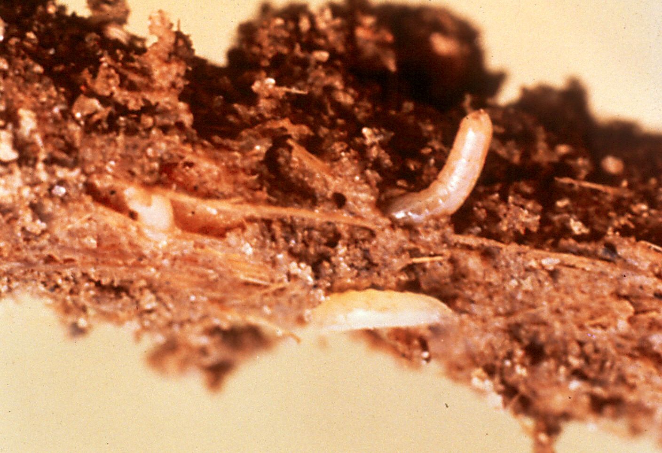

Colorado potato beetle, 1st generation
Base temperature = 50ºF
Begin counting when first eggs appear
1st instar larva at 185 DD₅₀
2nd instar larva at 240 DD₅₀
3rd instar larva at 300 DD₅₀
4th instar larva at 400 DD₅₀
Pupa at 675 DD₅₀

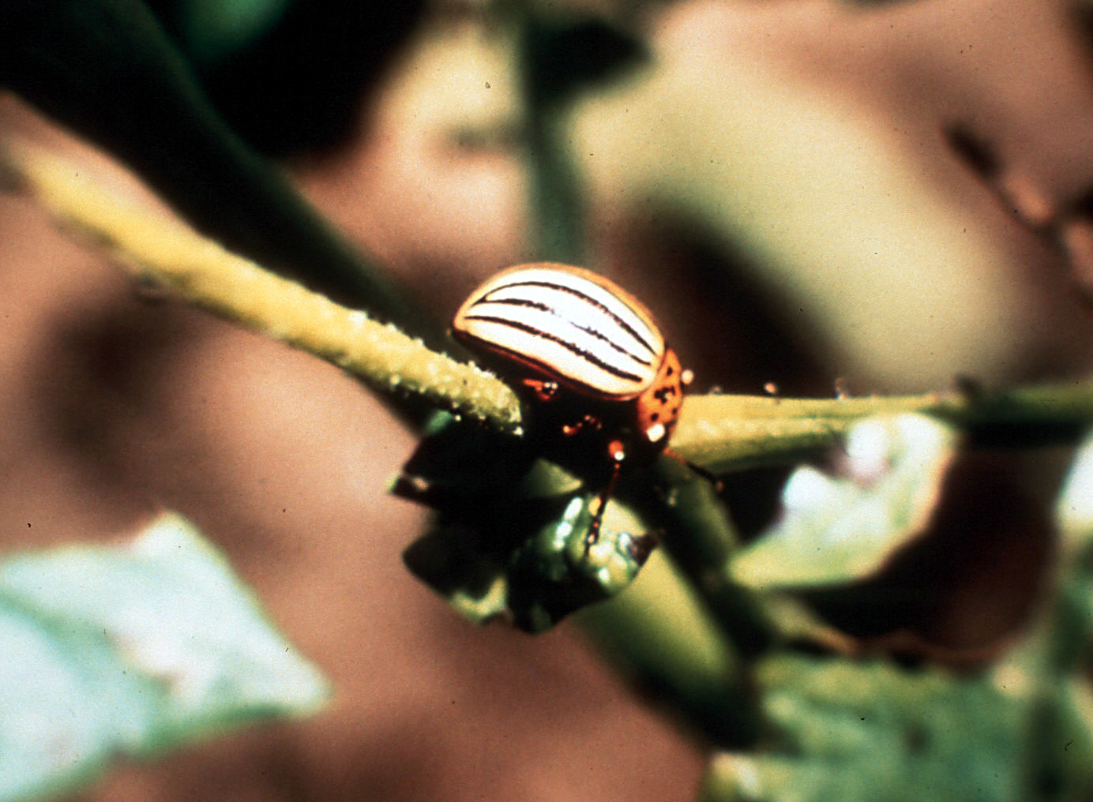

Common Asparagus Beetle
Base temperature = 50ºF
Egg laying at 150 – 240 DD₅₀
(Amelanchier full bloom, redbud early to full bloom, Black Hills spruce bud caps splitting)

Corn Rootworm
Base temperature = 50ºF
Adult beetles present at 1300 DD₅₀
(Canada thistle seed ripe, Queen Anne’s lace early bloom)

Revised

Apr. 20, 2005

European Corn Borer
Base temperature = 50ºF
1st spring moths at 375 DD₅₀
(Spiraea x vanhouttei in full bloom)
1st eggs at 450 DD₅₀
(Pagoda dogwood late bloom)
Peak spring moths at 631 DD₅₀
(Black locust full bloom)
1st summer moths at 1400 DD₅₀
(Mountain-ash fruit golden yellow, most Canada thistle seed ripe)
1st eggs at 1450 DD₅₀
1st egg hatch at 1550 DD₅₀
Peak summer moths at 1733 DD₅₀
Summer treatment period at 1550 – 2100 DD₅₀
(Queen Anne’s lace full bloom – 1500 to goldenrod early bloom – 2100)

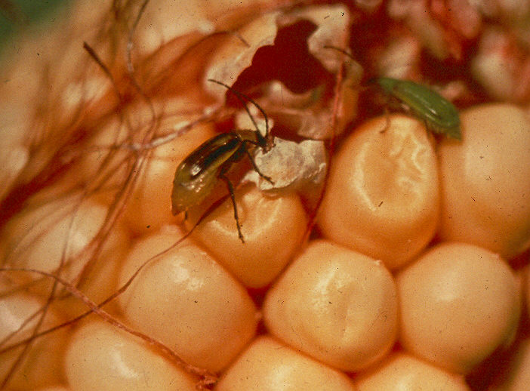

Fleabeetles
Base temperature = 50ºF
150-200 DD₅₀
(Norway maple late bloom, Amelanchier blooming, redbud early bloom)

Imported Cabbageworm
Base temperature = 50ºF
Adult butterflies at 150-240 DD₅₀
(Amelanchier full bloom, redbud early to full bloom, Black Hills spruce bud caps splitting)

Onion Maggots
Base temperature = 40ºF
680, 1950, 3230 DD₄₀ for 1st, 2nd, & 3rd generation flies
1st generation eggs laid 230-280 DD₄₀

University of Wisconsin Garden Facts

Squash Vine Borer
Base temperature = 50ºF
Egg laying at 900-1000 DD₅₀
(Chicory full bloom)

Seed Corn Maggot
Base temperature = 39ºF
200, 600 for 1st and 2nd generation flies

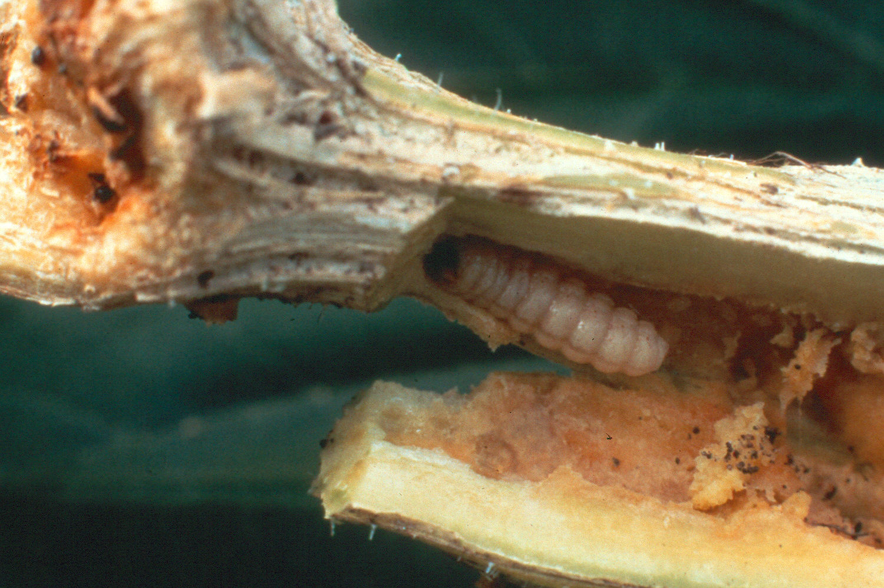

Common fruit insects that can be monitored
using degree days or indicator plants

Apple Maggot*
Base temperature = 50ºF
1st adult fly emergence 900 DD₅₀
1st egg laying 1100 DD₅₀
Peak fly emergence 1600 DD₅₀
Peak egg laying 1750 DD₅₀
End of fly emergence 2800 DD₅₀

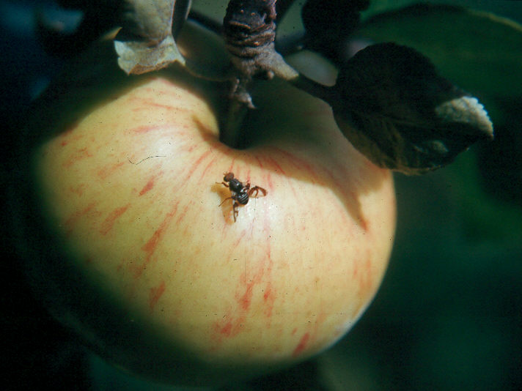

* These degree days assume normal soil moisture. Under dry conditions, all apple maggot events will be delayed until the soil is moist.

For more information on phenology: See University of Wisconsin Garden Facts XHT1085, XHT1086 and XHT1088, or contact your county Extension agent.

Codling Moth
Base temperature = 50ºF
1st generation moth emergence 150 DD₅₀
Eggs laid 250 DD₅₀
1st generation peak moth emergence 500 DD₅₀
Peak egg laying 550 DD₅₀
2nd generation first moth emergence 1150 DD₅₀
2nd generation peak moth emergence 1600 DD₅₀
2nd generation peak egg laying 1700 DD₅₀

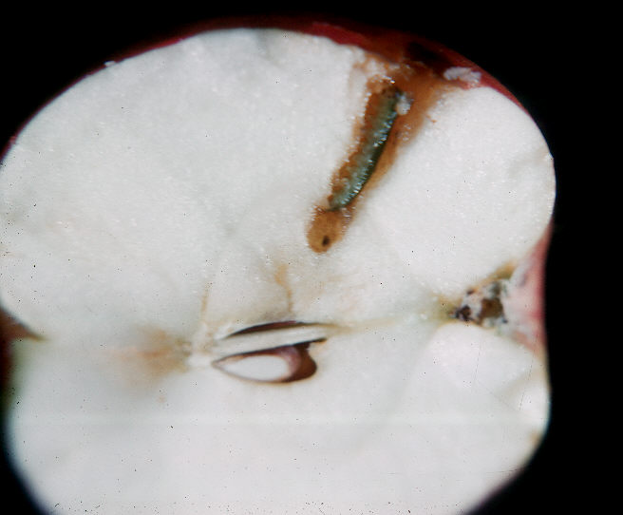

Obliquebanded Leafroller
Base temperature = 43ºF
1st generation moth emergence 600 DD₄₃
1st generation peak moth emergence 800 DD₄₃
1st generation peak egg laying 1250 DD₄₃
2nd generation moth emergence 2050 DD₄₃
2nd generation first eggs laid 2300 DD₄₃

© 2002 by the Board of Regents of the University of Wisconsin System doing business as the division of Cooperative Extension of the University of Wisconsin Extension.

An EEO/Affirmative Action employer, University of Wisconsin Extension provides equal opportunities in employment and programming, including Title IX and ADA requirements. This document can be provided in an alternative format by calling Brian Hudelson at (608) 262-2863 (711 for Wisconsin Relay).

References to pesticide products in this publication are for your convenience and are not an endorsement or criticism of one product over similar products. You are responsible for using pesticides according to the manufacturer’s current label directions. Follow directions exactly to protect the environment and people from pesticide exposure. Failure to do so violates the law.

Thanks to Michelle Miller and Susan Mahr for reviewing this document.

A complete inventory of University of Wisconsin Garden Facts is available at the University of Wisconsin-Extension Horticulture website: wihort.uwex.edu.

