
University of Wisconsin Garden Facts

Provided to you by:

XHT1077

Downy Mildew
Jim Olis* and Brian Hudelson, UW-Madison Plant Pathology

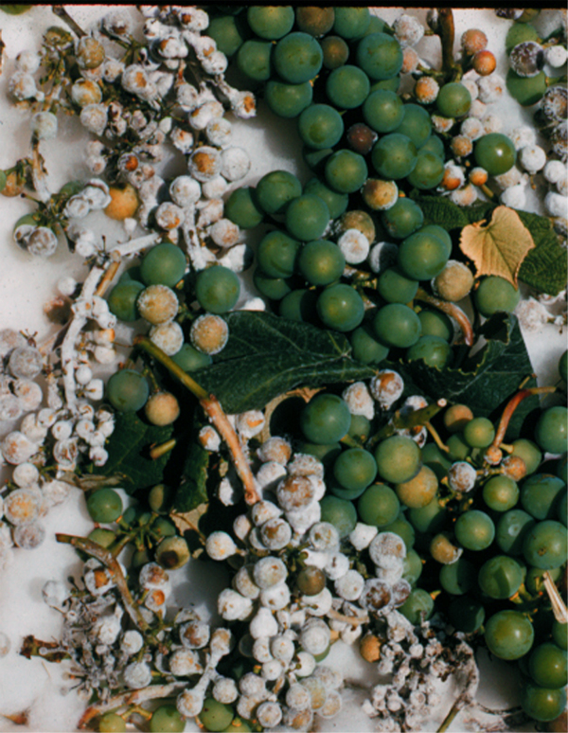
What is downy mildew? The downy mildews are a group of fungal diseases that cause destruction of the leaves, stems, flowers and fruits of many plant species worldwide. In Wisconsin, downy mildews are common on grapes, cucumbers, roses and Viburnum.
Downy mildew can cause severe losses in regions where grapes are produced.

What does downy mildew look like? Downy mildew symptoms begin as small, green or yellow, translucent spots that can eventually spread to an entire leaf, stem, flower or fruit. Infected plant parts may eventually brown or bronze. The causal fungus appears on infected stems, flowers and fruits, and on undersurfaces of infected leaves, as a downy, gray-white fuzz. Microscopic examination of this fuzz is necessary to confirm a downy mildew diagnosis.

Where does downy mildew come from? Downy mildew is caused by several closely related fungi (e.g., Peronospora spp., Plasmopara spp. and Pseudoperonospora spp.) that survive in plant debris or on infected plants. Downy mildew fungi are fairly host specific. The downy mildew fungus that infects one type of plant (e.g., rose) is not the same downy mildew fungus that infects another (e.g., grape). However, if you see downy mildew on one plant, then environmental conditions (i.e., cool, wet weather) are favorable for development of downy mildews on a wide range of plants.

How do I save a plant with downy mildew? Downy mildews can be controlled using fungicides. Those containing chlorothalonil, copper sulfate and lime (e.g., Bordeaux mix), fosetyl-Al, mancozeb, metalaxyl, mefenoxam, or trifloxystrobin are labeled for downy mildew control. Be sure to read and follow all label instructions of the fungicide that you select to insure that you use the fungicide in the safest and most effective manner possible.

How do I avoid problems with downy mildew in the future? Consider buying downy mildew resistant varieties, when available. In new plantings, space plants far apart. In established plantings, prune or thin plants to increase airflow. This will reduce humidity and promote rapid drying of foliage. Avoid overhead watering and apply water directly to the soil at the base of your plants. At the end of the growing season, remove and destroy infected plant debris as this can serve as a source of spores for the next growing season.
For more information on downy mildew: See UW-Extension Bulletin A2129, or contact your county Extension agent.

*Completed as partial fulfillment of the requirements for a BS in Plant Pathology at the University of Wisconsin Madison.

© 2001 by the Board of Regents of the University of Wisconsin System doing business as the division of Cooperative Extension of the University of Wisconsin Extension.

Revised

June 7, 2009

An EEO/Affirmative Action employer, University of Wisconsin Extension provides equal opportunities in employment and programming, including Title IX and ADA requirements. This document can be provided in an alternative format by calling Brian Hudelson at (608) 262-2863 (711 for Wisconsin Relay).

References to pesticide products in this publication are for your convenience and are not an endorsement or criticism of one product over similar products. You are responsible for using pesticides according to the manufacturer’s current label directions. Follow directions exactly to protect the environment and people from pesticide exposure. Failure to do so violates the law.

Thanks to Lisa Johnson, Ann Joy and Kristin Kleeberger for reviewing this document.

A complete inventory of University of Wisconsin Garden Facts is available at the University of Wisconsin-Extension Horticulture website: wihort.uwex.edu.

