
University of Wisconsin Garden Facts

Provided to you by:

XHT1081

Invasive Plant Series

Garlic Mustard
Lisa Johnson, Commercial Horticulture Agent, UW-Extension Milwaukee/Waukesha Counties

What is garlic mustard? Garlic mustard (Alliaria petiolata) is a European woodland plant introduced to North America by early settlers for its culinary and alleged medicinal qualities. In North America, European insects and diseases that control the plant’s population are not present. Garlic mustard starts growing earlier in the season than our native plants, and outcompetes them. It also produces large quantities of seed. For these reasons, garlic mustard spreads rapidly in wooded areas, forming tall, dense stands that smother native wildflowers, and native tree and shrub seedlings. It can overrun a forest floor in a few years, destroying a previously healthy ecosystem by eliminating many plant species. In addition, animals, birds and insects that depended on a diversity of plant species for food and shelter can then no longer live in the infested area.

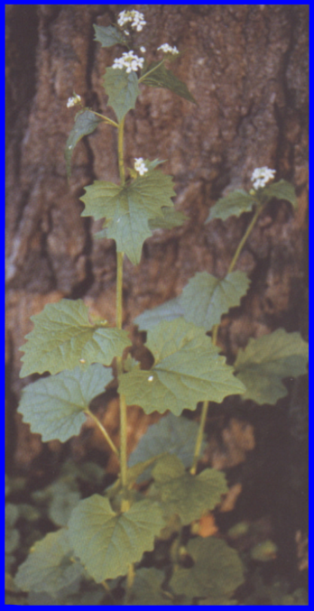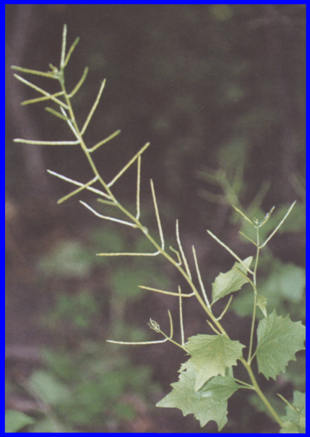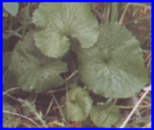
Garlic mustard: First year rosette (left), second year plant with flowers (middle), and mature plant with seed pods (right).

What does garlic mustard look like? Garlic mustard is a biennial plant with a two-year life cycle. The first year, it forms a rosette of round, scalloped-margined leaves that stay semi-evergreen through winter. The second year, it sends up a flower stem with triangular toothed leaves that bears tiny white flowers with four petals. The plant dies after producing long narrow seedpods. At maturity, garlic mustard plants may be 3 to 4 ft. tall and bear up to 500 seeds per plant.

How can I control garlic mustard? Repeat any control method for several years since garlic mustard seeds can survive in the soil for up to 7 years. Hand-pull small infestations, but do not compost the plants because most compost piles do not get hot enough to kill the seeds. Dispose of pulled plants by burying deeply in an area that will not be disturbed, or landfilling. Call the Bureau of Endangered Resources at 608-266-7012 if you need permission to landfill garlic mustard. To burn collected plants, burn them while still moist, because dried garlic mustard seedpods can burst open and spread the seed. If you use an herbicide, spray early in spring or late in fall, because our native plants are dormant at these times, but garlic mustard is still green and vulnerable to sprays. A 1-2% solution of a glyphosate-containing herbicide is very effective. Glyphosate is a nonselective herbicide, so avoid spraying nontarget plants. Read and follow all label directions on the herbicide product. Encourage your community to scout for garlic mustard in your area and remove it, if found.
For more information on garlic mustard: See UW-Extension brochure #2000 - “Garlic Mustard, a Major Threat to Wisconsin’s Woodlands”, or contact your county Extension agent.

© 2001 by the Board of Regents of the University of Wisconsin System doing business as the division of Cooperative Extension of the University of Wisconsin Extension. This fact sheet is based on UW-Extension brochure #2000 written by Paul Hartman, UW-Extension Brown County. Left photo courtesy of Laurie Weiss, middle and right photos courtesy of Elizabeth J. Czarapata.

Revised

Apr. 27, 2004
An EEO/Affirmative Action employer, University of Wisconsin Extension provides equal opportunities in employment and programming, including Title IX and ADA requirements. This document can be provided in an alternative format by calling Brian Hudelson at (608) 262-2863 (711 for Wisconsin Relay).

References to pesticide products in this publication are for your convenience and are not an endorsement or criticism of one product over similar products. You are responsible for using pesticides according to the manufacturer’s current label directions. Follow directions exactly to protect the environment and people from pesticide exposure. Failure to do so violates the law.

Thanks to Brian Hudelson, Kristin Kleeberger, Laura Jull, Ann Wied and Paul Hartman for reviewing this document.

A complete inventory of University of Wisconsin Garden Facts is available at the University of Wisconsin-Extension Horticulture website: wihort.uwex.edu.

