
University of Wisconsin Garden Facts

Provided to you by:
XHT1018

Grub Control in Home Lawns
R. Chris Williamson, UW Turf and Ornamental Specialist
M. J. Ballweg, UW-Extension Sheboygan County

Listed below are trade names and common chemical names of insecticides available to homeowners for controlling white grubs in lawns.

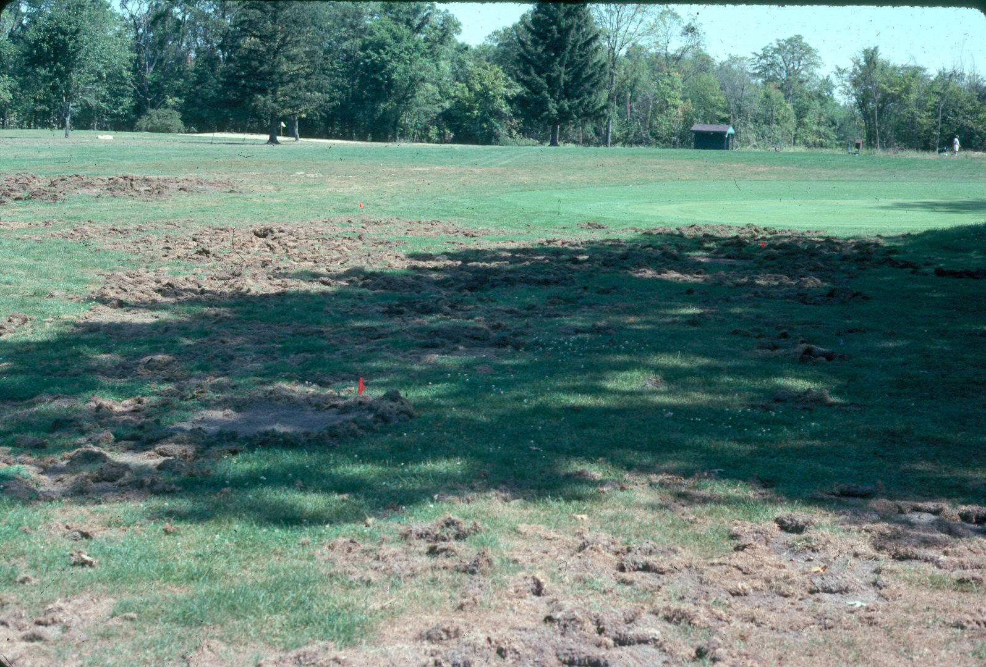
White grub damage.

Preventative Control Products

Due to the development of new and improved insecticide chemistries, season-long residual or “preventive” controls of white grubs are now available, and are becoming the preferred management strategy. Preventative control strategies require insecticide application prior to egg lay or hatch. Timing varies depending on grub species: May/June beetle; late-May – early-June, and Japanese beetle; late-June – late-July.

Preventative Control Products
Trade Name | Company | Common  Chemical Name | Overall Toxicity | Application Timing
Season-Long Grub Control | Bayer Advanced Lawn | Imidacloprid | Low | Late-May – Late July
GrubEx | Scotts | halofenozide | Low | Late-May – Late July

Applications of preventative control products should not be made after August 1st!

Revised

Apr. 25, 2004

University of Wisconsin Garden Facts

Curative Control Products

The curative control approach entails applying a control product when grubs are present, active, and causing measurable damage. Insecticides should be applied when grubs are feeding in the root zone. However, greater control can be attained if the insecticide is applied to smaller or younger grubs – usually in July for May/June beetles, or August for Japanese beetles.

Curative Control Products
Trade Name | Company | Common Chemical Name | Overall Toxicity | Application Timing
24 Hour Grub Killer | Bayer | trichlorfon | Low | Mid-May – Early October
Sevin | Numerous | carbaryl | Low | Mid-May – Early October
Diazinon | Numerous | diazinon | High | No longer recommended.
Dursban | Numerous | chlorpyrifos | High | No longer recommended

Remember that grubs feed in the root zone. Thus the control product must reach them in order to be effective. Therefore, regardless of insecticide brand or formulation, you must water the insecticide into the root zone to achieve maximum effectiveness. Apply at least ¹∕2 inch of irrigation or rainfall on sandy soils, and up to ³∕4 inch on heavier clay soils. Apply water within 24 hours after application to get the most benefit from insecticides. For spray formulations, wash spray off grass plants and into the soil before the spray dries. Liquid formulations of some products have shown greater efficiency.

For more information on May/June beetles and Japanese beetles: See UW-Extension bulletins A3275 and A3714, and UW-Extension Garden Facts X1062, or contact your county Extension agent.

© 2001 by the Board of Regents of the University of Wisconsin System doing business as the division of Cooperative Extension of the University of Wisconsin Extension.

An EEO/Affirmative Action employer, University of Wisconsin Extension provides equal opportunities in employment and programming, including Title IX and ADA requirements. This document can be provided in an alternative format by calling Brian Hudelson at (608) 262-2863 (711 for Wisconsin Relay).

References to pesticide products in this publication are for your convenience and are not an endorsement or criticism of one product over similar products. You are responsible for using pesticides according to the manufacturer’s current label directions. Follow directions exactly to protect the environment and people from pesticide exposure. Failure to do so violates the law.

A complete inventory of University of Wisconsin Garden Facts is available at the University of Wisconsin-Extension Horticulture website: wihort.uwex.edu.

