
University of Wisconsin Garden Facts

Provided to you by:
XHT1123

Guignardia Leaf Spot
Brian Hudelson, UW-Madison Plant Pathology

What is Guignardia leaf spot? Guignardia leaf spot is a common fungal leaf spot that affects vining plants such as Boston ivy and Virginia-creeper. The pathogen that causes Guignardia leaf spot also causes a leaf spot and fruit rot of grape called black rot.

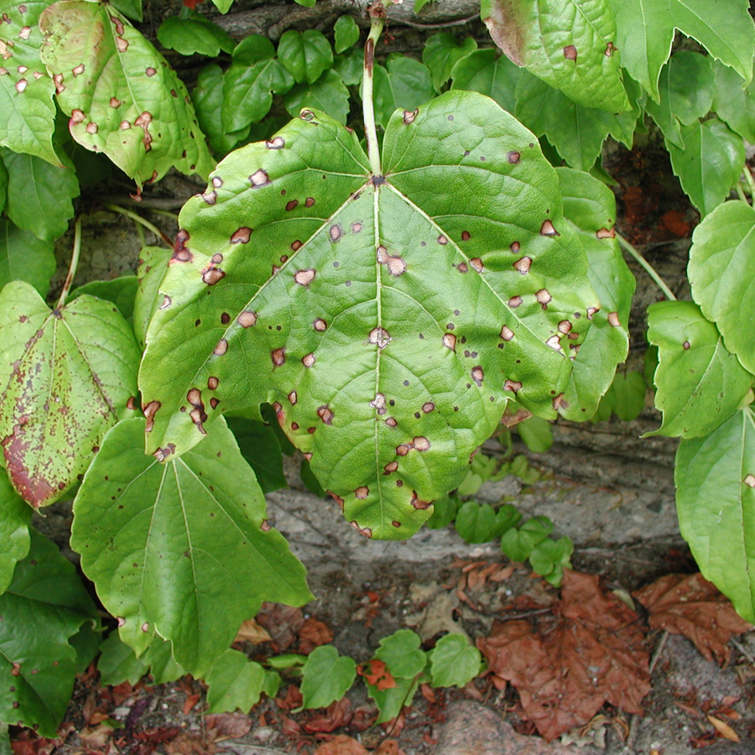
What does Guignardia leaf spot look like? Symptoms of Guignardia leaf spot include roughly circular, or sometimes angular, ¼ to ½ inch diameter dead spots on affected leaves. Spots often have a purple-red border, and the centers may eventually fall out. Young leaves are more susceptible to infection than mature leaves. If infections occur before leaves fully expand, leaves can become puckered and distorted. Within individual leaf spots, a diffuse ring of black dots (reproductive structures of the pathogen) is typically visible.
Roughly circular, red-bordered spots on Boston ivy typical of Guignardia leaf spot.

Where does Guignardia leaf spot come from? Guignardia leaf spot is caused by the fungus Guignardia bidwellii, which survives in leaf litter. Spores of the fungus are produced under cool, moist conditions and can be dispersed by wind or splashing water.

How do I save a plant with Guignardia leaf spot? DO NOT panic! Guignardia leaf spot is most often a cosmetic disease, making an affected plant look a little ragged, but not killing the plant. Only occasionally will the disease be more severe, and defoliation may result.

How do I avoid problems with Guignardia leaf spot in the future? Remove and discard fallen, infected leaves. Thin affected plants to increase airflow and promote rapid drying of foliage. Water plants at the base using a soaker or drip hose to minimize wetting of leaves and reduce movement of spores of Guignardia bidwellii. If a plant has been severely defoliated by Guignardia leaf spot for several years, preventative fungicide treatments may be necessary. Make an initial fungicide application as leaves first begin to emerge. If the weather is cool and wet, make additional applications at seven to 14 day intervals until hotter, drier weather develops or until leaves are fully expanded and mature. For each application, use a broad-spectrum fungicide such as one containing chlorothalonil, copper, mancozeb or thiophanate-methyl, but DO NOT use the same active ingredient for all treatments. Instead, alternate the use of at least two active ingredients. This strategy will help minimize problems with fungicide-resistant strains of Guignardia bidwellii. Be sure to read and follow all label instructions of the fungicide(s) that you select to ensure that you use the fungicide(s) in the safest and most effective manner possible.
For more information on Guignardia leaf spot: Contact your county Extension agent.

© 2003-2011 by the Board of Regents of the University of Wisconsin System doing business as the division of Cooperative Extension of the University of Wisconsin Extension.

Revised

Apr. 28, 2012
An EEO/Affirmative Action employer, University of Wisconsin Extension provides equal opportunities in employment and programming, including Title IX and ADA requirements. This document can be provided in an alternative format by calling Brian Hudelson at (608) 262-2863 (711 for Wisconsin Relay).

References to pesticide products in this publication are for your convenience and are not an endorsement or criticism of one product over similar products. You are responsible for using pesticides according to the manufacturer’s current label directions. Follow directions exactly to protect the environment and people from pesticide exposure. Failure to do so violates the law.

Thanks to Lisa Johnson, Ann Joy and Patti Nagai for reviewing this document.

A complete inventory of University of Wisconsin Garden Facts is available at the University of Wisconsin-Extension Horticulture website: http://hort.uwex.edu.

