
University of Wisconsin Garden Facts

Provided to you by:
XHT1165

Lantana
Susan Mahr, UW Horticulture

What is lantana? The genus Lantana (also commonly known as lantana) includes more than 150 species of hairy-leaved and often prickly-stemmed shrubs and herbaceous perennials in the verbena family (Verbenaceae). These plants are native to the tropical Americas and most are hardy only to USDA cold hardiness zone 8. Spanish colonists were interested in lantanas for their reputed medicinal value, using them to make infusions as a tonic for the stomach or to cure snake bites. Today, lantanas are prized for their long-stalked, flat-topped clusters of small, colorful, tubular blossoms that are attractive to butterflies. If successfully pollinated (a rare occurrence in Wisconsin), lantana flowers produce fleshy, berry-like green fruits that turn bluish-black. Lantanas are plants that tend to be avoided by deer and rabbits.

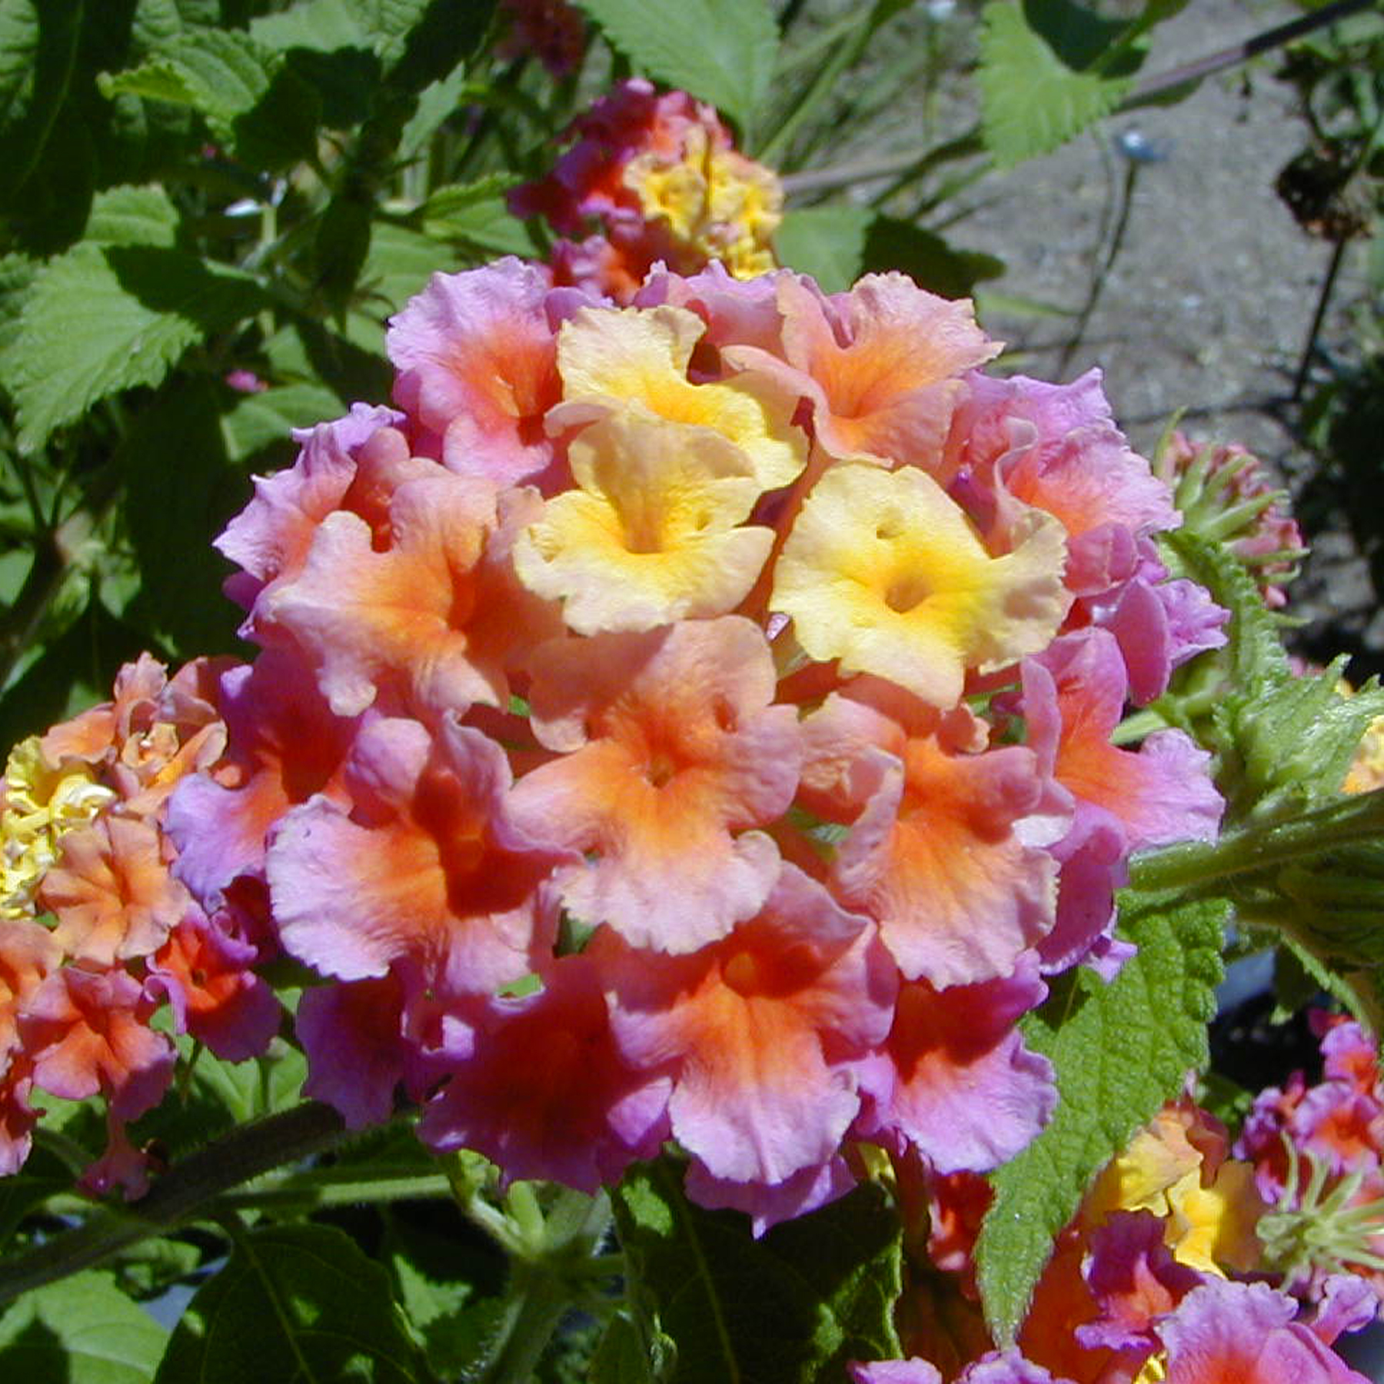
While valuable as ornamentals, lantanas do have some potentially problematic characteristics. Some people find that lantana leaves have a disagreeable odor when rubbed and crushed. In addition, leaves can cause contact dermatitis or minor skin irritation in some people. Finally, unripe lantana berries are poisonous.
Lantanas produce long-stalked, flat-topped clusters of small, colorful, tubular flowers.

There are several species of lantana that can be used in Wisconsin gardens. Common lantana (Lantana camara) is a small perennial shrub in its native range, but in Wisconsin is best treated as an annual. It is popular due to its fast growth rate, and profuse production of yellow, orange or red flowers. Trailing lantana (Lantana montevidensis) is a low-growing, spreading plant that produces a profusion of lavender, purple or white flowers. There are many named varieties/cultivars and hybrids of lantana. These varieties/cultivars and hybrids are more compact, bloom earlier, produce more colorful flowers, or hold their flowers better in rainy weather than the "common" type. Some new varieties/cultivars are almost sterile (i.e., they rarely set seed) which means deadheading is not as important for continuous bloom. Sterile varieties/cultivars are also less likely to become invasive in areas of the U.S. (e.g., Hawaii, Texas, Florida) where this is of concern. Trailing lantanas typically have the best flowering, followed by mounding types and upright types, respectively. There are numerous varieties/cultivars of lantana that will perform well in Wisconsin gardens.

- 'Confetti' has multicolored yellow, pink and magenta flowers.
- 'Dallas Red' has solid red flowers.
- 'Gold Mound' has a profusion of yellowish-orange flowers.
- 'Imperial Purple' is a trailing variety with a profusion of purple flowers.
- 'Irene' is a compact variety with intense magenta flowers (tinged with lemon-yellow and orange) that do not fade in strong sun.
- 'Lemon Drop' is a trailing variety with a profusion of yellowish-white flowers.
- 'New Gold' is a small (i.e., one-foot-tall, two-feet-wide) variety covered with dark golden-yellow, two-inch-wide clusters of blossoms that are produced just above the foliage.
- 'Patriot Dove Wings' has a profusion of white flowers.
- 'Patriot Firewagon' is an upright-growing variety with red flowers.

Revised

May 8, 2009
- 'Patriot Rainbow' is a free-blooming, compact variety with magenta flowers.

University of Wisconsin Garden Facts

- 'Patriot Sunburst' is a free-blooming variety with yellow flowers.
- 'Patriot Tangerine' is a consistent bloomer with hot-orange flowers.
- 'Radiation' is a medium-sized (i.e., three to five-foot-wide and high) variety having multicolored yellow and coral flowers with orange throats.
- 'Samantha' ('Lemon Swirl') has variegated, yellow-edged leaves and bright-yellow flowers.
- 'Silver Mound' is a mounded variety with a profusion of creamy, golden-eyed flowers.
- 'Spreading Sunset' is an upright variety with orange, coral-centered flowers.
- 'Sunny Daze' is a trailing variety with bright, lavender and purple flowers.
- 'Weeping White' is a trailing variety with white flowers.
- 'White Lightning' is a trailing variety with a profusion of white flowers.

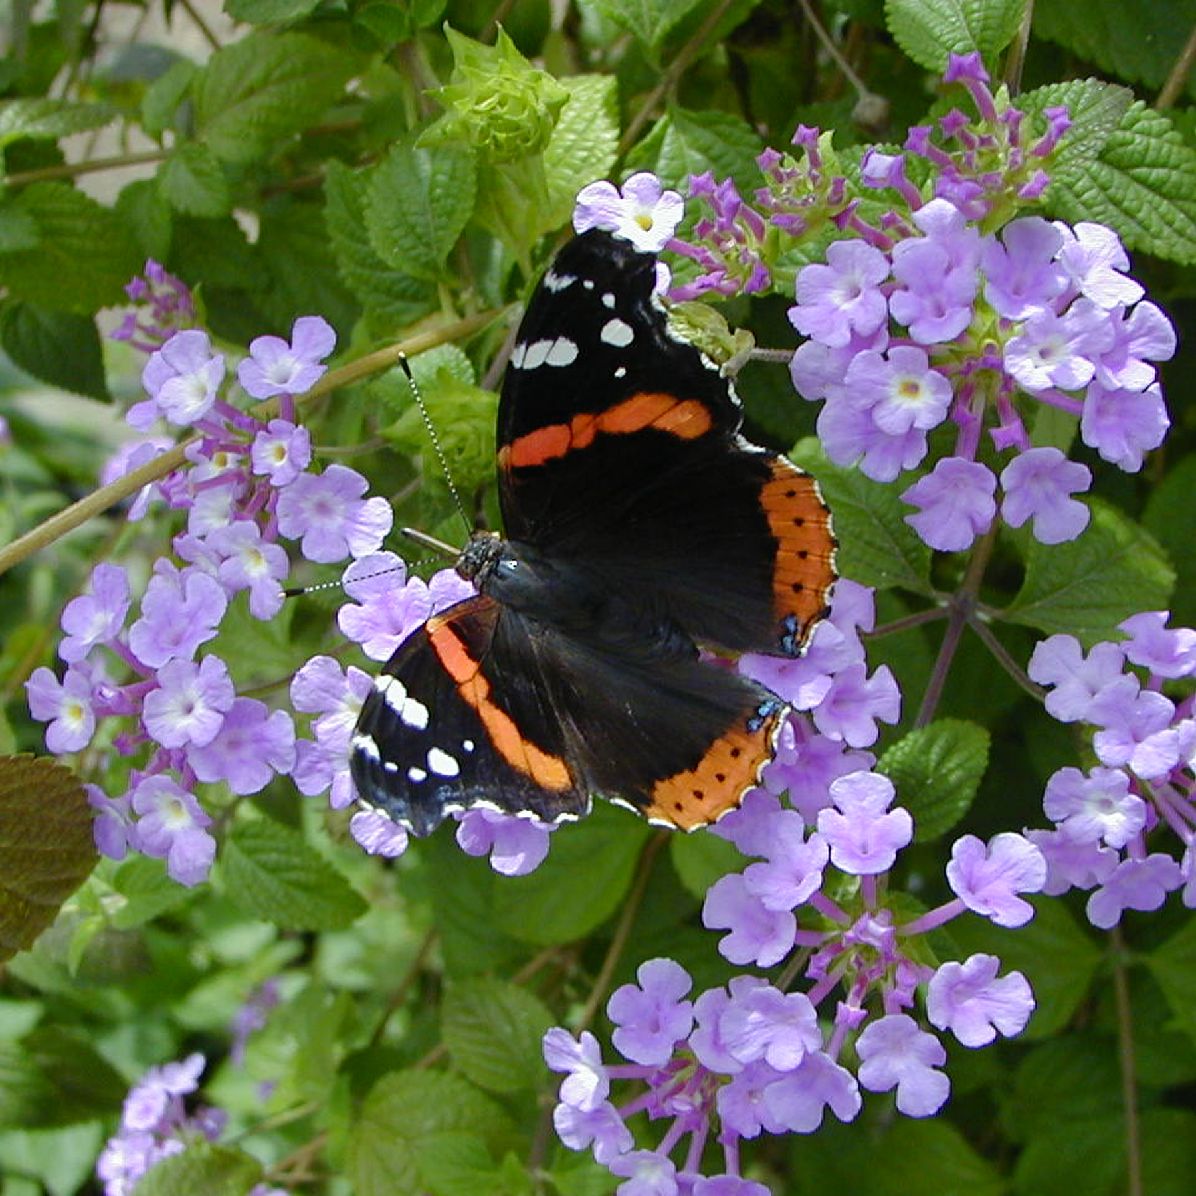
Note that not all of the varieties/cultivars of lantana listed above may be readily available in Wisconsin. Therefore, in order to obtain a particular variety, you may have to purchase the variety from a supplier in the southern U.S.
Lantana flowers are particularly attractive to butterflies.

Where do I get lantana? Lantana can be grown from seed or from cuttings. Seedlings take a long time to bloom, however. In Wisconsin’s short growing season, purchasing rooted plants is recommended. Altenatively, you can take hardwood cuttings from plants in the fall to produce young plants for the following spring. Lantana is killed at 28°F, so cuttings must be protected from frosts and moved indoors for the winter.

How do I grow lantana? Lantana is easy to grow. It does best in full sun and in moist, well-drained soil. Lantana is heat and drought tolerant. Too much water and fertilizer will reduce bloom. When lantana is grown in containers, fertilize one to two times per month. When growing lantana in flowerbeds, fertilize only when a soil fertility test indicates a need. Plants should be deadheaded to encourage continuous bloom, by either clipping individual faded flowers, or trimming the entire plant with hedge clippers.

How do I use lantana most effectively in my garden? Lantana can be used in mixed beds or as a border plant. It also can be used effectively as a container plant, particularly in hanging baskets or window flower boxes. Lantana can also be trained on standards. Indoors, in areas of high light intensity, lantana can be grown as a houseplant.

For more information on lantana: Contact your county Extension agent.

© 2009 by the Board of Regents of the University of Wisconsin System doing business as the division of Cooperative Extension of the University of Wisconsin Extension.

An EEO/Affirmative Action employer, University of Wisconsin Extension provides equal opportunities in employment and programming, including Title IX and ADA requirements. This document can be provided in an alternative format by calling Brian Hudelson at (608) 262-2863 (711 for Wisconsin Relay).

References to pesticide products in this publication are for your convenience and are not an endorsement or criticism of one product over similar products. You are responsible for using pesticides according to the manufacturer’s current label directions. Follow directions exactly to protect the environment and people from pesticide exposure. Failure to do so violates the law.

Thanks to Diana Alfuth, Laura Jull and Erin LaFaive for reviewing this document.

A complete inventory of University of Wisconsin Garden Facts is available at the University of Wisconsin-Extension Horticulture website: wihort.uwex.edu.

