
University of Wisconsin Garden Facts

Provided to you by:
XHT1069

Peach Leaf Curl
Patricia McManus and Brian Hudelson, UW-Madison Plant Pathology

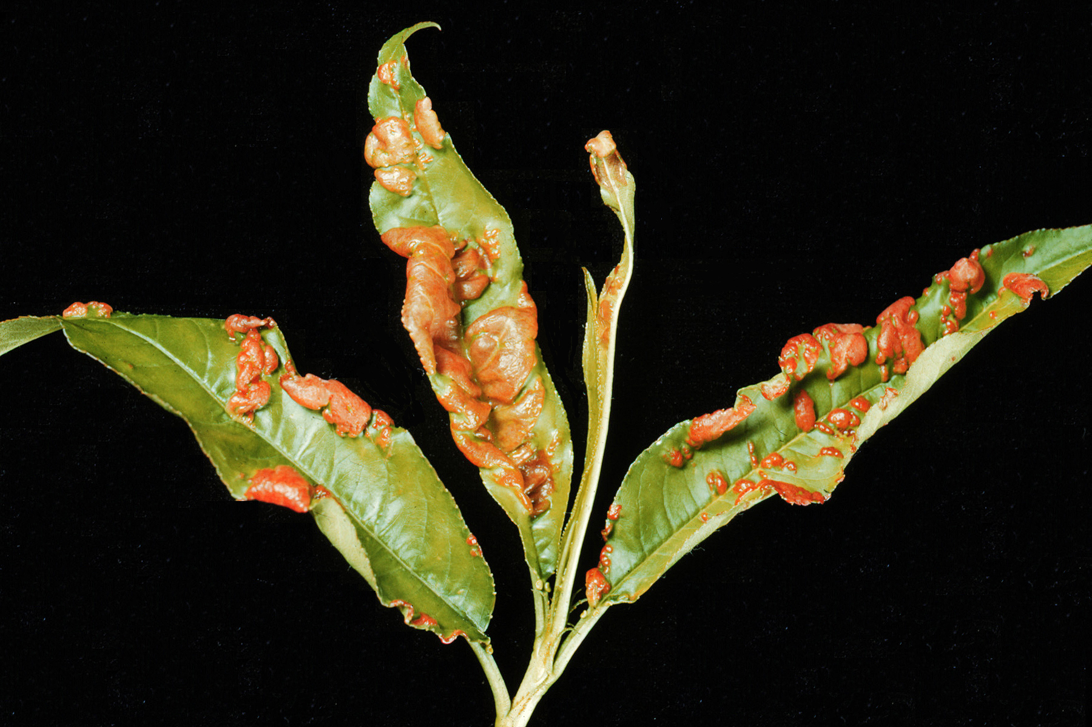
What is peach leaf curl? Peach leaf curl is a common disease on peach and nectarine trees throughout the Midwest and eastern U.S. Where the disease is severe, tree vigor and fruit quality and yield are diminished. Reports of peach leaf curl have increased in recent years, possibly because relatively mild winters have been favorable for the survival of the organism that causes the disease. A related disease, plum pockets, affects plums.
Leaf distortions and discoloration typical of peach leaf curl.

What does peach leaf curl look like? Diseased leaves are distorted with puckered, thickened, twisted areas that are reddish to purple in color. Leaves later turn brown and fall from the tree. Diseased shoots are stunted with small, yellowish leaves, or have leaves arranged in tight whorls (rosettes). Diseased flowers may abort, leading to reduced fruit set, while diseased fruit are bumpy, reddish in color, and fall prematurely.

Where does peach leaf curl come from? Peach leaf curl is caused by the fungus Taphrina deformans, which overwinters in bark and bud scales of peach and nectarine trees. Fungal spores infect leaves and shoots during spring while leaves are still in the bud, and as they just begin to emerge. Mild (50-70°F), wet weather during this period favors infection. As the fungus grows in plant tissues, it disrupts normal cell development resulting in distorted, off-color leaves, shoots, and fruit. Additional spores form on the surface of diseased tissue, and these spores cause new infections if the weather remains mild and wet.

How do I save trees that have peach leaf curl? Peach leaf curl is unlikely to kill a peach or nectarine tree on its own. However, if significant premature leaf drop occurs, trees will be susceptible to drought stress and winter injury. To help maintain tree vigor, irrigate during dry periods, fertilize with nitrogen (but not later than August 1), and thin fruit if the crop load is heavy. Avoid late summer fertilization as this will prevent trees from hardening off thoroughly before winter.

Revised

Apr. 25, 2004

How do I avoid problems with peach leaf curl in the future? Because Taphrina survives in bark and bud scales, removal of diseased leaves in the fall will not reduce disease. In addition, no peach varieties are immune to peach leaf curl. However, varieties derived from Redhaven are more resistant than varieties derived from Redskin. In addition, a single fungicide spray in the fall after leaf drop, or in the spring before buds begin to swell will control peach leaf curl (as well as plum pockets). Effective fungicide active ingredients include chlorothalonil, copper (e.g., Bordeaux mixture), and ferbam. Be sure when selecting a fungicide that you choose one that is labeled for use on edible food crops. Also, be sure to read and follow all label instructions of the fungicide that you select to insure that you use the fungicide in the safest and most effective manner possible.

For more information on peach leaf curl: Contact your county Extension agent.

© 2001 by the Board of Regents of the University of Wisconsin System doing business as the division of Cooperative Extension of the University of Wisconsin Extension.

An EEO/Affirmative Action employer, University of Wisconsin Extension provides equal opportunities in employment and programming, including Title IX and ADA requirements. This document can be provided in an alternative format by calling Brian Hudelson at (608) 262-2863 (711 for Wisconsin Relay).

References to pesticide products in this publication are for your convenience and are not an endorsement or criticism of one product over similar products. You are responsible for using pesticides according to the manufacturer’s current label directions. Follow directions exactly to protect the environment and people from pesticide exposure. Failure to do so violates the law.

Thanks to Patti Nagai, Teryl Roper, and Ann Wied for reviewing this document.

A complete inventory of University of Wisconsin Garden Facts is available at the University of Wisconsin-Extension Horticulture website: wihort.uwex.edu.

