
University of Wisconsin Pest Alert

Provided to you by:

XGT1002

Soybean Rust

Brian Hudelson, UW-Madison Plant Pathology and Bryan Jensen, UW-IPM Program

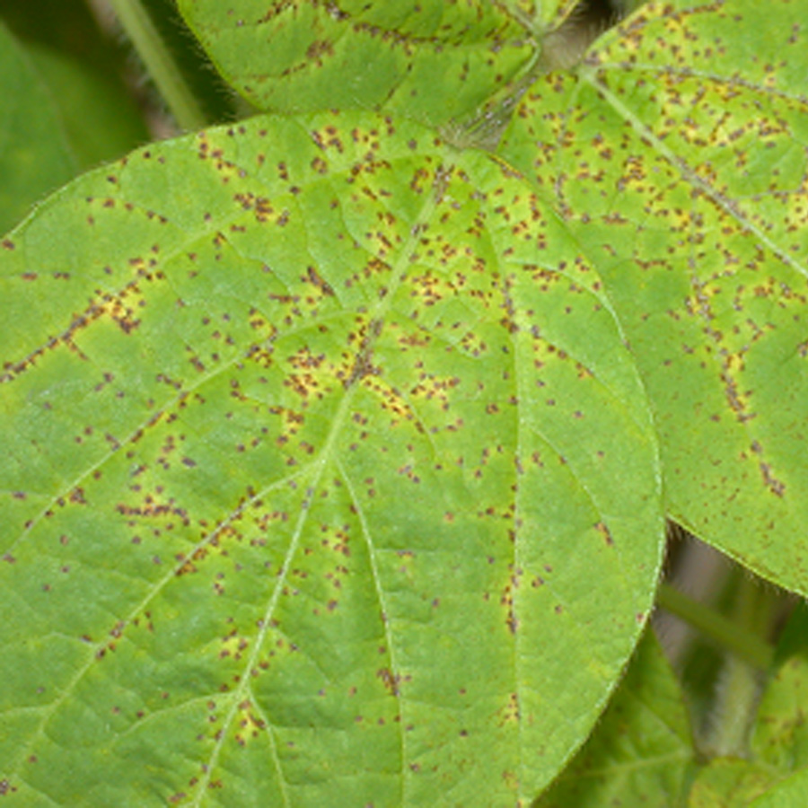
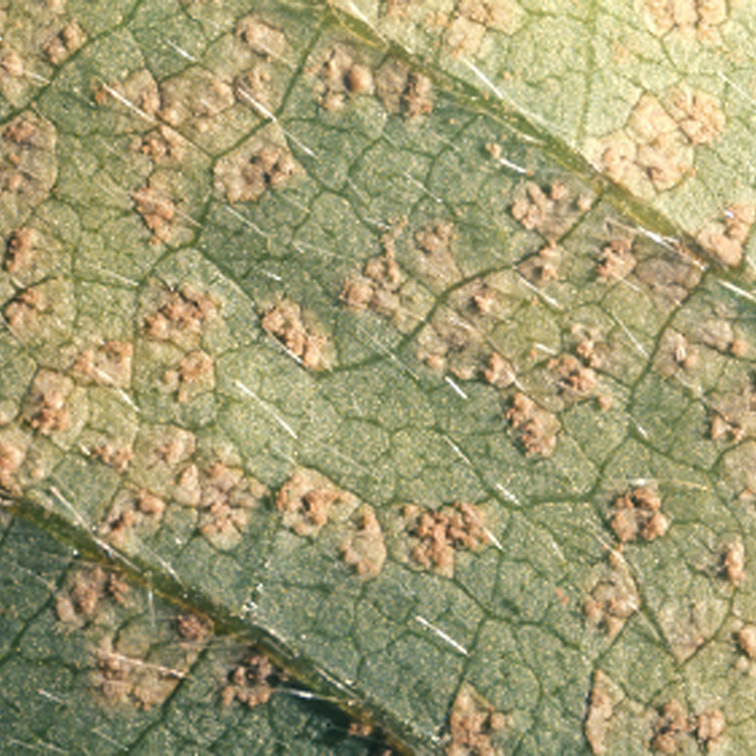
What is soybean rust? Soybean rust is an extremely serious fungal disease of soybean that was first reported in the continental United States in November of 2004. Currently, soybean rust has been found in Alabama, Arkansas, Florida, Georgia, Hawaii, Louisiana, Mississippi, Missouri, South Carolina and Tennessee. Soybean rust had previously been reported in Asia, Australia, Africa and South America, where yield losses due to the disease have ranged from 10 to 80%. In addition to soybean (Glycine max), soybean rust affects approximately 90 other plant species in the legume family. In Wisconsin, other potential hosts include snap and kidney bean (Phaseolus vulgaris), American bird’s-foot trefoil (Lotus unifoliolatus), crimson clover (Trifolium incarnatum), Korean clover (Kummerowia stipulacea), white clover (Trifolium repens), purple crownvetch (Coronilla varia), Chinese lespedeza (Lespedeza cuneata), lupine (Lupinus spp.), pea (Pisum sativum), rattlebox (Crotalaria spp.), yellow sweetclover (Melilotus officinalis), ticktrefoil (Desmodium spp.), and winter vetch (Vicia villosa).
Soybean rust causes small tan to reddish brown leaf spots (left) that first appear on lower leaves of soybean plants. Pimple-like pustules that are filled with tan spores form on the lower surface of infected leaves (right).

What does soybean rust look like? Initial symptoms of soybean rust include formation of small, gray spots on soybean leaves, particularly on the undersides of leaves. Spots are most likely to occur first on lower leaves where conditions are more favorable for spores to germinate and infect. Infections can also occur on petioles, stems and pods. Spots increase in size over time and change color from gray, to tan or reddish-brown. Tan lesions mature to form small pimple-like structures (called pustules) on the lower leaf surface. Pustules contain powdery tan spores that give the leaves the appearance that they have dandruff. Reddish-brown lesions are composed of primarily necrotic (i.e., dead) tissue and typically have only a limited number of pustules. As plant canopies close and pods begin to set, the soybean rust fungus can rapidly spread from lower to upper foliage of plants. Other diseases of soybean including brown spot, bacterial pustule and particularly downy mildew could potentially be confused with soybean rust.

Revised

Dec. 12, 2004

University of Wisconsin Pest Alert

Where does soybean rust come from? Soybean rust is caused by the fungi Phakopsora pachyrhizi and Phakopsora meibomiae. P. pachyrhizi is the more aggressive of the two species, and the fungus that was recently detected in the continental United States. P. pachyrhizi is thought to have been brought to the U.S. through hurricane activity in the late summer of 2004. Soybean rust fungi must overwinter on living plant tissue. Therefore, if soybean rust fungi ever reach Wisconsin, they are not likely to survive Wisconsin winters. In the South, however, plants such as kudzu (Pueraria montana var. lobata) can serve as overwintering hosts. Soybean rust spores produced on these plants could be moved north each year by prevailing winds, as is known to occur with other rust fungi (e.g., the corn rust pathogen). Soybean rust fungi may eventually reach Wisconsin via this route. This movement of spores via prevailing winds could occur each year, thus making soybean rust a recurring problem.

How do I save a soybean plants infected with soybean rust? If you suspect that your soybeans are suffering from soybean rust, proper diagnosis is crucial to document the presence of the disease in Wisconsin. See University of Wisconsin Pest Alert XG1001 (available at www.plantpath.wisc.edu/pddc) for details on submitting a sample for diagnosis. Keep in mind however that once soybean plants are infected and the soybean rust fungus has begun to produce spores, control of the disease is difficult and significant yield losses are likely. Fungicides with “curative” properties will likely be registered for use against soybean rust in Wisconsin by the 2005 growing season. However, curative fungicides have a very limited ability to eliminate existing disease and by the time soybean rust is observed, these products will likely not provide adequate control. Therefore, every attempt should be made to prevent infections (see below), rather than to attempt to control soybean rust after infections have occurred.

How do I prevent problems with soybean rust? Plant soybeans as early as possible, so that if soybean rust does occur, plants are as mature as possible when infection occurs, and yield loss can be minimized. Researchers throughout the soybean-producing regions in the United States will be monitoring for soybean rust in 2005. Watch for reports of the disease to the south of Wisconsin and consider preventative fungicide treatments as the rust fungus approaches the state. Currently products containing chlorothalonil (e.g., certain formulations of Bravo® and Echo®), azoxystrobin (e.g., Quadris®) and pyraclostrobin (e.g., Headline®) can used preventatively for control of soybean rust. Other preventative and “curative” fungicides will likely be registered for use in Wisconsin by the 2005 growing season. Both types of products will be most effective if used to prevent infections. If you decide to use fungicides for control, be sure to select a formulation that is labeled for use on soybeans, and be sure to read and follow all label instructions of the fungicide that you select to insure that you use the fungicide in the safest and most effective manner possible.
For more information on soybean rust or help in diagnosing this disease: Contact Craig Grau, Department of Plant Pathology, University of Wisconsin-Madison, 1630 Linden Drive, Madison, WI 53706-1598, [phone: (608) 262-6289, fax (608) 263-2626, email: cg6@plantpath.wisc.edu]; or contact Brian Hudelson, Plant Disease Diagnostics Clinic, University of Wisconsin-Madison/Extension, 1630 Linden Drive, Madison, WI 53706-1598 [phone: (608) 262-2863, fax: (608) 263-2626, email: bdh@plantpath.wisc.edu]; or contact your county Extension agent.

© 2004 by the Board of Regents of the University of Wisconsin System doing business as the division of Cooperative Extension of the University of Wisconsin Extension.

An EEO/Affirmative Action employer, University of Wisconsin Extension provides equal opportunities in employment and programming, including Title IX and ADA requirements.

References to pesticide products in this publication are for your convenience and are not an endorsement or criticism of one product over similar products. You are responsible for using pesticides according to the manufacturer’s current label directions. Follow directions exactly to protect the environment and people from pesticide exposure. Failure to do so violates the law.

Thanks to Greg Andrews, Craig Grau and Laura Paine for reviewing this document.

