
University of Wisconsin Garden Facts

Provided to you by:
XHT1147

Wisconsin Lawn Care Calendar
Barb Larson, UW-Extension Kenosha County and
Sharon Morrisey, UW-Extension Milwaukee County

The following lawn care calendar provides an overview of home lawn maintenance. Not all lawns require every maintenance activity. Be sure to customize the care of your lawn to its specific problems and needs. For details on specific activities listed below, check out the University of Wisconsin-Extension bulletins (available at http://learningstore.uwex.edu) and University of Wisconsin Garden Facts (available at http://hort.uwex.edu) that are referenced at the end of this fact sheet. Finally, be sure to read and follow all label instructions of any pesticides that you select to ensure that you use these products in the safest and most effective manner possible.

April
- Rake and clean up winter debris as weather allows.
- Reseed bare spots, and establish a new lawn, if you desire.
- Apply a pre-emergent crabgrass herbicide to your established lawn.
- Mow your lawn to remove ¹/3 of the current grass height. Grass should be 2¹/2 to 3¹/2 inches tall after mowing.

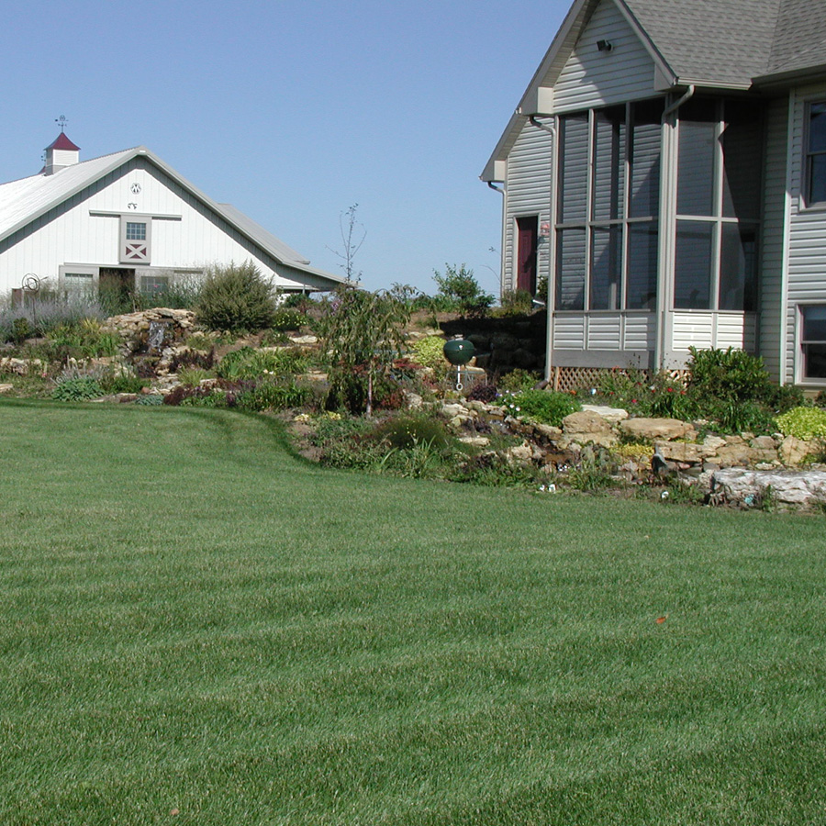
May
Regular care and maintenance will yield a lawn that is lush and beautiful.
- After your grass is actively growing, core aerate your lawn if the thatch layer is over one inch thick.
- Late in May (e.g., around Memorial Day), fertilize your lawn using a controlled-release or slow-release formulation. For grass growing in the sun, use the label rate of the fertilizer that you have selected. For grass growing in the shade, apply half of the label rate.
- Apply an herbicide to your established lawn to control actively growing broadleaf weeds. DO NOT use herbicides on newly seeded areas. If possible, apply the herbicide to weeds when they are blooming. Many fertilizer products also contain herbicides for broadleaf weed control, so combining fertilizer and herbicide applications may be possible.

June
- If you have not applied one previously, apply an herbicide to your lawn for broadleaf weed control.
- Begin watering your lawn as needed for the summer. Or alternatively, do not water and allow the lawn to go dormant (i.e., turn brown) if natural rains are insufficient.
- Watch for insect pests, diseases, and other lawn problems.

Revised

Dec. 27, 2011

July
- Water your lawn as needed. If you do not water, your lawn will naturally go dormant.

University of Wisconsin Garden Facts

- Early in July (e.g., around Independence Day), fertilize with a controlled-release or slow-release fertilizer. For grass growing in the sun, use the label rate of the fertilizer that you have selected. For grass growing in the shade, apply half of the label rate. If your lawn has been consistently fertilized for 10 to 15 years, if you leave clippings on your lawn when you mow, or if your lawn has gone dormant, skip this application.
- Apply a grub control product to your lawn if there is a history of grub problems and/or your lawn is a high maintenance (i.e., regularly watered) lawn.
- Avoid seeding and spraying for weeds.
- Watch for insect pests, diseases, and other lawn problems.

August
- Water your lawn as needed.
- Establish a new lawn or renovate your current lawn. Note that mid-August to mid-September is the best time to establish a lawn in Wisconsin.
- Watch for insects, diseases, and other lawn problems.

September
- Early in September (e.g., around Labor Day), fertilize your lawn using a controlled-release or slow-release formulation. For grass growing in the sun, use the label rate of the fertilizer that you have selected. For grass growing in the shade, apply half of the label rate.
- Apply an herbicide to your established lawn to control broadleaf weeds. Fall is the best time to apply herbicides for weed control. DO NOT apply herbicides to lawns planted in August or September.
- Core aerate actively growing lawns if the thatch layer is over one inch thick, or if the soil is compacted.

October
- Apply a broadleaf herbicide to your lawn if you did not apply one in September and the weeds are still growing.
- If you have removed clippings from your lawn all season, fertilize your lawn in early October using a controlled-release or slow-release formulation. For grass growing in the sun, use the label rate of the fertilizer that you have selected. For grass growing in the shade, apply half of the label rate.

November
- Continue to mow your lawn until it goes dormant for the winter.
For more information on lawn care and lawn pests: See University of Wisconsin-Extension bulletins A1990, A2303, A3179, A3237, A3271, A3275, A3434, A3435, A3700, A3710, and A3714 (available at http://learningstore.uwex.edu), and University of Wisconsin Garden Facts XHT1018, XHT1023, XHT1062 and XHT1114 (available at http://hort.uwex.edu), or contact your county Extension agent.

© 2005-2011 by the Board of Regents of the University of Wisconsin System doing business as the division of Cooperative Extension of the University of Wisconsin Extension.

An EEO/Affirmative Action employer, University of Wisconsin Extension provides equal opportunities in employment and programming, including Title IX and ADA requirements.

References to pesticide products in this publication are for your convenience and are not an endorsement or criticism of one product over similar products. You are responsible for using pesticides according to the manufacturer’s current label directions. Follow directions exactly to protect the environment and people from pesticide exposure. Failure to do so violates the law.

Thanks to Donna Henderson, Jason Kruse, Doug Soldat and John Stier for reviewing this document, and to Diana Alfuth for providing the photograph.

A complete inventory of University of Wisconsin Garden Facts is available at the University of Wisconsin-Extension Horticulture website: http://hort.uwex.edu.

